|  |  |
| --- | --- |
|  |  |

 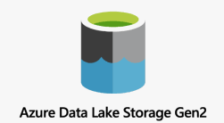  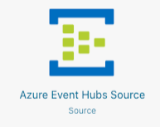

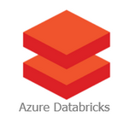 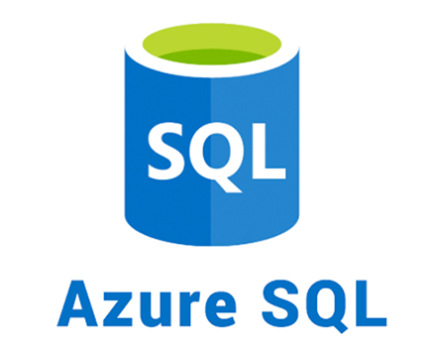 

Contents

Introduction 5

Overview 5

Azure Free Account 11

Azure Portal Overview 13

Azure Databricks 16

Overview 16

Creating Azure Databricks Service 19

Azure Databricks Architecture 41

Project Solution Databricks Notebooks 44

Databricks Clusters 50

Overview 51

Azure Databricks Cluster Configuration 57

Creating a Databricks Cluster 60

Azure Databricks Cluster Pool 76

Databricks Notebooks 85

Mounting Data Lake Container to Databricks 85

Databricks File System ( DBFS ) 85

Databricks Mount Overview 93

Creating Azure Data Lake Storage Gen 2 95

Creating Azure Service Principal 110

Mounting Azure Data Lake Storage – Gen 2 115

Secret Scopes Overview 123

Creating Secret Scope and Secrets in Key Vault 124

Mounting Data Lake using Secrets 137

Project 146

Overview 146

Data 146

Upload Raw Data to Data Lake 157

Project Requirements 161

Solution Architecture Overview 163

Spark Cluster Architecture 176

Spark Dataframes 178

Data Ingestion 178

Overview 178

Data Ingestion – Circuits 180

Dataframe Reader 180

Specify Schema 191

Select Columns 200

withColumnRenamed 207

withColumn 208

DataFrameWriter 211

Data Ingestion – Races Data 218

Partitioning 222

Data Ingestion – JSON 224

Read JSON File 225

Transform and Write Data 229

Data Ingestion – Results Assignment 240

Data Ingestion – Pitstops 244

Data Ingestion - Laptimes 249

Qualifying – Requirements 257

Databricks Workflows 261

Including a Child Notebook 261

Passing Parameters to Notebooks 266

Notebook Workflows 272

Databricks Jobs 280

Filter and Join Transformations 293

Filter Transformation 293

Join Transformation – Inner Join 299

Outer Join 306

Join Transformations 311

Join Transformation – Race Results 314

Setup Environment – Presentation Layer 316

Join Race Results – Solution 319

Aggregations 329

Simple Aggregate Functions 329

Group By 336

Window Functions 344

Driver Standings 350

Constructor Standings 363

Using SQL in Spark Applications 365

Local Temp View 365

Global Temporary Views 370

Databases, Tables and Views 377

Databases, Tables and Views 377

Databases 378

Managed Tables 384

External Tables 391

Views 400

Formula 1 project SQL Requirement 406

Create Table – CSV Source 408

Create Table – JSON Source 413

Create Table – Multi Files Source 419

Create Table – Parquet Source ( Processed Data ) 425

Create Table – Parquet Source ( Presentation Data – Assignment ) 435

Spark SQL – Filters, Joins, Aggregations 440

SQL DML Basics 440

SQL Simple Functions 444

SQL Aggregates, Window Functions 448

SQL Joins 454

Spark SQL – Analysis 460

Create Race Results Table 460

Dominant Drivers – Analysis 465

Dominant Teams – Analysis 470

Dominant Drivers – Visualization 474

Dominant Teams – Visualization 481

Create Dashboards – Drivers 487

Create Dashboard – Teams 492

Incremental Load 498

Data Loading Design Patterns 498

Formula 1 - Project Scenario 504

Formula 1 – Project Data Setup 507

Full Refresh Implementation 510

## Introduction

### Overview

The primary focus of this course is as Azure Data Bricks, which is a widely adopted, spark based unified data analytics platform optimized for Microsoft Cloud. Apart from learning the standard database capabilities and tools, we'll also learn Spark using Python as well as SQL. I've also created a dedicated section on Delta Lake and how we can use Delta Lake to implement the emerging legacy architecture. I've also provided the necessary knowledge on the other services required to complete this course. The course uses Azure Data Lake Storage Gen 2 as the storage solution. I'll take it through all the way from creating a Data Lake service for reading and writing data to the Data Lake. We use Azure Data Factory to create a schedule and monitor data pipelines. I have dedicated an entire section spanning nearly an hour and a half for Azure Data Factory. This is by no means a course on Azure Data Factory, but will cover the necessary knowledge required for creating pipelines for data bricks notebooks and for scheduling and monitoring those pipelines. The course focuses on building a production quality data engineering solution. So secrets are managed by Azure Key Vault, and the course provides the necessary knowledge required to achieve this. I'll also take you through how we can connect to the data in Data Bricks from Power BI to create BI reports.

We'll be doing a project on building a cloud data platform for reporting and doing analysis of the data from Formula One motorsport. In this project, we'll build a Data Lake in Azure by ingesting Formula One race data from an external API. We will then transform this data as required for reporting and analysis purposes and make them available in our presentation layer. We will then analyse the data for trends using Data Bricks and create the necessary dashboards. We will also make the data available for reporting.

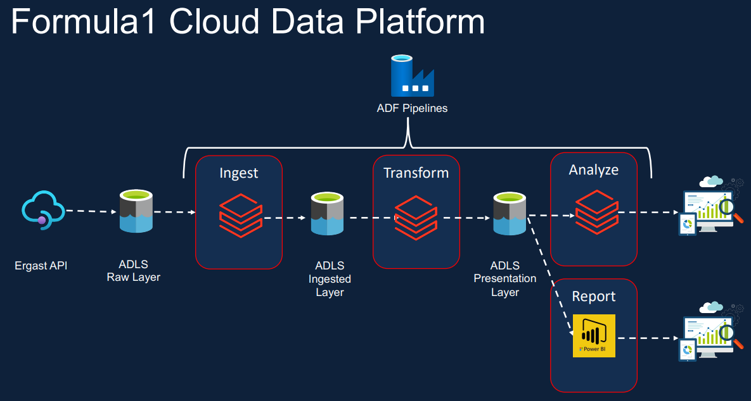

And I'll demonstrate how to access this data from Power BI. All of this process will be scheduled and triggered by Azure Data Factory pipelines. We will then go through the new and emerging Data Lake architecture and convert our solution to create a Data Lake House using Delta Lake. Along the way, we'll do some interesting analysis on the data to identify the most dominant drivers and the teams in the history of Formula One.

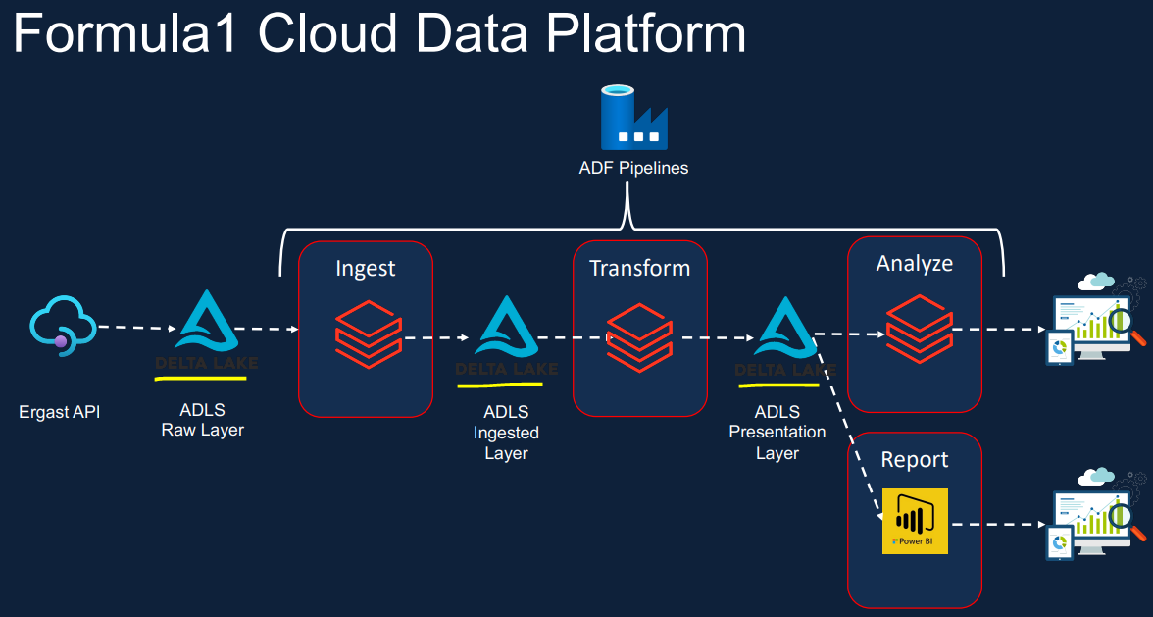

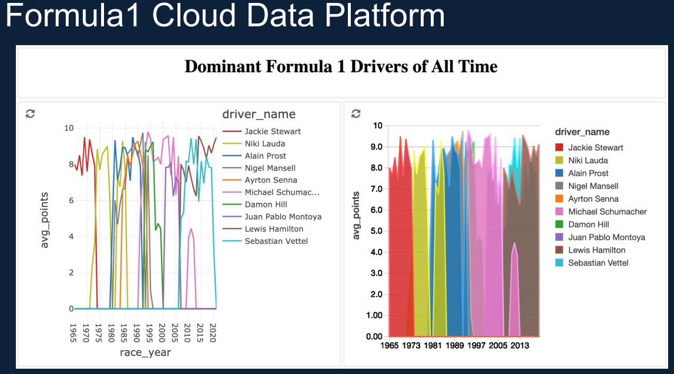

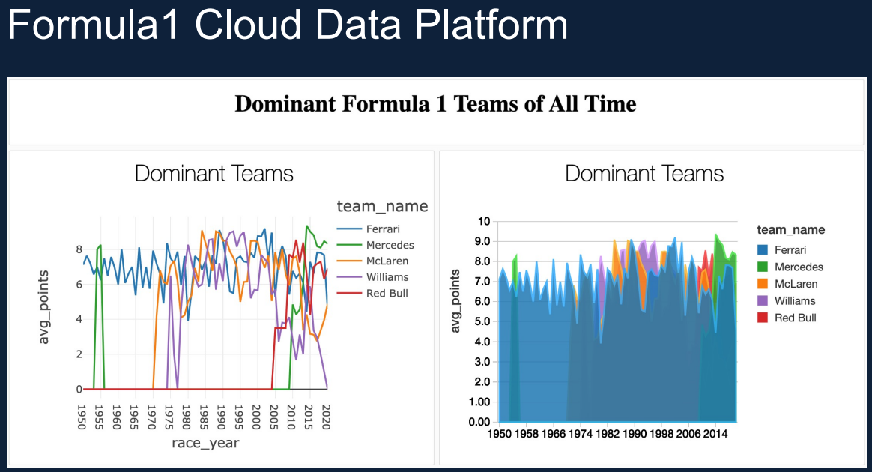

This course covers some of the technologies required for this as your data engineer associate certification exam, DP 203. But this course is not specifically designed to help you pass the certification exam or to teach you all the topics covered by the exam. So if your primary goal is only to pass the certification, this course alone won't be sufficient. You will have to learn more. So please look out for other suitable courses. The primary objective of the course is to teach Databricks and Spark Core. It doesn't cover things like Spark and Spark Streaming. So if you are looking to learn one of those, you should look out for a different course. Also in this course, I teach Spark using Python and SQL, doing this in Scala or Java will be straightforward, but the course doesn't teach those explicitly.

Most importantly, we need a Azure account.

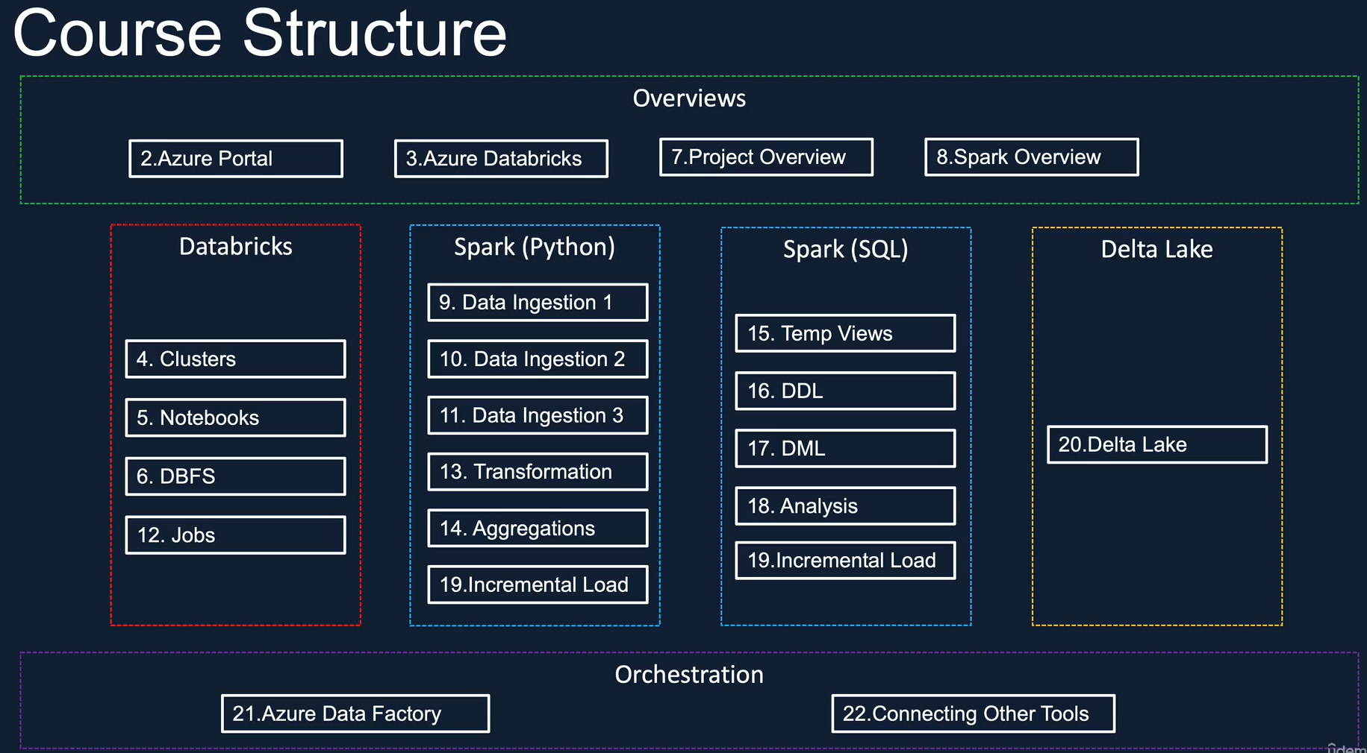

There are 21 sections in the course apart from this one, and they can be split into six broad categories as shown here. The next section is an optional one in which we will create a 3 tier subscription if you haven't already got one. And also, I'll give you an overview of the Azure portal. If you're new to Azure. The other overview sections are on the architecture and the user interface of the Azure Data Bricks Service. A Project Overview, which includes an overview of the Formula One season and the data and also the API and the project requirements. We also have an overview of the Spark architecture, as well as the data frame and data sources API. As for Data Bricks, we have separate sections for cluster, cluster pools, note books, database file system and also data protection jobs. We use Pyspark to ingest the source data into our data lake. During ingestion will deal with a few types and complexities of data. So there are separate sections to deal with each one of those. We also look at some transformations during the ingestion process. We then have a dedicated section for Filters, Joins and Aggregations. As for Spark SQL , we have sections on temp views and how to access them from PySpark, creating databases, tables and views. And also we've got a section on inserting data into tables, applying filters, joints and aggregations. We also have a separate section on using Spark SQL to do some interesting analysis.

Section 19 is an advanced topic on implementing different design patterns for data loading. At the end of this section we will implement the incremental load pattern to our project. This will be done by both using PySpark and as well as Spark SQL. In Section 20, we talk about the pitfalls of Data Lakes and then discuss the Lake House Architecture and how it can help us resolve some of these issues. We will also use Delta Lake to implement Lake House architecture as part of the solution for our project.

In Section 21, we create pipelines using as your Data Factory to schedule the execution of Data Bricks notebooks. We will also create triggers to invoke the pipelines and monitor them. Section 22, will teach us how to connect to Dara Bricks from Power BI so that we can create reports on the data from the Delta Lake. Every module in this course builds on the previous model, so for best results, my advice is to follow the model in the underspecified and also complete all the lab sessions before continuing to the next model.

**Useful Links**

Azure Portal – [https://portal.azure.com](https://portal.azure.com/)

Ergast API Documentation - <http://ergast.com/mrd/>

PySpark Documentation - <https://spark.apache.org/docs/latest/api/python/index.html>

PySpark API Reference - <https://spark.apache.org/docs/latest/api/python/reference/index.html>

Spark SQL Reference - <https://spark.apache.org/docs/latest/sql-ref.html>

### Azure Free Account

The easiest thing to do is search the web for create as your free account and that will take you to this and click on the create as your free account today. Link here and you come to this page. So from here you can click on the start for free to create your free account.

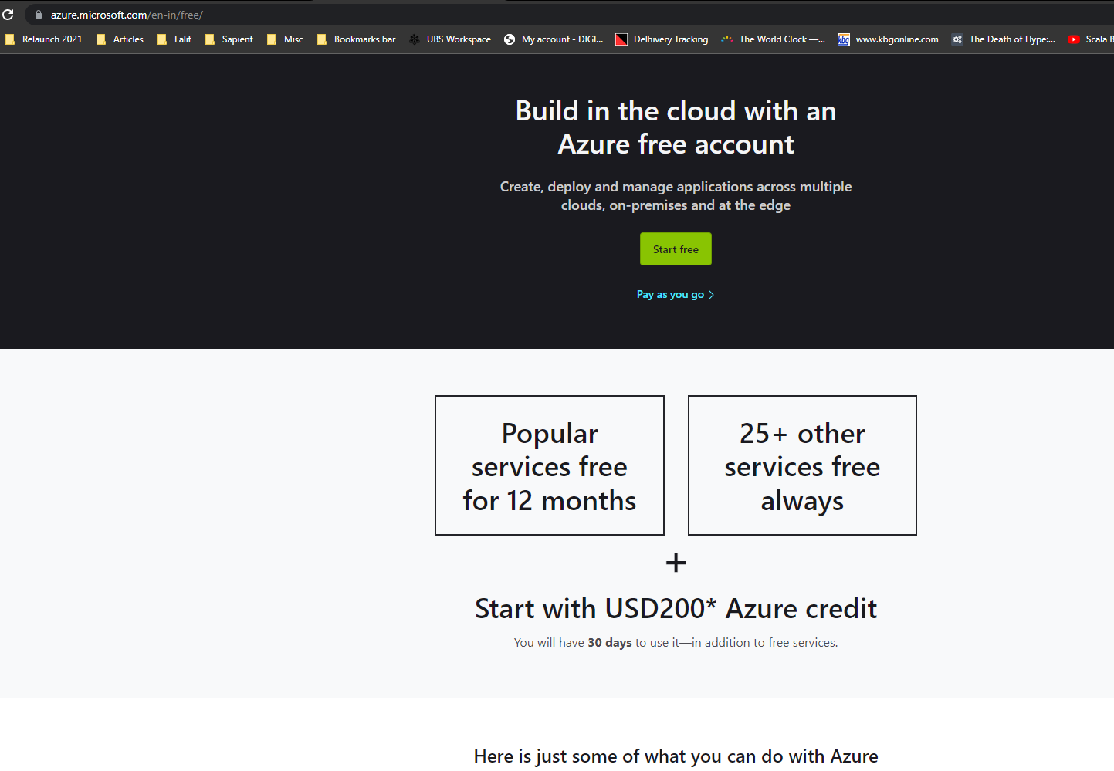

You can click on the link to see what they are. And there are some services which are always free. So that will be a 400 I use per second as your customers day, which you can play with experiment and use it for your learning purpose. And they've got a million requests for months of Asgeir functions, for example. But you can go through those. Actually there are more than 25. So you can look at the full list here as well. Most importantly, you get the hundred and fifty pounds are the 200 US dollars of free credit, which will be more than sufficient to do our cost. So let's click on the start for free to create a free account. That'll take you to this page from here, you can create the free account, so in order to create a free account, you need to have a Microsoft account, which you can use to sign in here. But if you haven't got a Microsoft account, you can create a new one. So click on this one and that will take you to this page where you can create a Microsoft account. You can even create a new email account. So, for example, if you wanted to have an outlook account or a Hotmail account, you can just create from there.

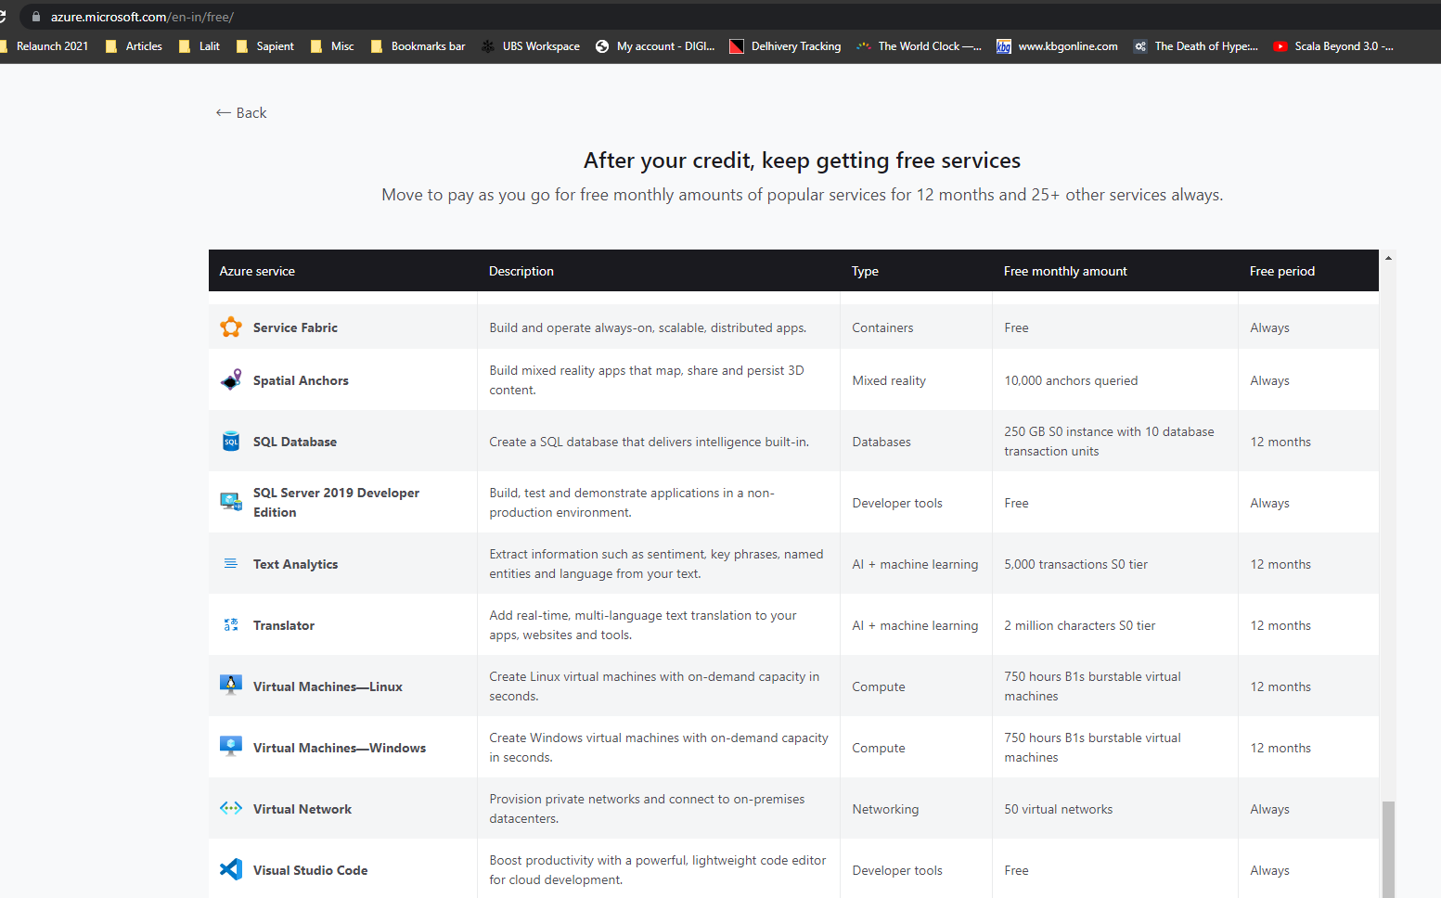

[lalit.r.nagpal@hotmail.com](mailto:lalit.r.nagpal@hotmail.com) – N****@****

So you come to this page and then you can click on Activate now to create your free account. There are differences between this free account and the standard fee account. This one is for students that, as you can see here, you don't get the five gigabytes on the blockbuster and the file store. And also you've got the Linux virtual machines 750 hours, but you don't have the Windows virtual machine. So there are some differences between this tool and free account and the standard free account. And also, I think this hundred dollars of free credit, which you get is applicable for the entire 12 months as opposed to the 30 days.

### Azure Portal Overview

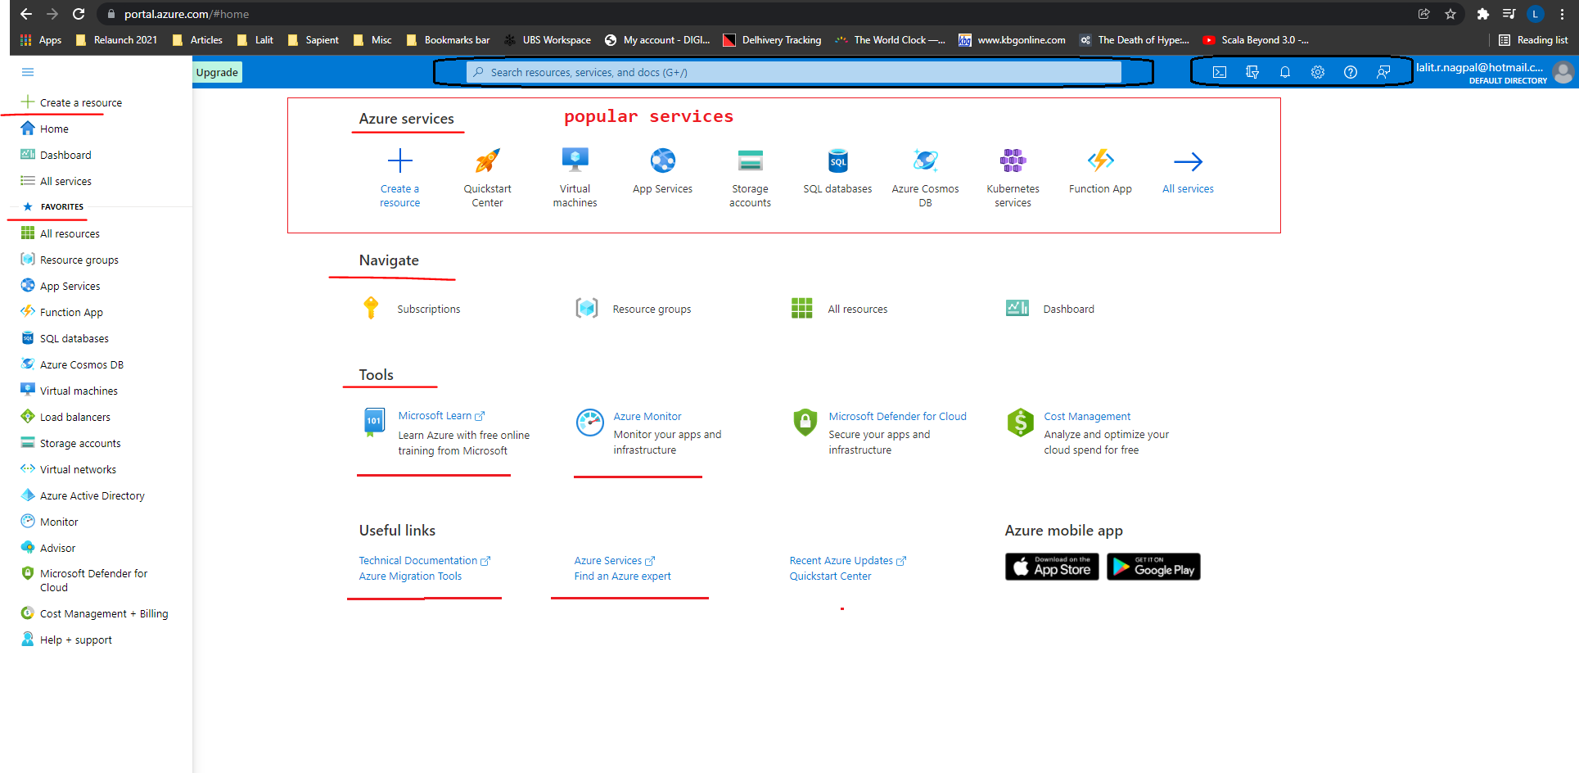

Once you've signed in, you'll come to this page, this page should be very similar for you as well, except that you won't have any recent resources here. And also it's worth bearing in mind that Microsoft has been updating the portal significantly over the last few months to make it easier for us to use. So it might be slightly different when you come to do this course. In the portal, you've got the top left, which is the menu, you can customize the sections here and from here you can create a resource, you can go to the home, which is this one, and you can go to your dashboards or go to all services. And if you favorite any of the services, then they'll appear here. And in the middle, you've got the top middle section, which is got the popular services within a year, so you can straightaway click and navigate those. And we talked about the recent resources when you access a resource that will automatically appear here. So I, for example, use this one four days ago and then these things like a month ago and things like that. It might be empty for you now, but it will start to populate when you come to create your new resources and things like that. And you've got some navigation options here. And you can go to as you monitor and you can go to Microsoft learn, which gives you a lot of help free online training from Microsoft. And you've got the useful links to any technical documentation and tools and services. And on the top, this is very useful, so you can search anything within your party when you start to create a lot of resources and many are doing a lot of work here. This is quite an easy tool. This is like being controlled to search for something. So if you want to find anything within Azure, this is where you will come and then you'll search for that on the right hand side.

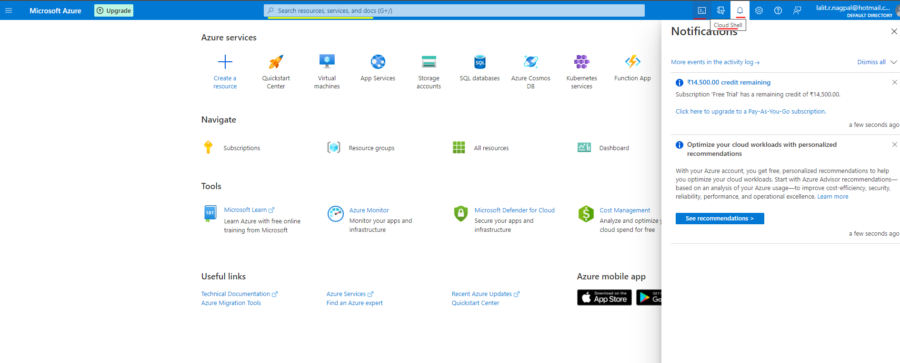

On the right hand side on the top, you've got the cloud shell first. So using this you can use either bash are power shell to interact with Azure. We won't be doing this in this course. We'll be using the portable graphical user interface to interact with Azure. But if you want to use power shell or bash, this is what you do. Actually, you can create a cloud shell and then you can work from there. And if you had multiple subscriptions, you can come and pick those from here. And you've got the notification, so if you, for example, started to deploy a service, then that would the status of that would appear in here. So you've got notifications here and this is your saying. So you can use this to customize your portal, for example, you can change between a default view of home and a dashboard, or you can have the menu here. Instead of that being fly out, you can duck it.

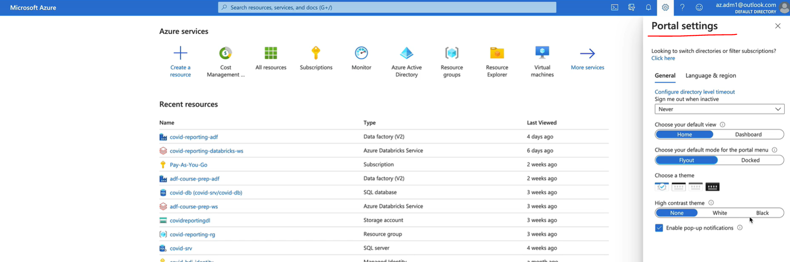

So you got it here and you can change the contrast theme. So I've got the default one. But if you like your black contrast, then you go for the black. And you can search help here, so you've got the help and support, you can come up and search for anything you want, and if you want to send your feedback to Microsoft, you can directly send them any feedback from here as well. So that is pretty much the Azure portal.

## Azure Databricks

### Overview

First, let's start by understanding what is, Azure Data Bricks from a high level, will then break it down in the forthcoming lessons and delve deeper into each of its components. At the core of Azure Data Bricks is the open source distributed compute processing engine called Apache Spark, which is widely used in the industry for developing big data projects. Data Bricks is a company created by the founders of Apache Spark to make it easier to work with Spark by providing the necessary management layers. Microsoft makes the data bricks service available on its Azure cloud platform as a first party service. These three offerings together makes Azure database. So let's start with a brief introduction to Apache Spark and then we look at the additional service offered by data bricks and Azure.

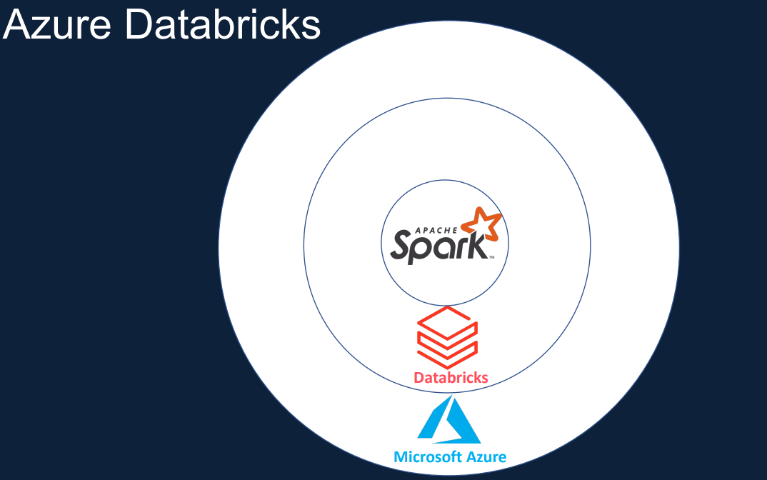

At a high level, Apache Spark is a lightning fast, unified analytics engine for big data processing and machine learning. It was originally developed at UC Berkeley in 2009 and open sourced in 2010 under BSD license. In 2013, it was donated to the Apache Spark Foundation and seen a significant adoption.

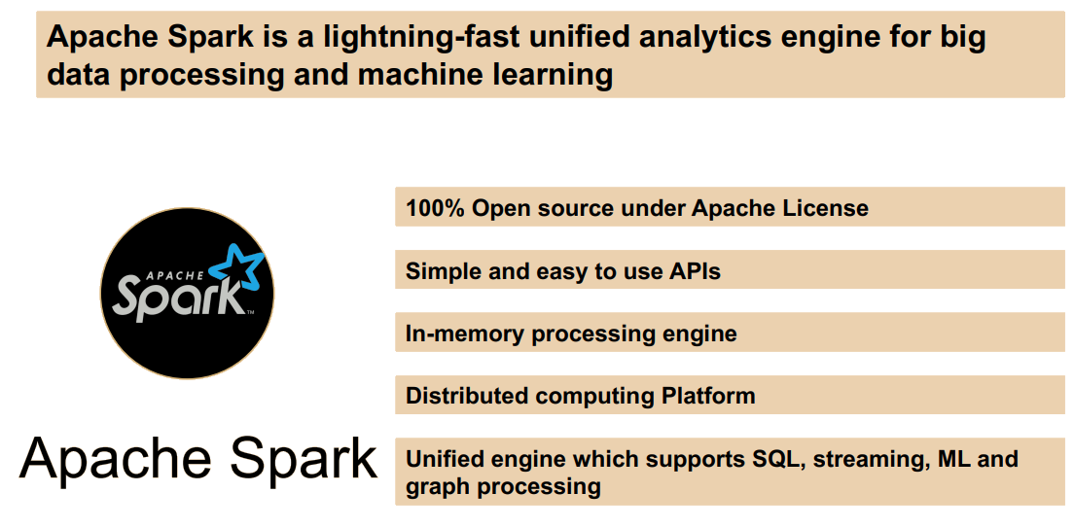

Since it's been used by the Internet giants such as Yahoo! eBay and Netflix for large scale data processing on multiple petabytes of data on clusters of thousands of nodes. Was built from the ground up to address the shortcomings of Hadoop, how to be slow and inefficient for interactive and iterative computing jobs. And it was too complex to learn and develop. On the other hand, SPARC offers a much simpler, faster and easier APIs to develop on.

Spark can be hundreds faster than Hadoop for large scale data processing by exploiting in-memory computing and other optimizations. Similar to most other big data engines, Spark runs on a distributed computing platform, Sparka has a unified engine to support varying workloads. For example, it uses a single engine for streaming and batch workloads. It doesn't have separate one for each of those. It comes packaged with high level libraries, including support for queries, streaming data, machine learning and graph processing. The standard libraries increase developer productivity and can be seamlessly combined to create complex workflows.

Let's now take a quick look at the high level architecture of Spark, so it'll be easier when we come to discuss the capabilities added by database and Azure. At the center of Spark architecture is Spark Core, this contains the basic functionality of Spark. The Spark Core takes care of scheduling tasks, memory management for recovery, communication with storage systems, etc. It's also home to its Sparks main programming abstraction API, called RDD or Resilient Distributed Datasets. RDDs are a collection of items distributed across various compute nodes in the cluster that can be processed in parallel, Spark provides the space to create and manipulate these RDD collections. Early development in Spark was done using these apps, but it had its drawbacks. It was difficult to use for complex operations and it was difficult to optimize for Spark and mainly down to the developer to write the optimized code. In order to optimize the workload, Spark introduced the SQL engine, it includes the Catalyst optimizer, which takes care of converting a computational theory to a highly efficient execution plan, and the Tungsten project, which is responsible for memory management and CPU efficiency.

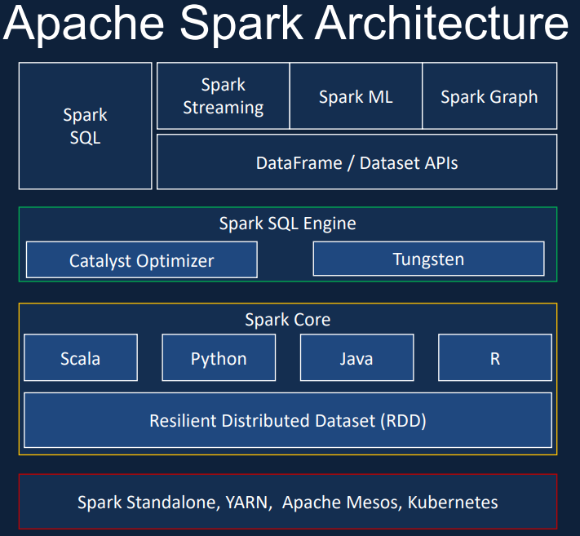

The higher level abstraction such as Spark SQL and the Data Set and the Dataframe APIs make it easier to develop applications and also benefit from the optimizations from the SQL engine. So the recommended approach to develop applications in SPark is to use these higher level APIs rather than the RDD API. The Dataset and the Dataframe APIs can be invoked from any of the domain specific languages such as Scala, Python, Java and R on top of this. We have this set of libraries such as Spark Structured Streaming for streaming, ML Lib for machine learning and also graphics for graph processing. Also as part comes with its Standalone resource manager, but you can choose other resource managers such as YARN, Apache Mesos and Kubernetes. Combining all of these Spark provides the unified platform for doing Streaming, Batch, machine learning and graph processing workloads, using a single execution engine and a standard set of.

Now, we know that Spark is a fast execution engine with an easy to use set of higher level APIs, but in order to work with Spark, we have to set up our own clusters, manage security and also use third party products to write our programs. That's where our databricks comes. Databricks is a company founded by the creators of Apache Spark to make it easier to work with Spark on the Cloud. In order for Spark to do Distributed computing, we need to spin up clusters and install the software. Databricks gives you the ability to spin up the clusters with a few clicks. You can choose the runtime which is suitable for your needs. For example, you can choose a runtime with ML libraries, supports for GPU, etc.. Also, you can choose from a wide range of clusters ranging from general purpose, memory optimized, compute optimized, GPU enabled. It provides a Jupiter notebook style IDE with additional capabilities to create your application, collaborate with your other colleagues, and also integrate with configuration management tools such as GIT. It provides administration controls that you can use to restrict or provide access to your users, to the workspace clusters, etc.. On top of this Databricks provides the Spark runtime, which is highly optimized for the Databricks platform and known to be up to five weeks faster than the vanilla Apache Spark. With the use of high metatable Databricks also provides the ability to create databases and tables in order to provide ACID transaction capability.

Databricks also comes with the Open Source Project Delta Lake and a recent addition to Data Bricks SQL Analytics, which provides the data analyst SQL based analytics environment. This allows the analyst to explore data, create dashboard, schedule a regular refresh of the dashboard, etc.. Also, it comes with managed ML flow on databricks, which allows us to manage the machine learning lifecycle, including experimentation, deployment model, registry, etc..

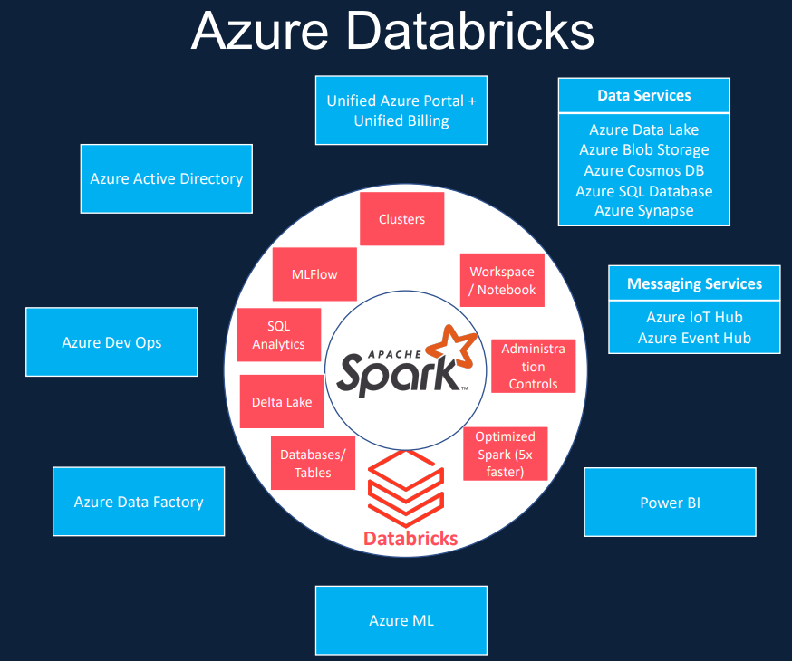

With the recent announcement from Google in February 2021, the Databricks cloud platform is now available on all three major cloud platforms such AWS, Microsoft Azure and Google Cloud. But Azures integration is deeper than others, Databricks is a first party service on Azure. What that means is on Azure you will be buying data directly from Microsoft and all support requests are handled by Microsoft. As a result, it provides a unified Azure portal for Databricks and the single unified bill for all your Azure services, including database. Azure Databricks leverages Azure security and seamlessly integrated as your Azure Active Directory and single Signon. It provides seamless integration and high speed connectors between various as your data services such Azure Data Lake, Block Storage Cosmos DB, SQL DB and Synapse. Messaging services such as Azure Event Hub and IOT Hub, Power BI and Azure ML. You can seamlessly run Databricks Notebooks from as your data factory and integrate with the rest of the data workflow in your data project. And finally, Databricks also connects with Azure Devops to enable continuous integration and continuous deployment. So just to summarize, Azure Databricks is a spark based unified data analytics platform as a service offering, that's optimized for the Microsoft Azure cloud.

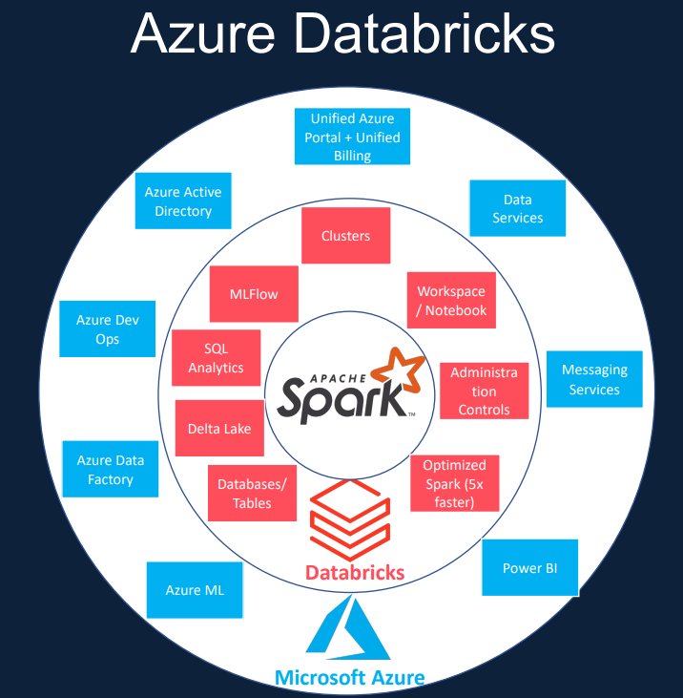

### Creating Azure Databricks Service

In this lesson, we are going to create a Databricks service in Azure, and I'll also give you an overview of the Databricks UI. Let's switch over to the Azure Portal and get started. Here we are in the Azure Portal, come over to the top left menu and then click create a resource. Now search for Azure Database and click create and now go through the visit to create the resource we need. So the first thing we want to do is pick the subscription, I'm going to go with my Pay as you Go subscription and then you need a resource group. So I'm going to create a new one.

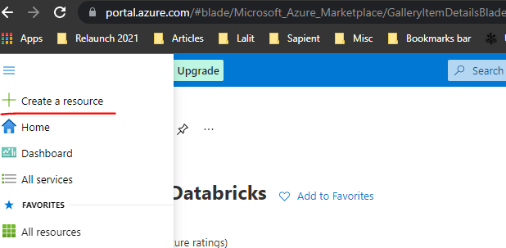 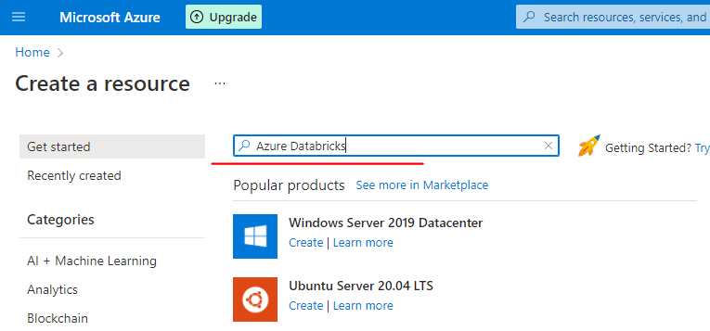

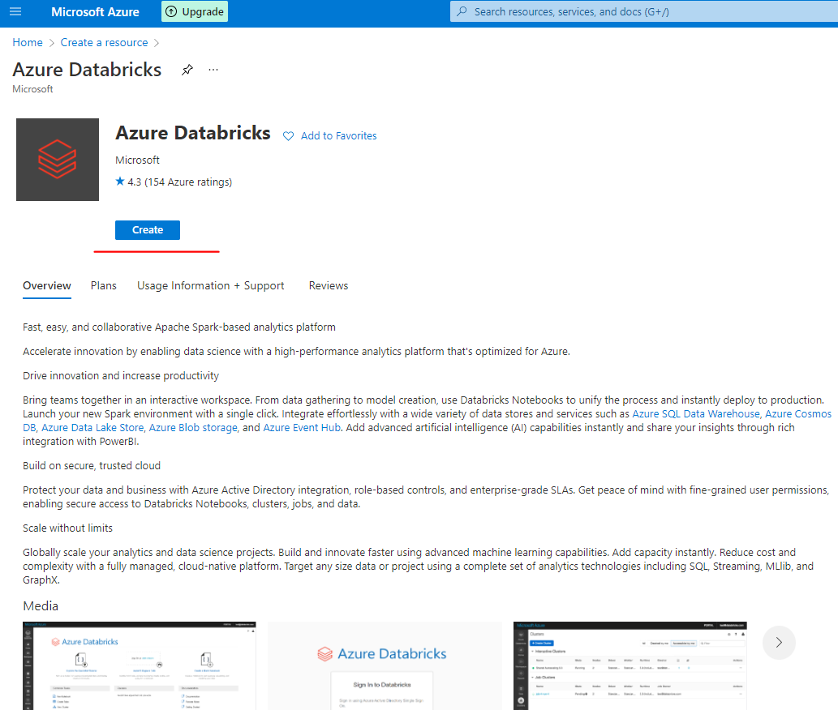

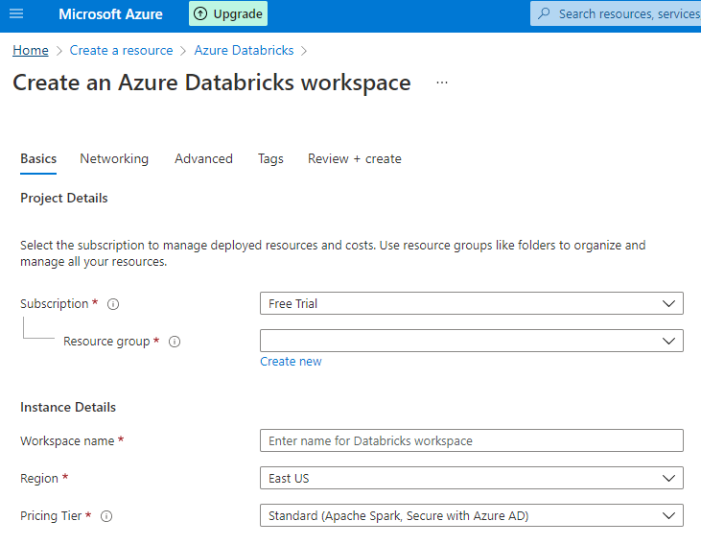 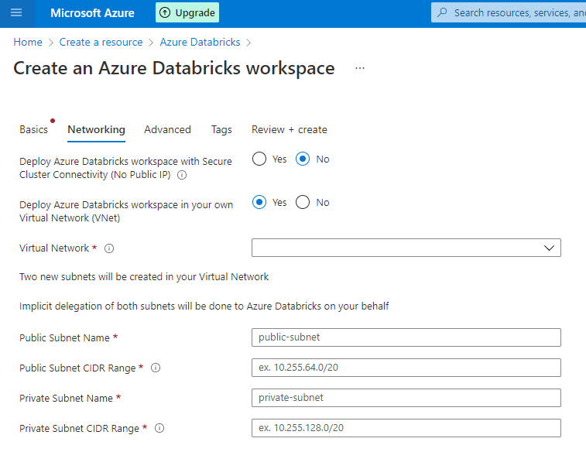

I'm going to call this one databrics-course-rg. And on the workspace name, I want to give it databricks-course-ws. And you want to pick a region closest to you. For me, it is the U.K. s I'm going to go with that. And for the pricing here, you've got a couple of options. You've got the standard premium and the trial, which is 14 day free DB use. I'm going to go with the standard pricing tier because we don't need access to role based access controls or anything like that for this cost. So let's go with Standard and click next to networking. You've got two options here. One, you can you can take off the public IP and also actually you can put the data service behind your virtual network if you got one. So if you click on it, then it'll give you the option to specify your virtual network. In our case, we're going to click now for both of them and keep it simple. Click next to Advanced.

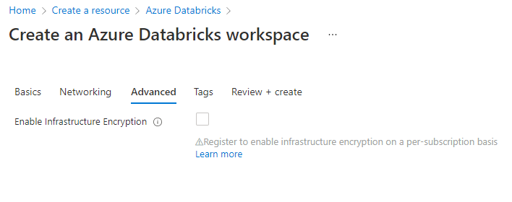 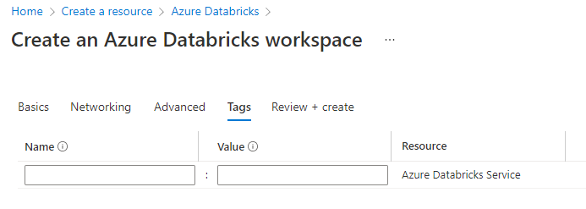

|  |  |
| --- | --- |
|  | So usually your storage accounts behind the databrics service are encrypted by default. But if you want another level of encryption, then you can click here to encrypt it. That gives you double encryption. You can learn more about that in here as well. And in this case, actually, we're going to keep it simple and click next to tax.  And if you want to specify a tag, you can do that. But we're going to just click review plus create and the validations now succeeded and click create to the resource. It'll take a couple of minutes to create the resource and we'll come back. OK, the data service is now being deployed |

So let's go to the resource, so let's go to resource and this will look very similar to any other services you create. But the main thing we want to focus here is the workspace. So in order to do that, you can click launch workspaces to get to the workspace.

But before we do that, let's spin this service into a dashboard so that we can keep everything together for this course and we can easily navigate. So let's click on the pin here and then we're going to create a new dashboard for this cost. So I'm going to call this one as data breaks calls dashboard. And click, create and spin, let's now launch the workspace..

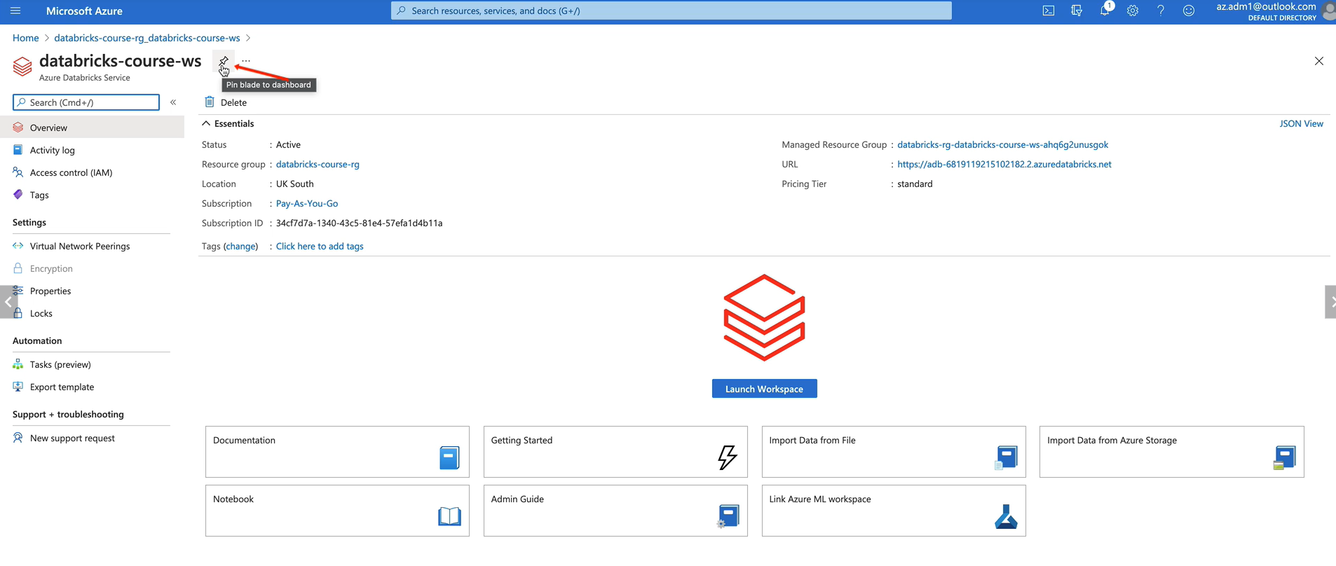

And that log's union via the Azure Active Directory, single sign on, and once you're in, you see the screen. This is your home screen within database

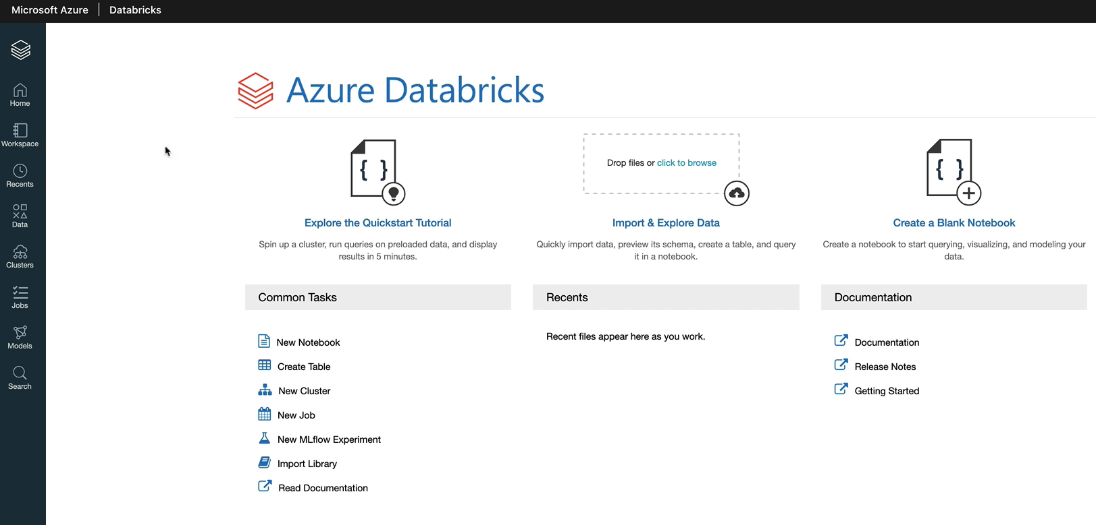

I had to create resource group first for this as below

|  |  |
| --- | --- |
|  |  |

|  |  |
| --- | --- |
|  |  |

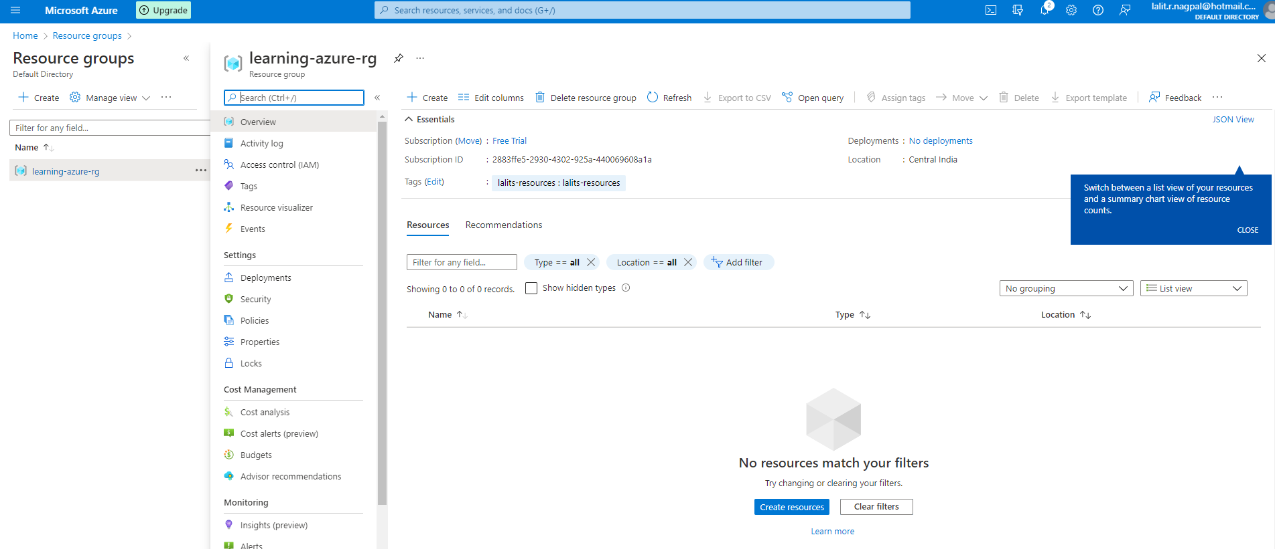

And then

|  |  |
| --- | --- |
|  |  |

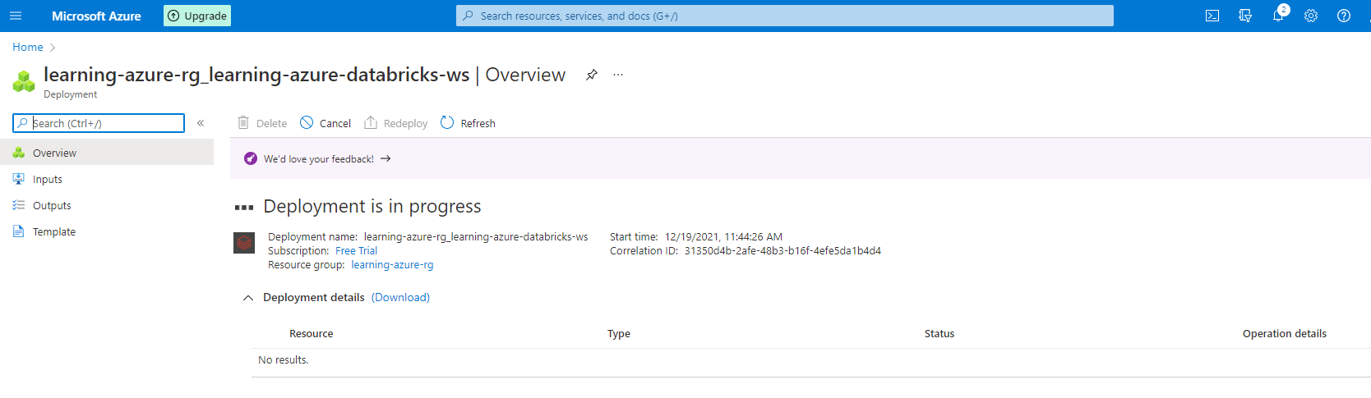

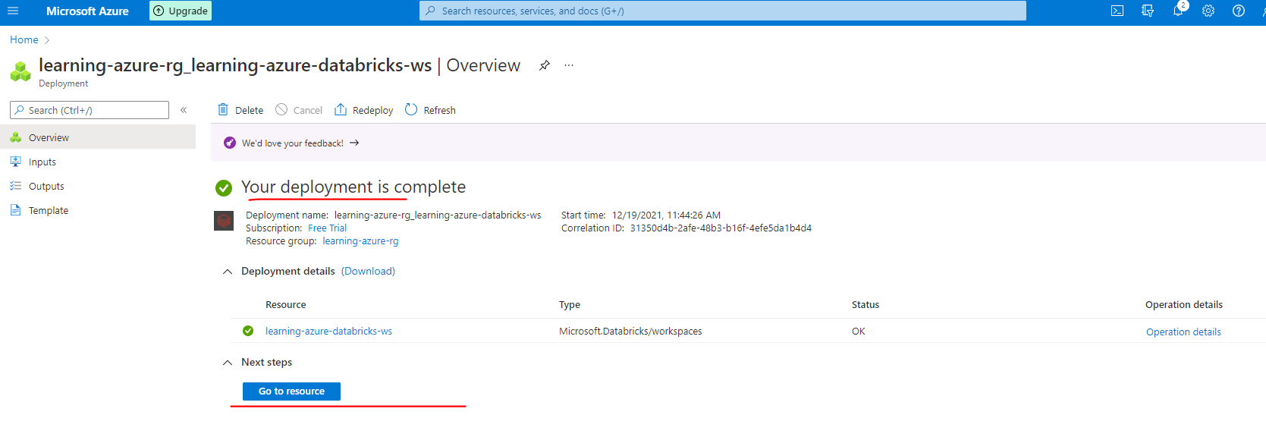

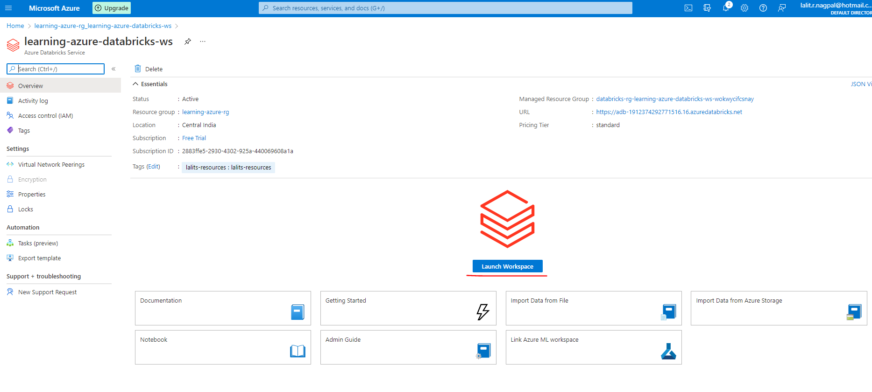

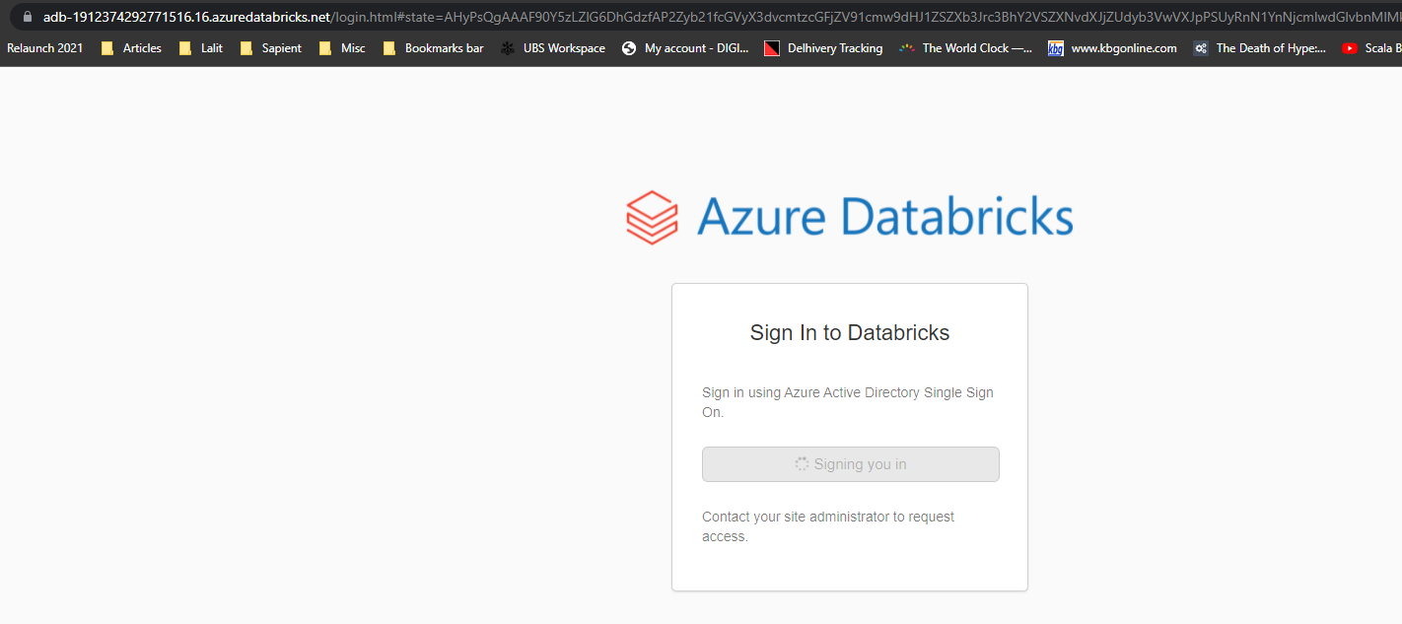

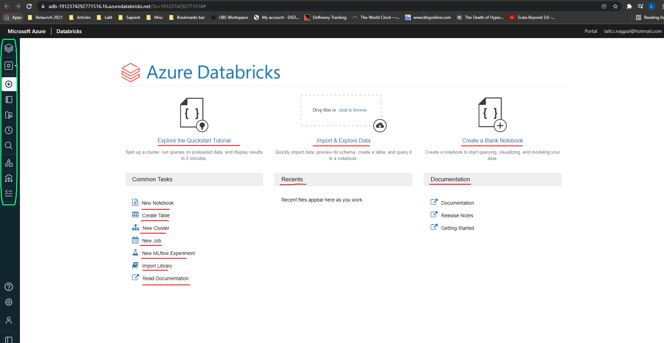

So this screen is split into three main areas. The first one is the center, which is your shortcut. So what you got here is if you wanted to create a quick notebook, you can click near new notebook and then you can create it. And if you wanted to import and explore some data, you can do that. You've got document links for documentation and release notes and things like that here. We won't be using much of this because we'll be using the main navigation menus here, which is on the left hand side. So from here you've got the option to navigate to your workspace. So each user is normally given a workspace. Workspace is basically a set of folders and files. So when you come in here, you've got the users and the shared shared is basically a workspace shared between all users in the database workspace and uses every user would have a folder for themselves. So when you come in here, you can create a notebook, you can create libraries, folders and things like that. Within that, you can clone another notebook, import, uh, notebooks and folders from elsewhere, and you can export what you got in here as well.

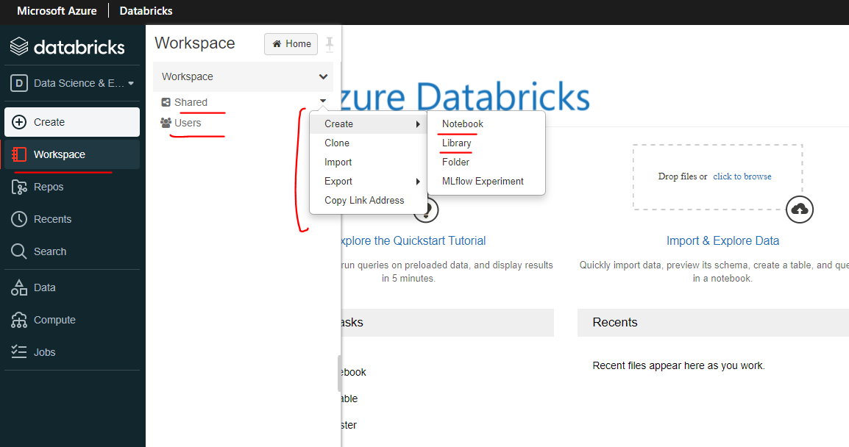 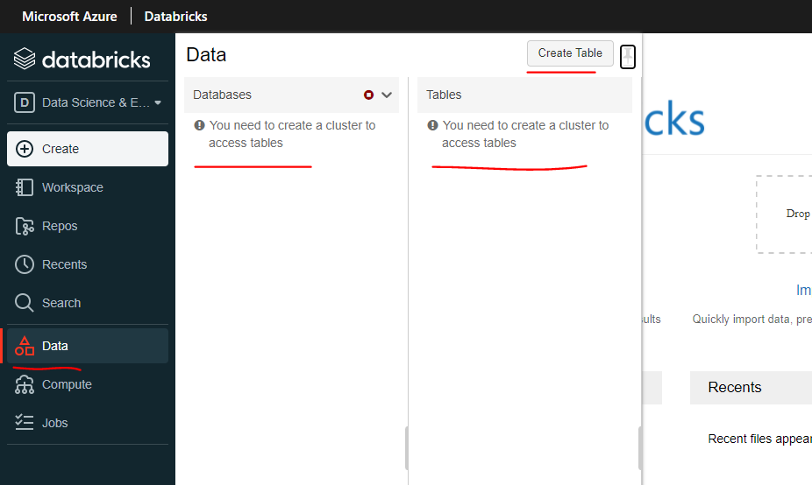

If you come out of this this specific for your workspace, so this will list you whatever you've recently visited, so if you open the notebook, that's going to left you here. So that's an easy, easy option to go back to when you worked on something that breaks, also gives you the ability to create tables and databases. So if you click on data that list you the databases and tables, we don't have anything at the moment.

|  |  |
| --- | --- |
| And also you need to have a cluster in order to access any databases and tables you've already got that takes you into clusters. So in order to do any kind of compute within database, you need to have a cluster. So to create a cluster, you would come here. You've got two different types of clusters. We'll go through those ones later. But generally, if you want to experiment something, you'll come in here and create an All-Purpose cluster and then you'll work on that. But if you have a job running, that will create a job cluster and then dalven the job on that cluster. |  |

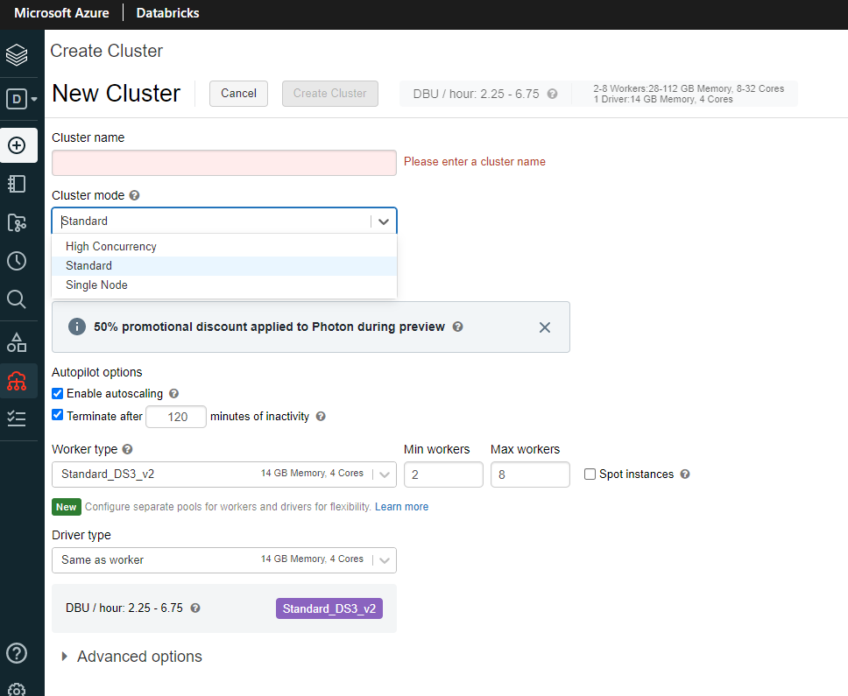 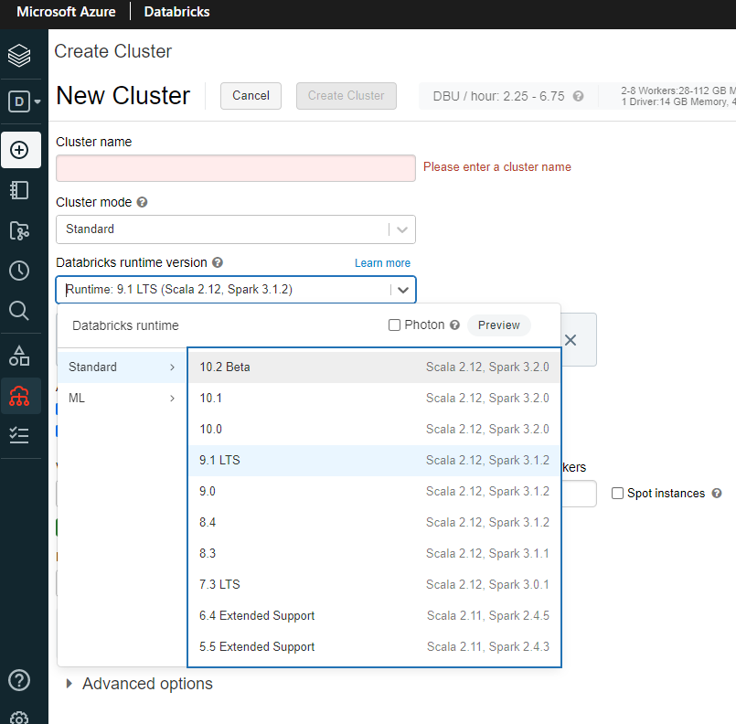

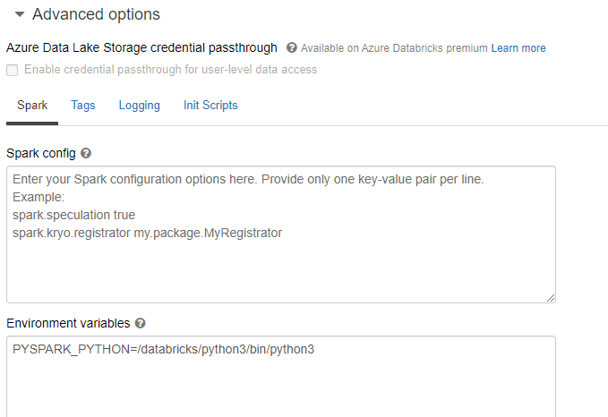 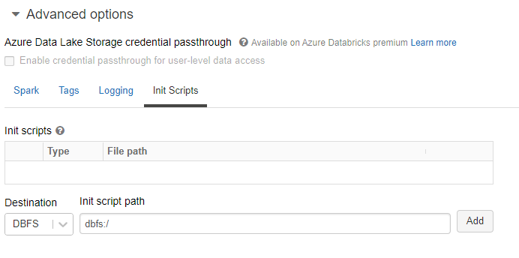

Repos

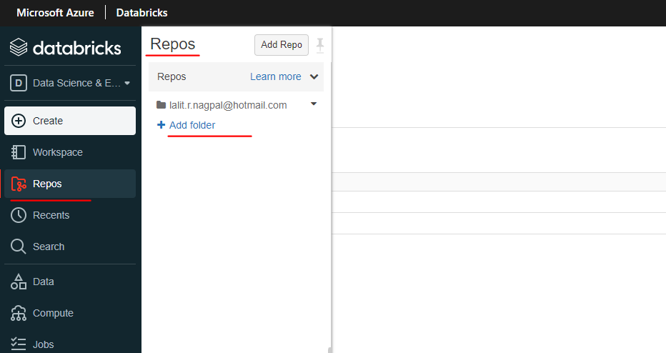

So that takes us to the jobs. So jobs are basically an option for you to be able to schedule your notebooks to run a regular interval. And also you can specify what kind of cluster you want to create for the job to run on. So you'll specify all of that in here. And once you've created the job, you can come and see whether that's run, what happened in the last run on all of those kinds of things in here models.

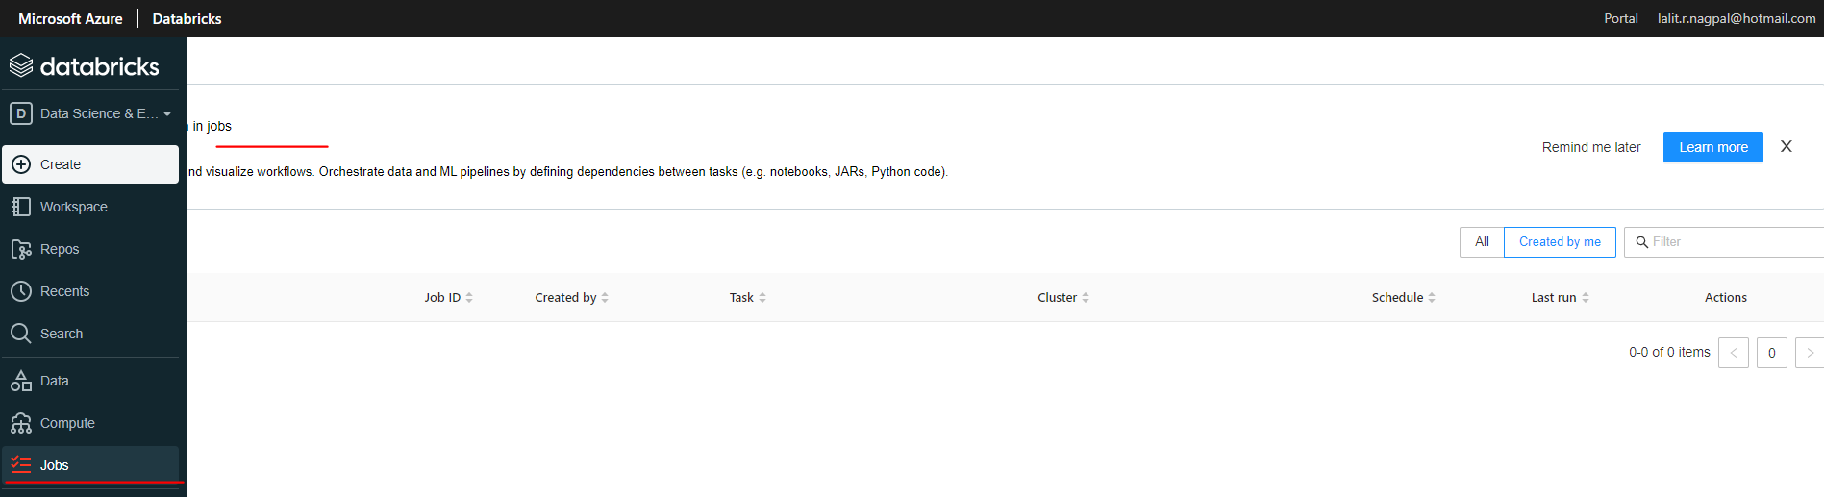

So if you have a model which is registered with ML flow, then you'll see them here and you'll see what stage it is in and whose last modified and all of that kind of information in models.

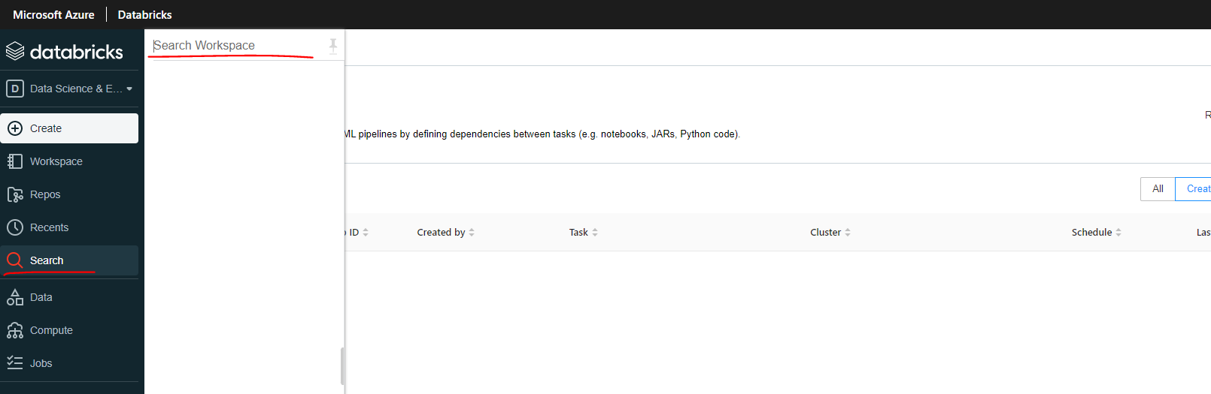

Search gives you a global search ability to search within the entire workspace so you can look for any any any words, for example, to search within the workspace. So the next thing is on the top, right, you've got some use settings and admin console

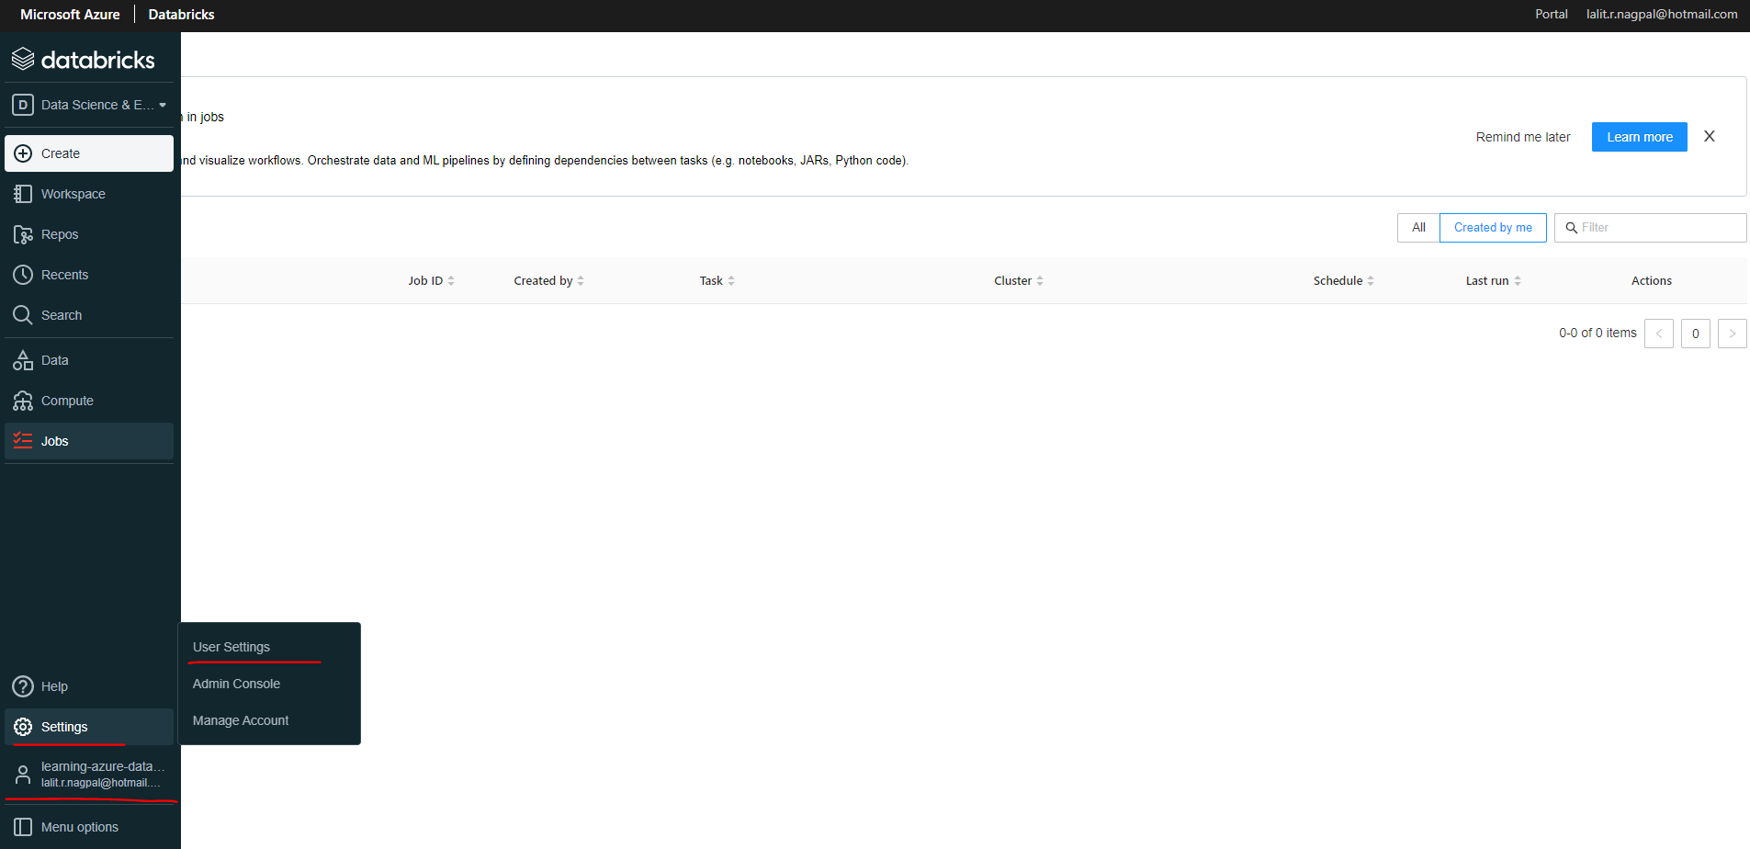

So you can come in here to create a new token, which you can use from another tool like Power BI to access your cluster's, which you've created using your credentials without using your credentials, you can generate a token that will be used to authenticate and access your Cluster's.

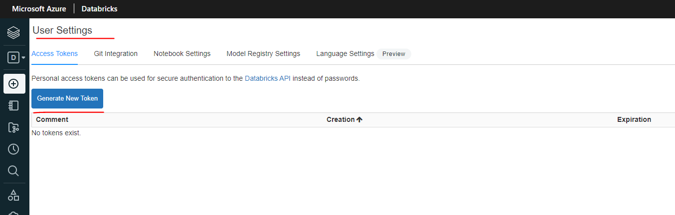

You can specify you get integration's and notebook's settings here and also you've got admin console, so at the moment, whoever creates the data breaks workspace initially becomes the admin.

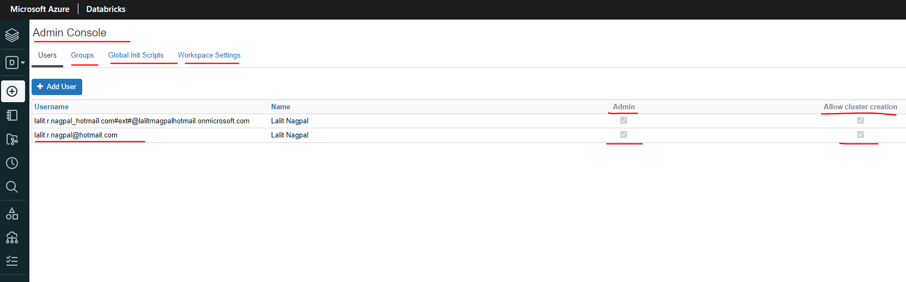

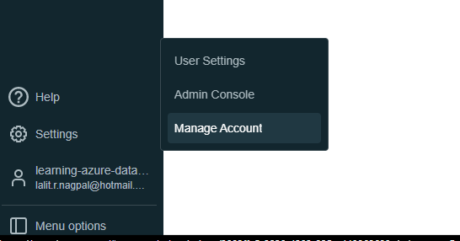

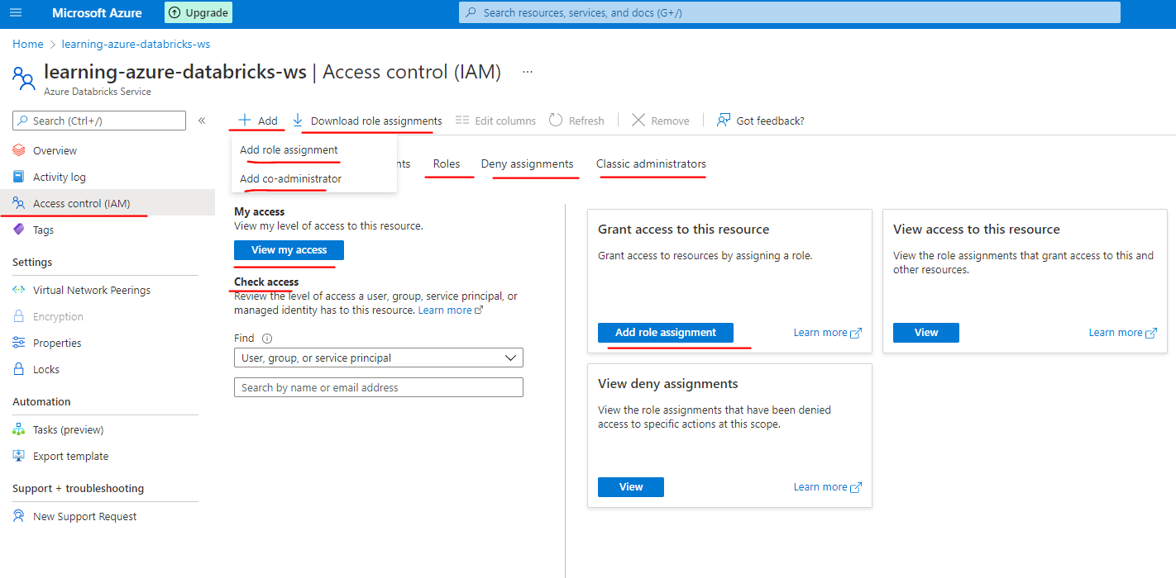

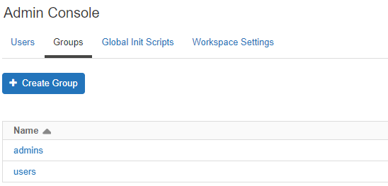 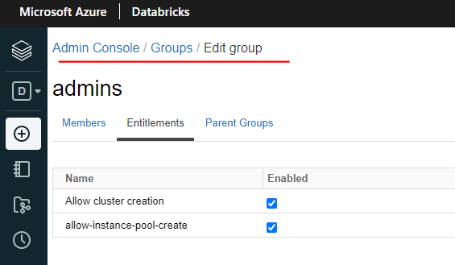

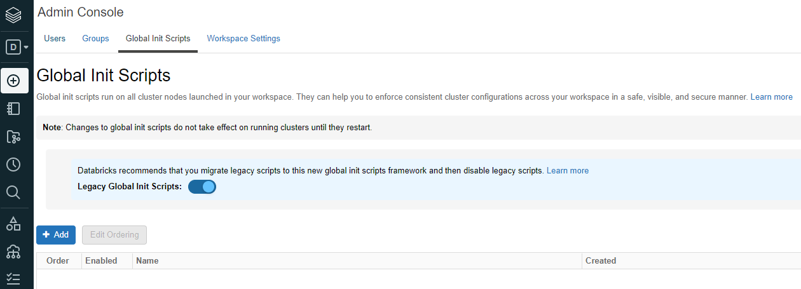

Workspace Settings.

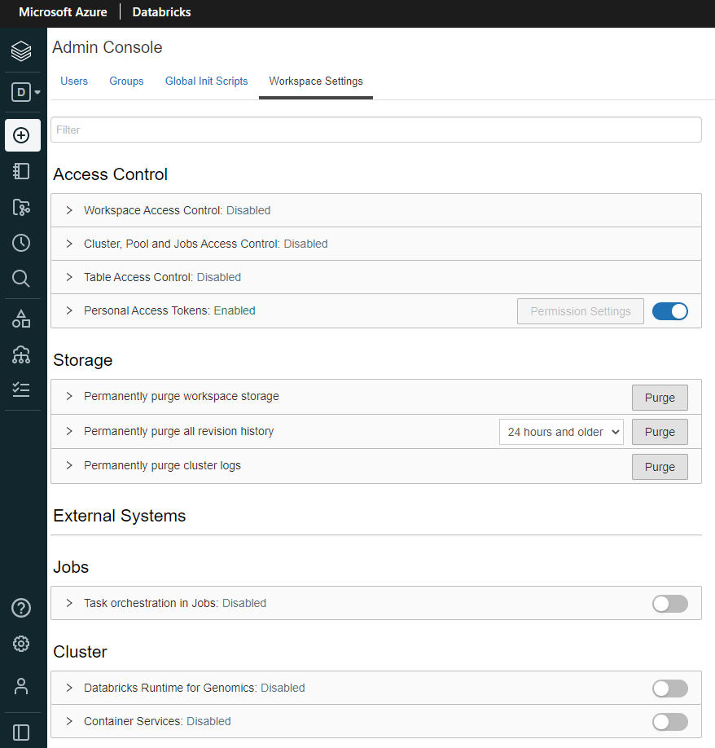 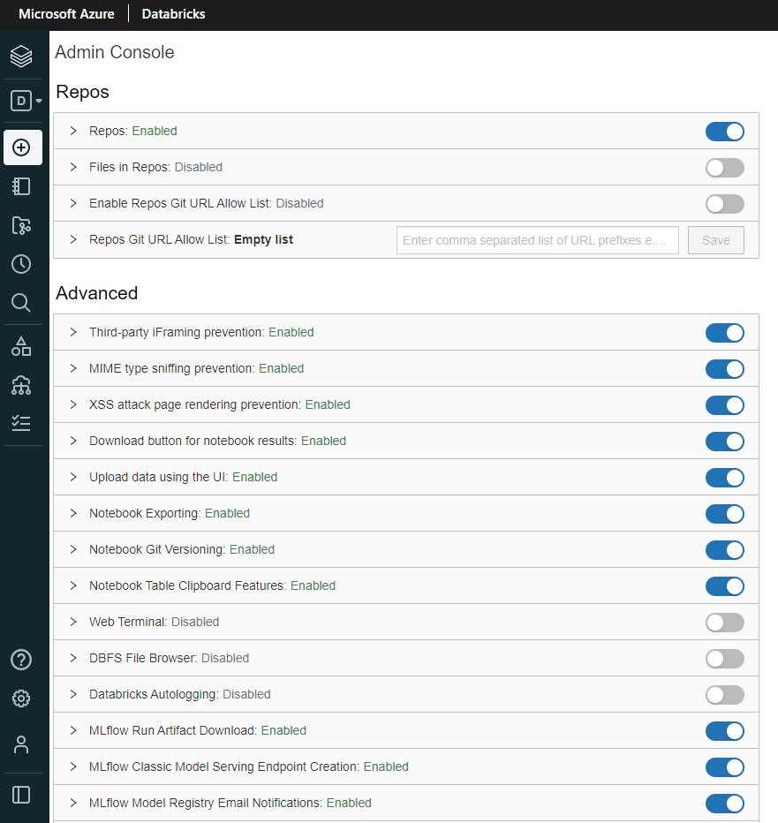

|  |  |
| --- | --- |
| But you can add other users and you can specify what kind of permissions you want them to have. You can create groups, you can specify various access controls for your workspace, your cluster pools, clusters and things like that and tables and all of those.  So that's what is in this dropdown here. And you can also log out from this workspace. But if you got multiple workspaces, you can navigate from here to.  So I hope that's given you an introduction to the database workspace here and in the forthcoming lessons will delve deeper into each one of those. |  |

The UI interface had everything related to data engineering, data science, as well as machine learning on one page. So this menu had things like models in it. But now data breaks have got two different options. So you can switch between data science and data engineering or machine learning view of the user interface. The default one is the data science and data engineering, and that's the one we want for this course. But the things like models which were previously in here have been moved into machine learning.

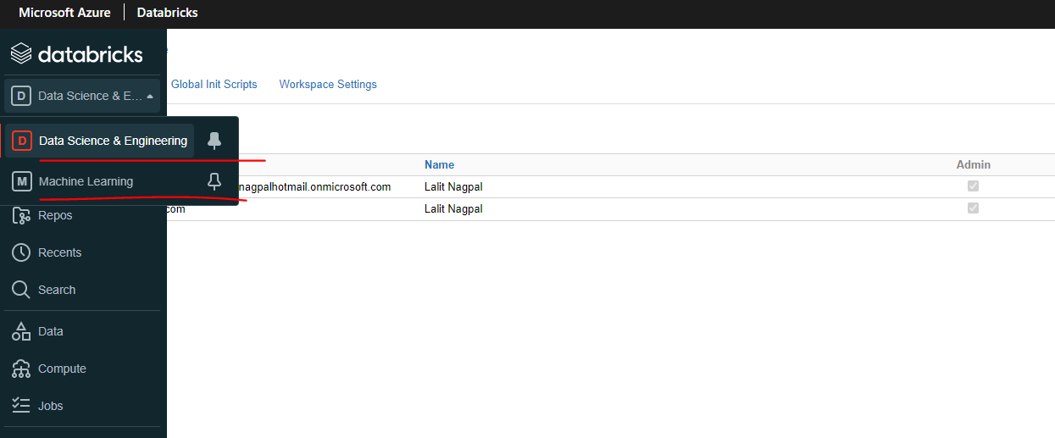

So let me click on that one. As you can see, not much is different between the two up to here, but you've got things like experiments, features, tools and models in the machine learning view of the user interface. But the data science and engineering doesn't have that. That's one difference. And the other one is a simple thing that is a shortcut to create things like notebooks, tables, clusters and jobs. But you can still create the notebooks, tables and clusters and jobs in the same way we previously did by going into, for example, workspace and then clicking here to create a notebook. I appreciate the changes are too small, but I still want to make sure that you understand the changes and I've given you a heads up on those.

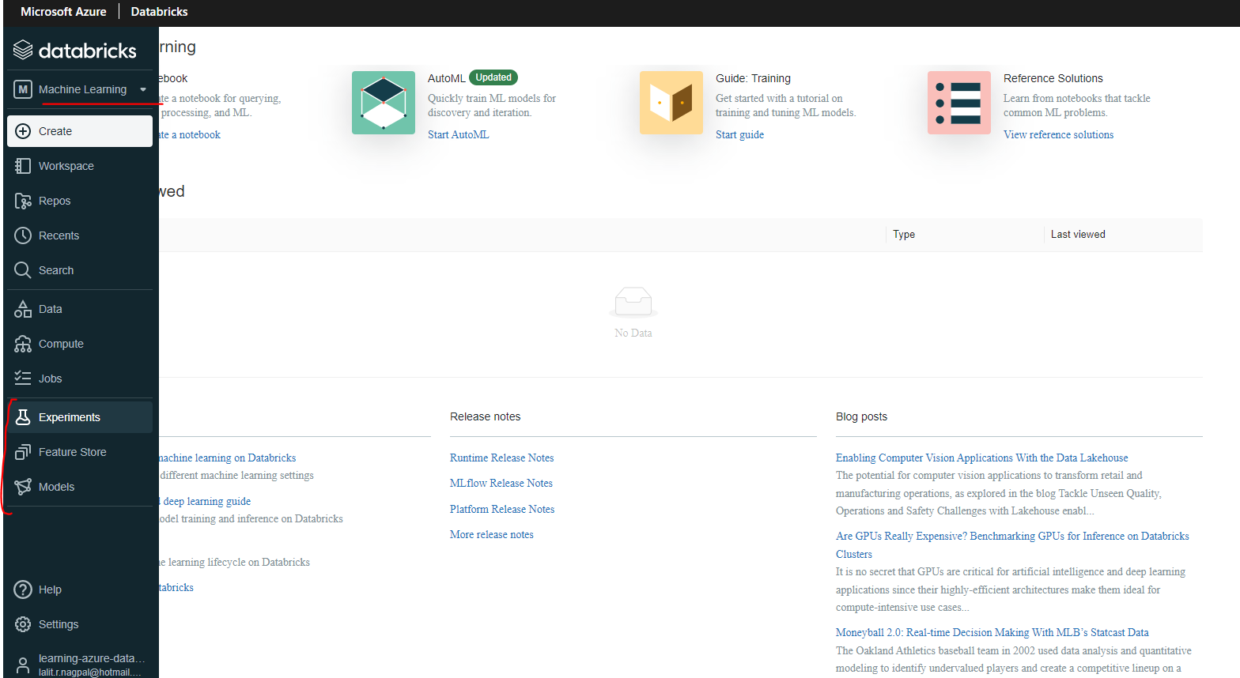

### Azure Databricks Architecture

Now that we've created our Databricks service, I want to talk you through the architecture. As you know, Databricks is a managed service on the cloud. As a developer, you may not need to understand how it works under the hood, but it is better to understand the Architecture so that you can reason out about where your data is stored and also where your computer is located. Data Bricks Architecture is basically split into two parts. One call the Control Plane and another one called the Data Plane. Control plane is located in data on subscription. This contains the Databricks UX and also the cluster manager. It's also home to the database file system DFS and also metadata about cluster's files mounted, etc.. Data Plane is located in the customer subscription. When you create a Data Bricks service in Azure, there are four resources created in your subscription a virtual network and network security group for the virtual network. Azure Blob Storage for the default storage and also a Databricks workspace. We've just created the Databricks service.

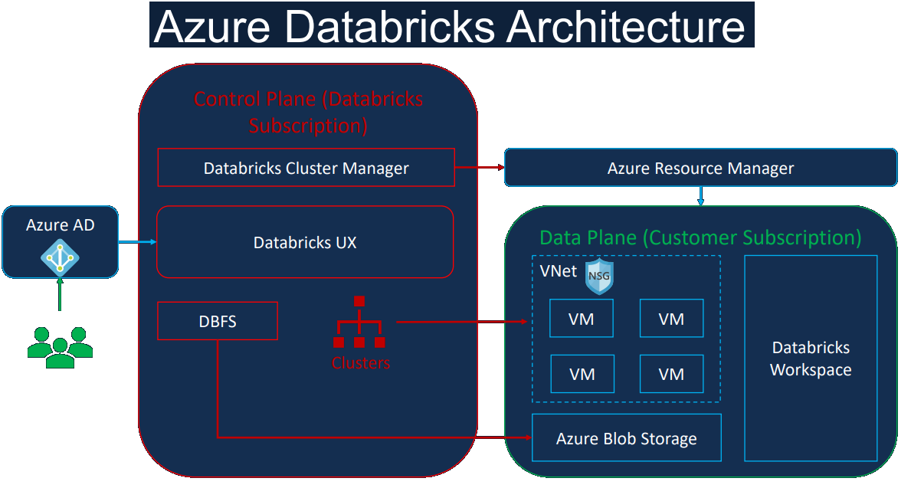

So let's switch over to the Azure portal and have a look at those. Here we are in the Azure portal. Let's go to all resources.

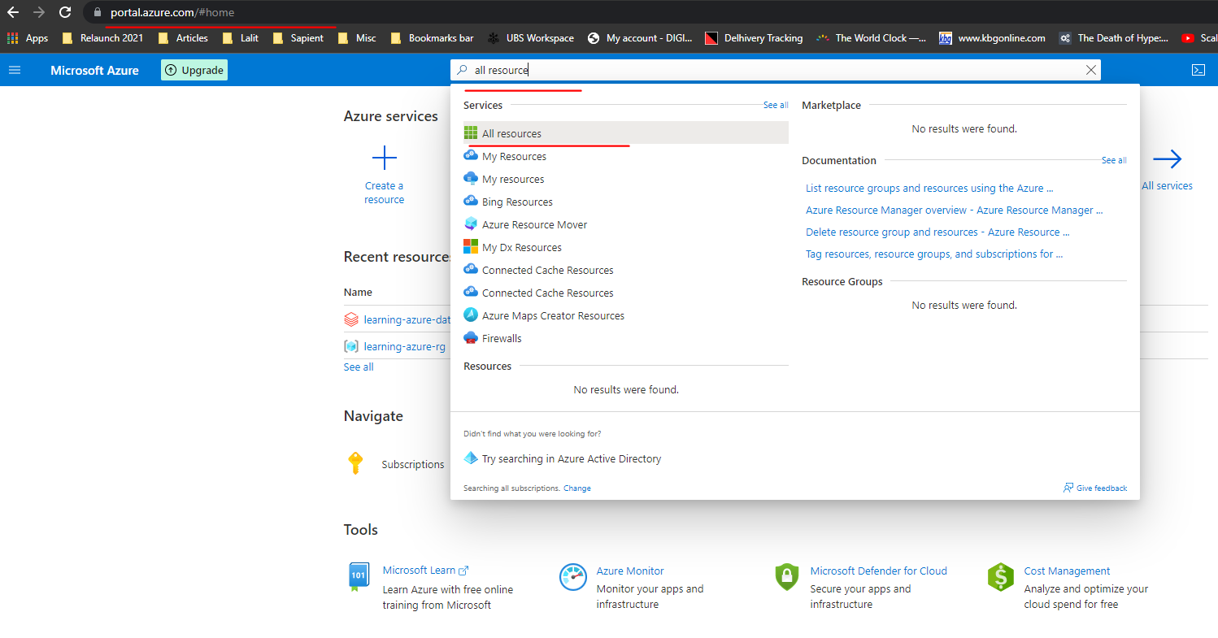

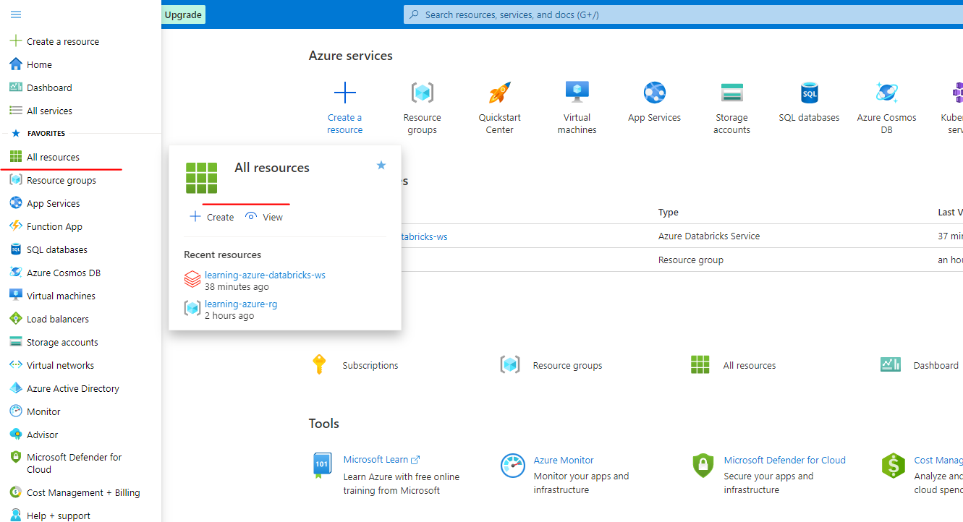

You can either go from here or you can go to the menu on the top left and then click on all resources. I've got plenty of resources from other projects here, so I'm going to just do a filter on resource group and I'm going to search for database scores because that's what we created.

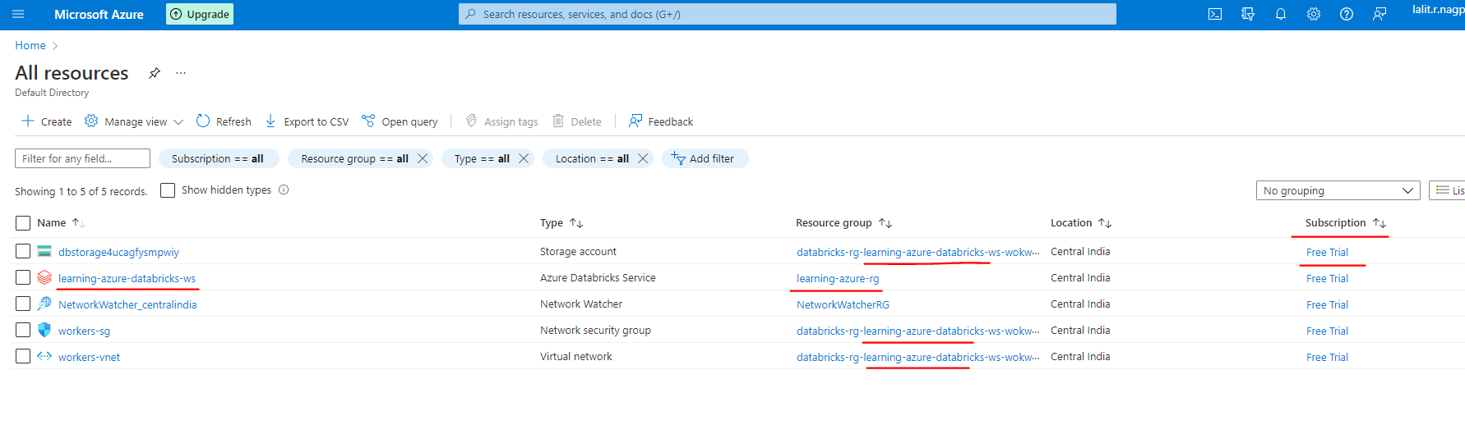

On fitlering

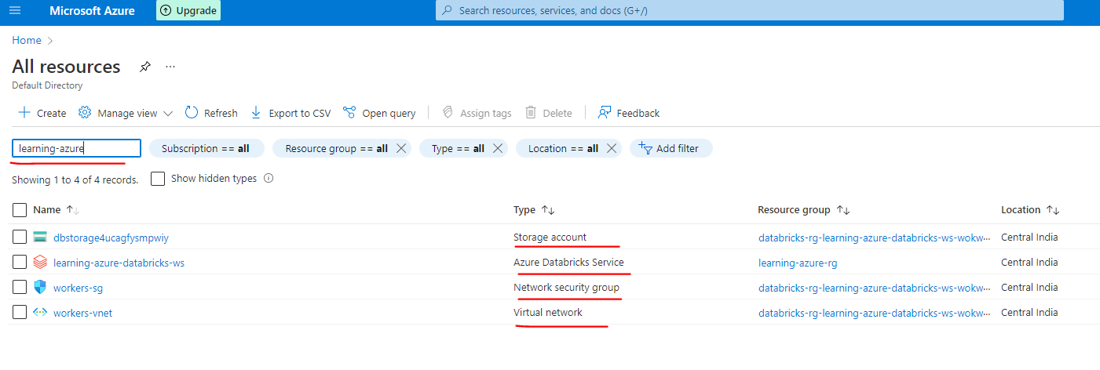

So as you can see here, we've got the full resources we talked about, the first one is your workspace that we created and then the other three are created by Databricks itself. They are still in our subscription. So that is in my free trial subscription ( could have been pay as you go subscription – had we opted for it ). But we didn't create these research group's database space, the research groups behind the scenes. And that will have the virtual network, as we talked about, and the network security group and also the default storage account for data breaks. So these are the four resources we saw in the presentation and these are created by Data Bricks. I hope that makes sense.

Let's go back to the presentation that the database uses, such as data engineers, data scientists and data analyst will use Active Directory single sign on to access the database service. When a user requests for it to be created, the data manager will create the required virtual machines in our subscription via the as the resource manager.



So none of the customer data leaves of subscription temporary outputs, such as running a display command or data for manage tables, are stored in the as block storage and the processing also happens within the Venette in our subscription the as your blood storage we have shown here is the default storage or otherwise called the DB route, and it's not recommended as a permanent data storage. For that, we can mount other storage accounts from our subscription, which will talk in detail in the coming lessons. You may not have understood all the concepts explained here and we'll be discussing these components in detail in the coming lessons. So I would recommend you to come back to this lesson one more time once you've gone through those. The key takeaway from this lesson is that our data always resides and processed in our subscription and we have full control over it.

### Project Solution Databricks Notebooks

I have made my project solutions available for you to import into your database workspace so you can refer back to it if you get stuck. In this lesson, this is the project solution database, note books lesson, I've got the dpc file, which is a databricks file format attached to the resource that is Formula One Project Solutions.dbc. So what you can do is download this into your laptop or the desktop and then we can import that. So I have already downloaded this resource file, so I'm going to show you how we can import it in Databricks.

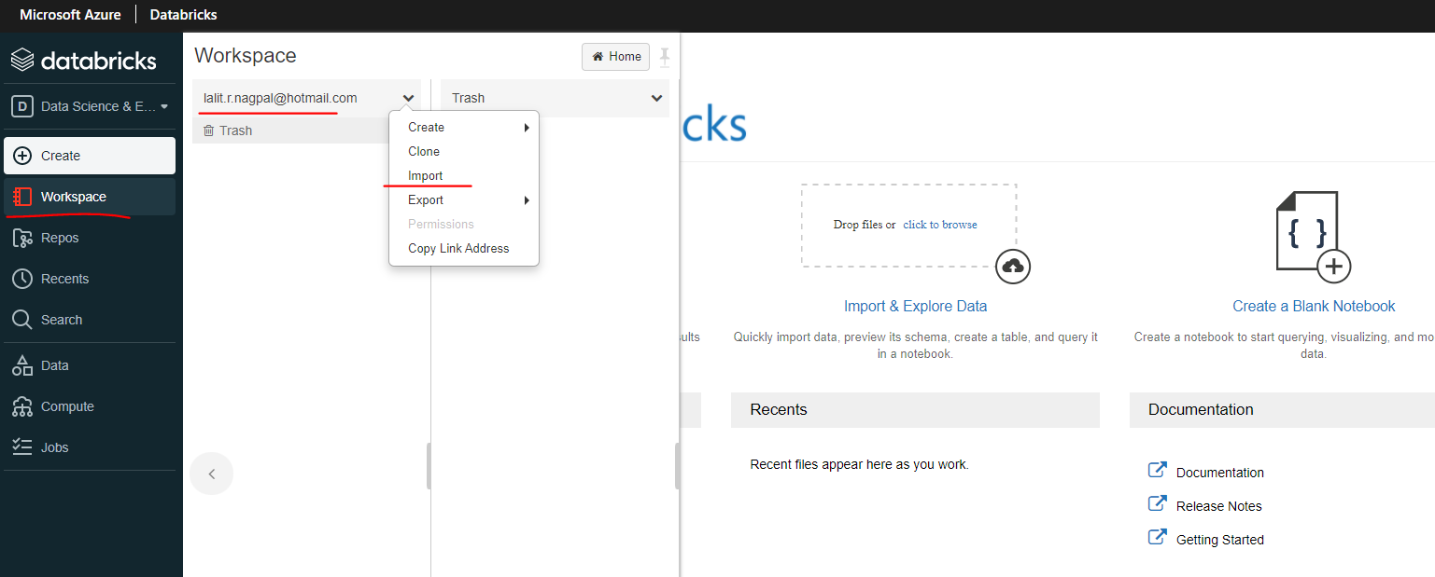

So I have already downloaded this resource file, so I'm going to show you how we can import it in database. So let me switch to my database workspace. So if you go to a workspace, you can pick any folder.

But I'm going to put straight into my workspace. If you click on the dropdown, you can click on import and you can pick a file. So as you can see, the accepted formats are DBC, .scala, .py and all of those once. But we've got a .dbc file. So .dbc is the Databricks file format which lets you not only export one not, but you can have an entire folder exported as well. So that's what I have done. I have downloaded the entire folder from from my workspace so you can use it. So I'm going to browse to my file and that's under here.

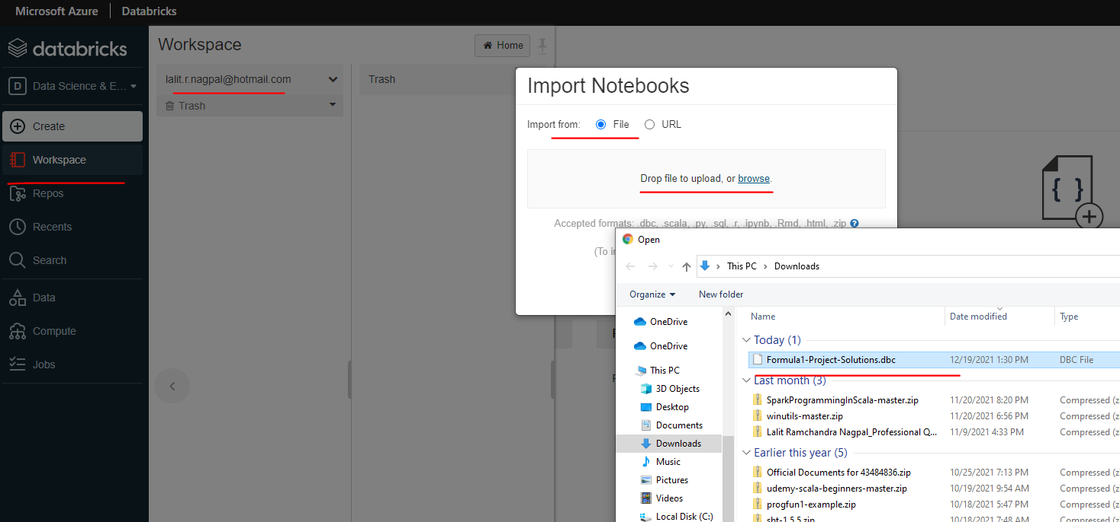

So this is the one I downloaded from the course material, which is Formula One, Project Solutions, DVC. So let's click open. If you click import, it should get imported now. And as you can see, that created a new folder called Formula One Project Solutions.

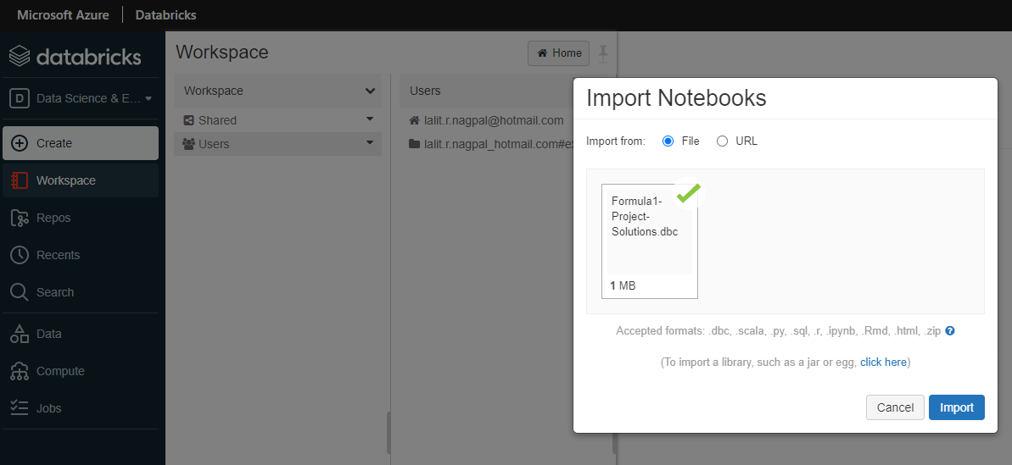

So what you see here is separate sections being titled as folders. And then you've got the end, of course, here. So at the end, of course, is the notebooks, which I had at the end of the course. So let me go into that. So that's my Formula One project folder.

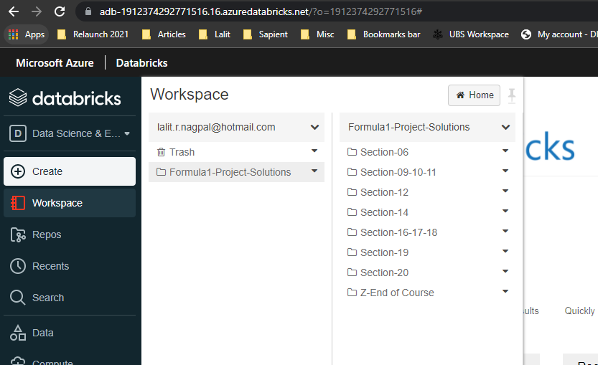

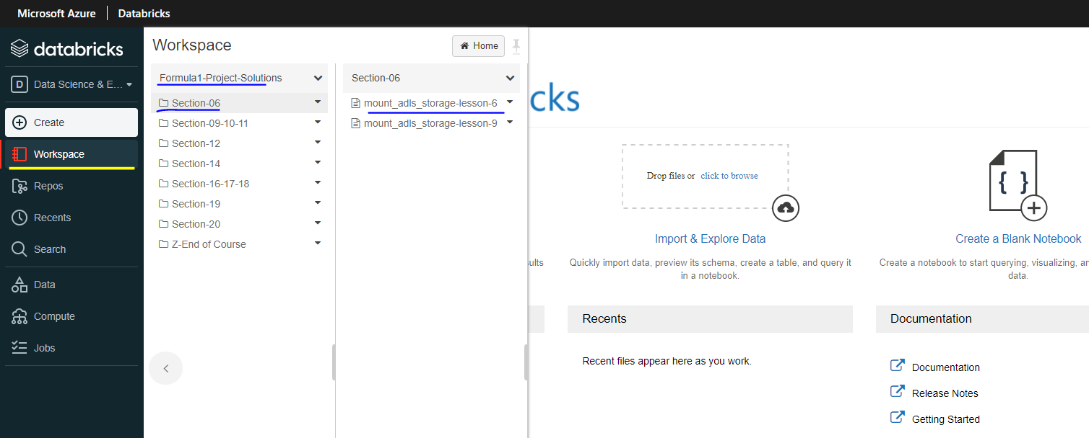

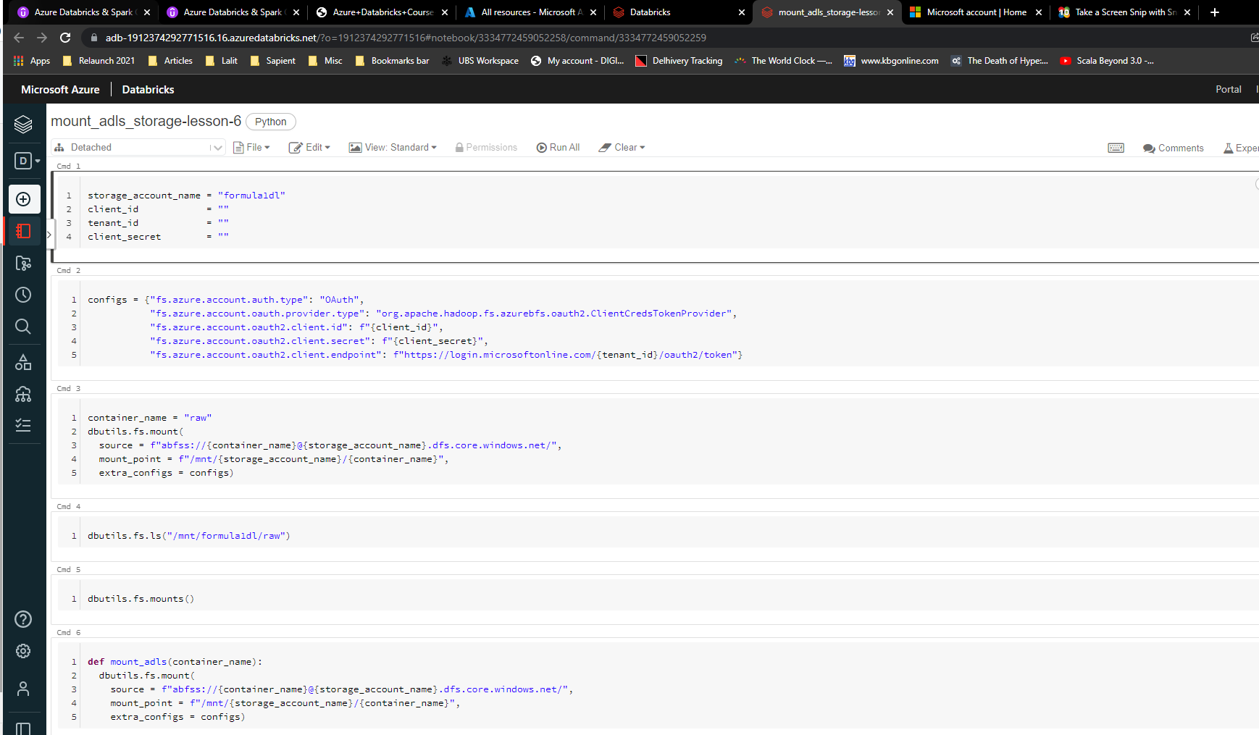

And under that, I've got these folders and here all the notebooks we created while doing the project.

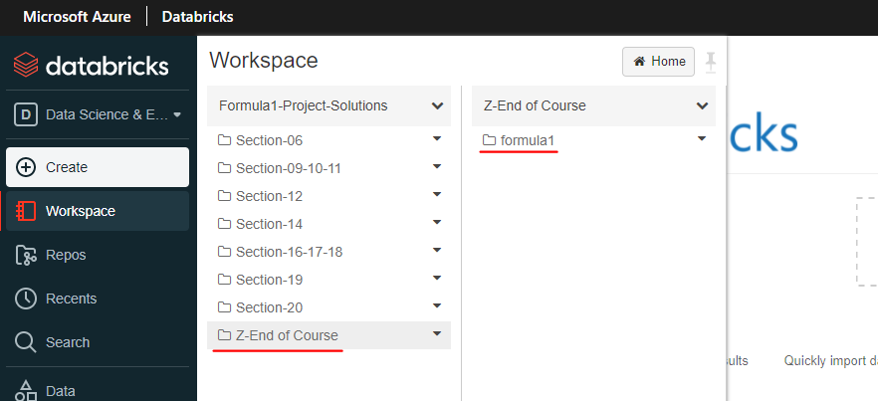

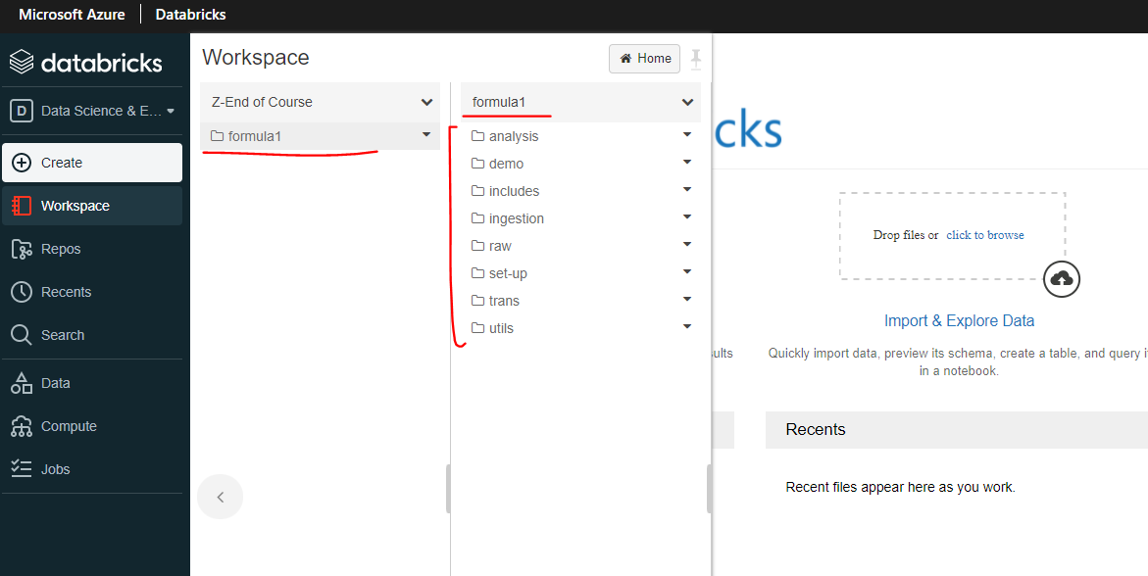

But what I thought is actually this might not be sufficient for you if you get stuck, because the way we develop a project is we develop the project in one set with one solution in mind, and then B, slowly improve the solution to make it better.

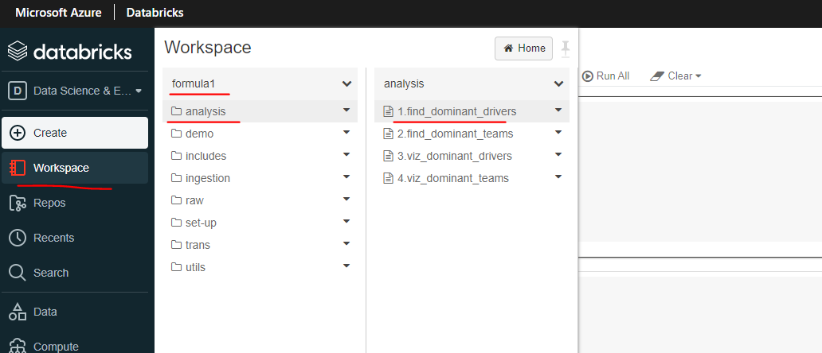

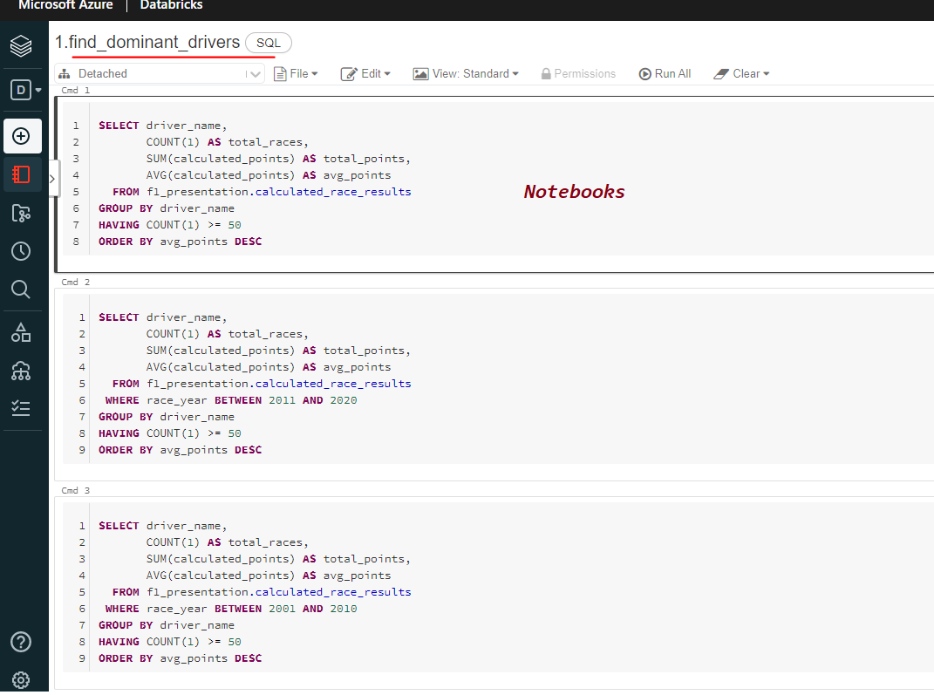

So I thought actually you might want to have the solutions and the notebooks from various stages. I haven't got the backup from every single stage, which will be impossible to do. But I have taken some of the backups for, for example, Section six, which is let me go here. So Section six is mounting data container data breaks and within the Section six, I've got two backups of notebooks and Section nine to 10, nine to 11.

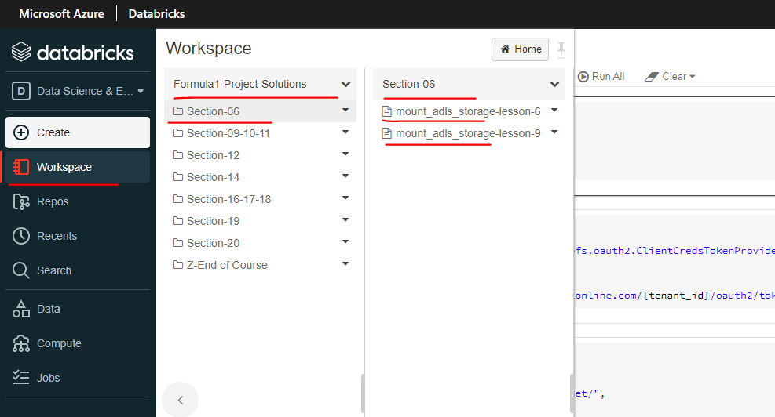

Sorry, I've got one backup, which is all around ingestion. So let's go to the course. And as you can see, we got data data ingestion running from nine to 11.

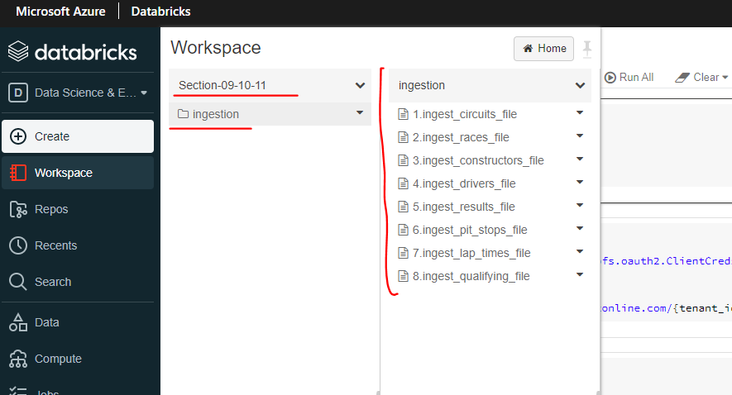

So in that one, I've got one backup for you, which is the ingestions, which will be at the end of Section eleven. That's what I have done. I hope this will be useful for you, but my recommendation would be you develop the solution yourself one layer. When you get stuck or only if you run out of time, come and pick the notebooks from here if you want to.

## Databricks Clusters

### Overview

|  |  |
| --- | --- |
|  | We will start by defining what a database cluster is, and then we'll look at the two types of clusters available in database will then go through various configuration options available for defining a cluster. And how to choose the correct configuration for your workload will then create a cluster that suits the needs of our project for this course. And finally, I'll take you through how we can use cluster pools to reduce cluster creation time and manage VM allocation will also create a cluster pool and see this in action. So by the end of this session, I hope you'll have a good understanding about what database clusters are and how to configure them for your project requirements. |

|  |  |
| --- | --- |
|  | Basically, a cluster is a collection of virtual machines in a cluster. There is usually a driver node which orchestrate the tasks performed by one or more worker nodes. Clusters allows us to treat these group of computers as a single computer via the driver node database clusters allows us to run different types of workloads, such as ETL for data engineering, data science and machine learning workloads. |

Database offers two types of clusters, the first one is the All-Purpose Cluster, which is created manually via the graphical user interface, CLI or the API, whereas the job clusters are created when a job starts to execute and the job has been configured to use a job cluster rather than an all purpose cluster. All purpose clusters are persistent, they can be terminated and restarted at any time. On the other hand, job clusters are terminated at the end of the job. They cannot be restarted, so they are no longer usable. Once the job has completed, all purpose clusters are suitable for ETL workloads and ad hoc analysis workloads. Job clusters are suitable for automated workloads, such as running an eternal pipeline or ML workflow at regular intervals. All purpose clusters can be shared among many users, and they are good for collaborative analysis. On the other hand, job clusters are isolated just for the job being executed. All purpose clusters are expensive to run compared to the job clusters. In summary, all purpose clusters are great for interactive analysis and ad hoc work, whereas job clusters are great for repeated production workloads.

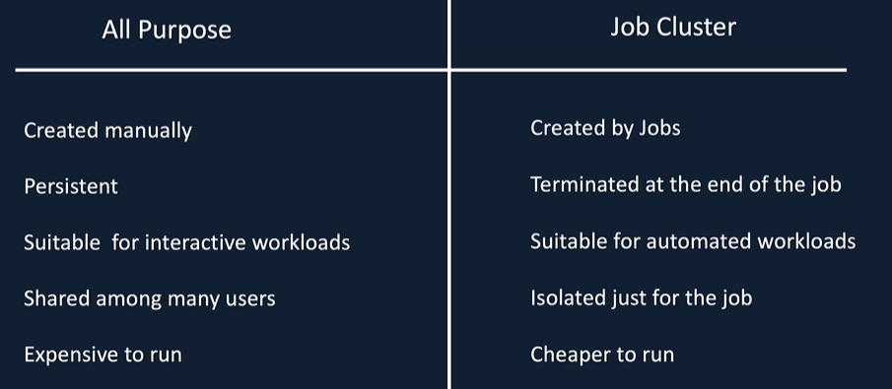

Now that we understand the different types of clusters, let's switch over to the database workspace and I'll show you then how to create these clusters. Here we are in our database workspace. In order to create a cluster, you will have to click on the cluster icon here on the left hand side manner, and then that will give you the option to create the clusters.

|  |  |
| --- | --- |
|  |  |
|  | So as you can see here, we got the all purpose clusters tab and then a job clusters and then a pools tab. So we talked about the all purpose clusters and the job clusters, but cluster pools give you the ability to keep some resource available so that when you create your cluster, it can be created quickly. Normally when you create a cluster. It takes about five to six minutes to spin up a cluster. So in order to speed up that time, you can have a pool of resources waiting for you. So that's where cluster pools come in. We will have a look at this in detail in the forthcoming lesson. If I go back to all purpose clusters, you've got the option to create a cluster here. But if I click on Job Cluster, you can't create a job cluster here. |

So the job clusters are created when you when the job starts to run. So you define the type of the cluster you want when you create your jobs. So let me go to jobs. Here you create the job by click on the job button. And as you can see here, we can specify the cluster. So if I click edit in here, you can specify all the options you want to specify for the cluster.

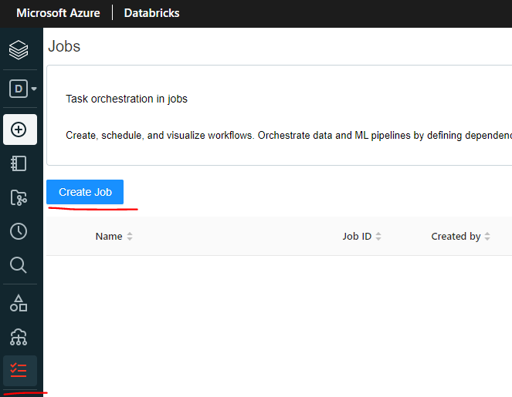

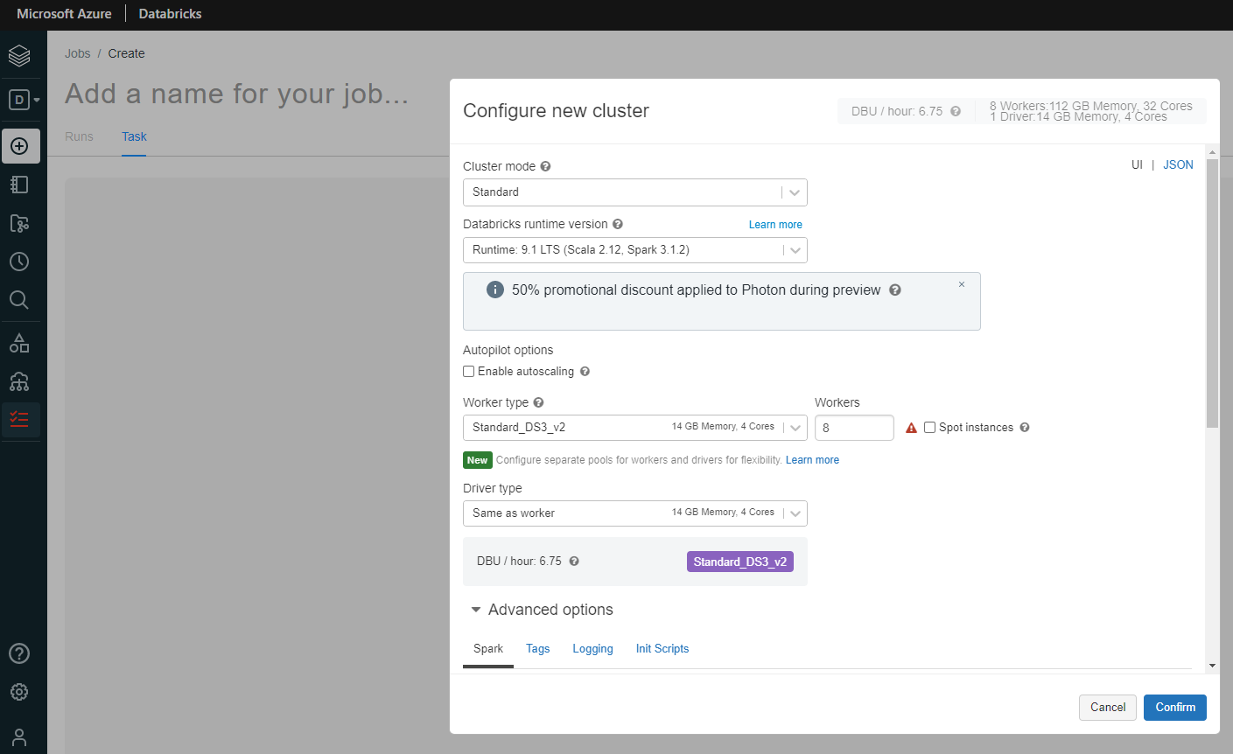

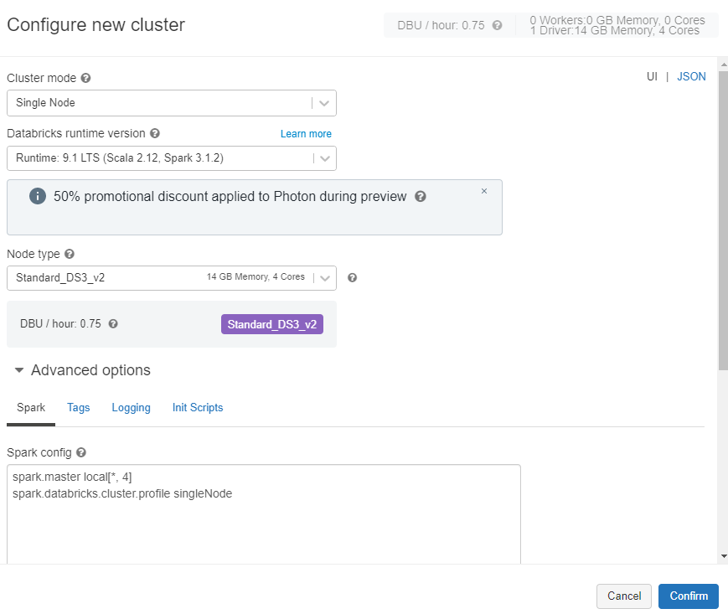

So things like your runtime, you want to have in your cluster the type of the driver and the worker nodes and things like that. Similarly, if I go back to their clusters and then click on All-Purpose Cluster and click Create Cluster, you've got the cluster configurations here, so that will be the class name your cluster mode.

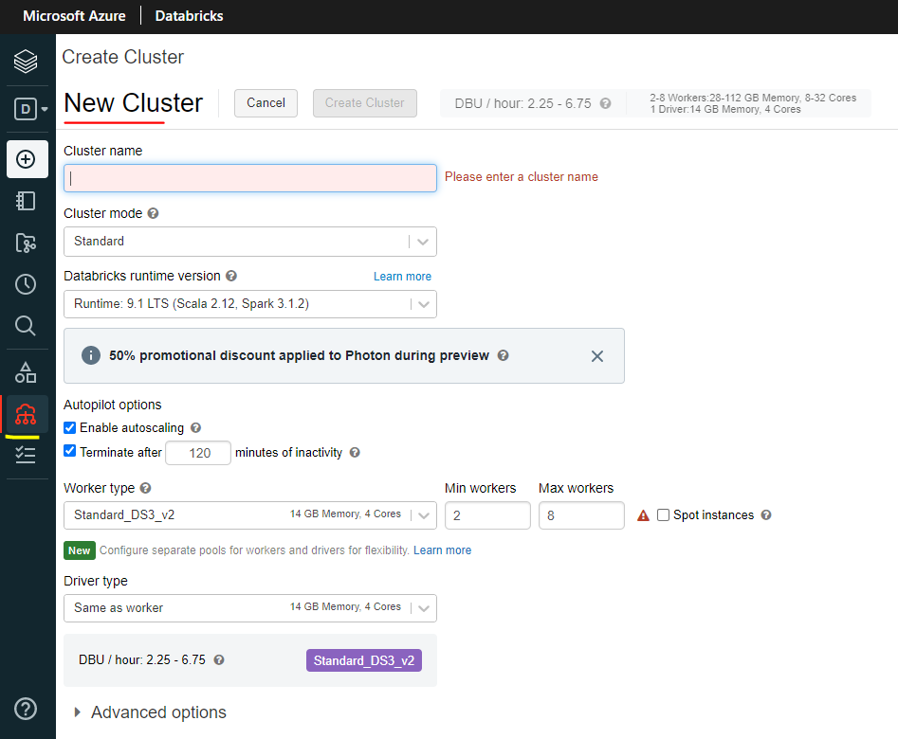

So there are a couple of options here.

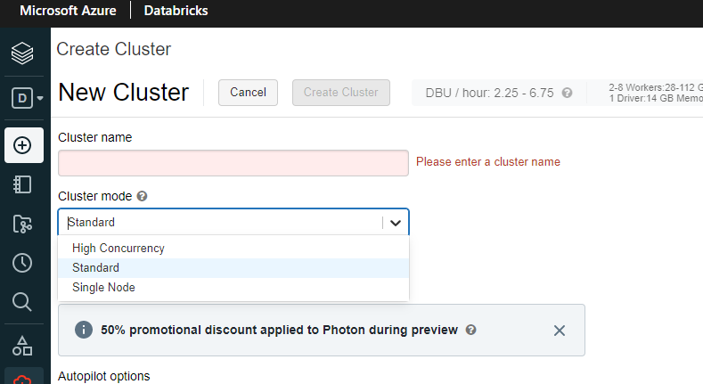

And also you can specify the cluster pool if you had one and you can specify the runtime versions that there are multiple runtime versions. You can go back to five point five.

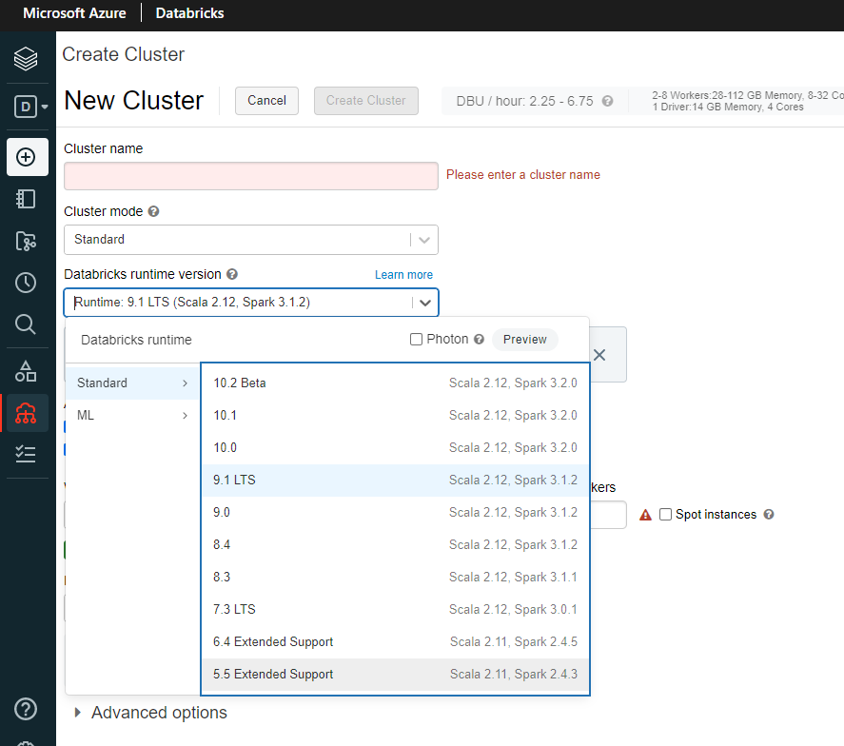

The latest version is eight point one and you can specify autopilot options and work nodes and the driver node types as well. So you've got multiple options here.

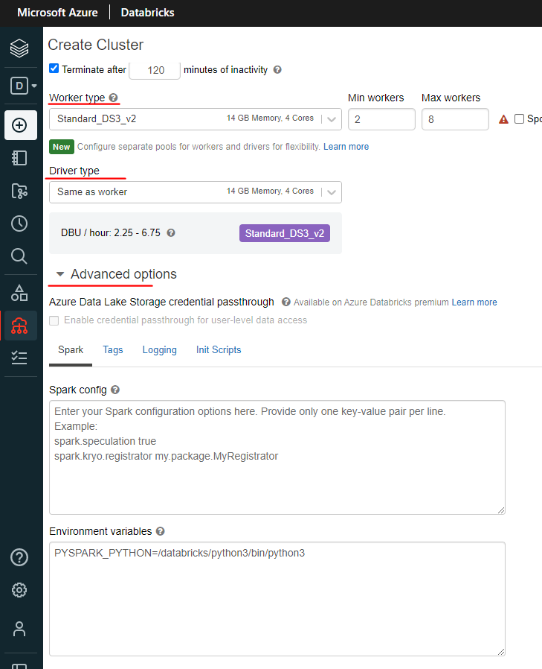

### Azure Databricks Cluster Configuration

Once we've decided on the cluster type, we need to look at the configuration of the cluster. First, we need to decide the cluster mode. Databricks of three different modes, namely standard high concurrency and single note clusters. They have different things to offer, and each one serves a very different purpose. Standard and single node clusters are meant for single users and a high concurrency cluster can be used by multiple users. Let's see why that is the case. Standard and single node clusters don't offer any processed isolation, so failure in one user's process may affect the other users. Also, they don't offer any task pre-emption. So one running process may use all the resources and others will fail. Whereas the high concurrency cluster offers both process isolation and task pre-emption to enforce fair sharing of resources. Both single node and standard cluster support all domain specific languages such as Scala, Python and R. Concurrency clusters don't support Scala in terms of use cases. Standard clusters are good for prediction workloads and adhoc development work. High concurrency clusters are good for interactive analysis, which is usually done by more than one analyst and also for ad hoc development.

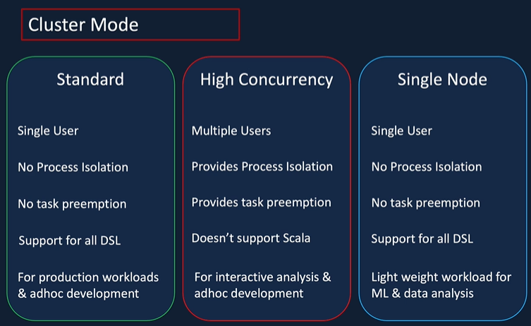

The administration overhead is low as we don't have to create separate clusters for each of the uses. Single node clusters are good for lightweight ML and data analysis workloads, which don't require any distributed processing data, breakfront run times or the set of core libraries that run on database clusters.

Databricks offers four types of runtime data breaks runtime data breaks, a runtime email database at runtime genomic and data breaks runtime light. Let's go through each one of these data breaks. Runtime includes an optimized version of Apache Spark Library, Java, Scala, Python and our libraries, Ubuntu and its accompanying system libraries, GPU libraries with GPU enabled clusters, Delta and next generation storage layer built on top of Apache Spark that provides ACID Transactions, optimized layouts and indexes and the database services that integrate with other components of the platform, such as notebooks, jobs and cluster manager.

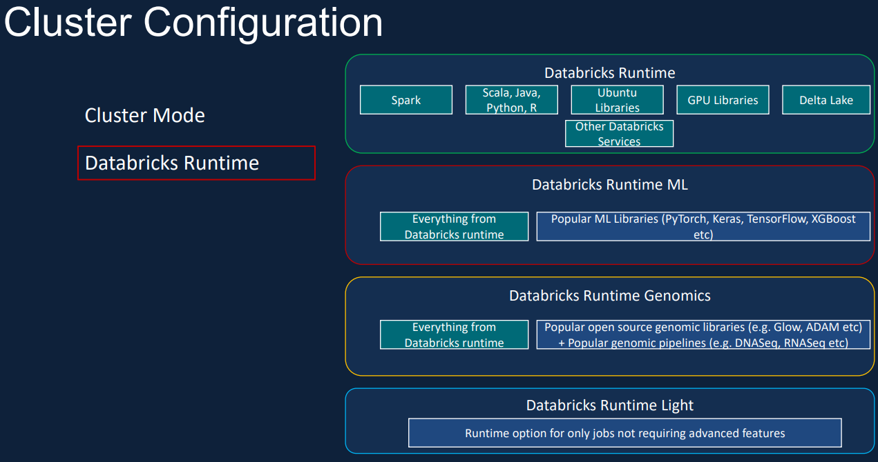

Data Bricks runtime ML includes all the libraries from the database runtime, plus the popular ML library, such as PyTorch, Keras, TensorFlow, XGBoost etc. Databricks runtime genomics includes all the libraries from the database runtime, plus the popular genomics library such as Glow and Adam, as well as popular genomics pipelines. Databricks runtime lite is a runtime option for only jobs not requiring advanced features such as auto scaling, reliability, improved performance, etc.? Also, it's only suitable for automated workloads. You can't use it for interactive workloads or Notebook jobs. Auto termination is a nice feature that will avoid unnecessary costs on idle clusters. It's especially useful on ad hoc clusters for preventing them from running during evenings and weekends when they're not in use. You can specify when to terminate your Databricks cluster if the cluster has not been in used, it will be terminated after the number of minutes specified default value for single note and standard clusters is 120 minutes but you can change the value. High concurrency clusters don't have a default value, but you can specify one. The accepted values range from 10 to 10000 minutes.



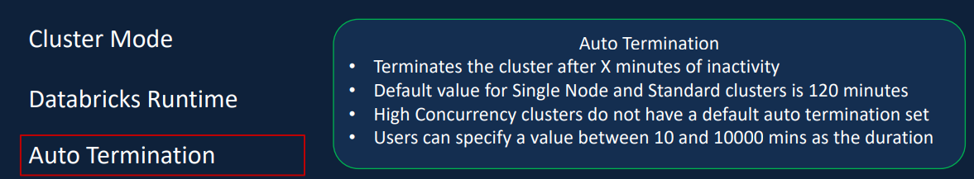

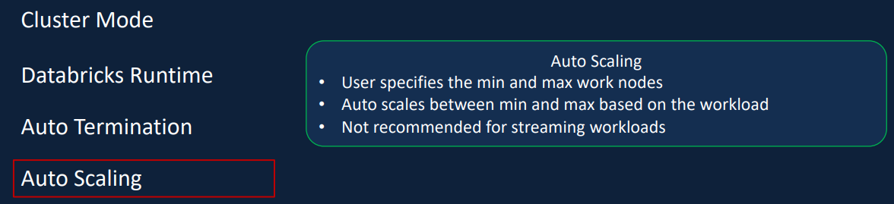

When you create a cluster, you can specify the minimum and the maximum number of worker nodes or the scaling will automatically add or remove nodes from the cluster depending on the workload. This can result in optimum utilization of the cluster. This is especially useful if you're unsure about the workload up front or your workload changes throughout the process. They're not recommended for streaming workloads, even if you specify them DataBricks defaults to the maximum number of workloads. As you know, there are a wide array of Azure VM types available for us to use. Databricks groups them into a small number of easy to understand groups. The memory optimized instance types are recommended for memory intensive applications, for example, and M workload that catches a lot of data in its memory. Computer optimized instant types are helpful for structured streaming applications where you need to make sure that the processing is about the input rate at peak times of the day. This can also be used for distributed analytics and data science applications. The storage optimized instant types are recommended for use cases requiring high disk throughput and IO. The general purpose types are recommended for enterprise grade applications and analytics within memory caching. And finally, the GPU accelerated Intense types are recommended for deep learning models that are data and compute intensive. This is given you an understanding about the configurations you can specify for a cluster to be created.

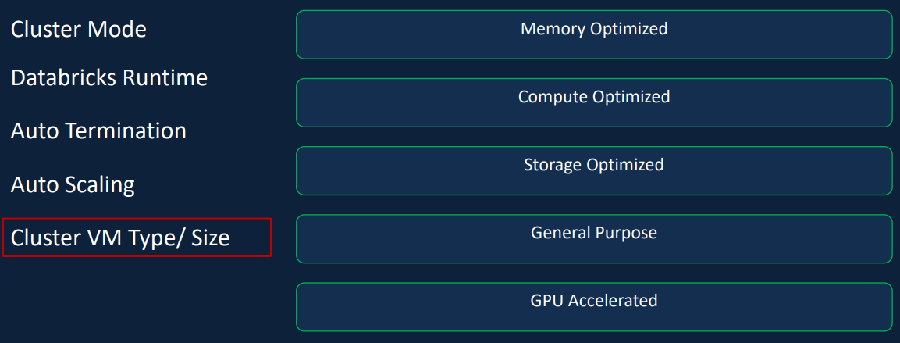

### Creating a Databricks Cluster

We are going to create a cluster in database and we're going to go through all the configuration parameters we went through in the last lesson. So let's switch over to the databricks workspace and get started. Here we are in our databricks workspace in order to clear the clutter, you come over to the left hand side menu and click on clusters and then click on Create Cluster. So I'm going to call my cluster as demo cluster for now. And as you can see, we got the cluster type. You can choose from the three options. We discussed high concurrency, standard and single node. So let's leave it a standard and we'll talk through these things and then we can change that. So the pool itself, we don't have a cluster pool. We haven't created one. We'll do that in a future lesson, but we don't have one at the moment. That's why it's default to none database runtime version. So it's default added to runtime eight dot zero, but in the later one is eight point one, which is available as well. And it also goes back all the way to 5.5.

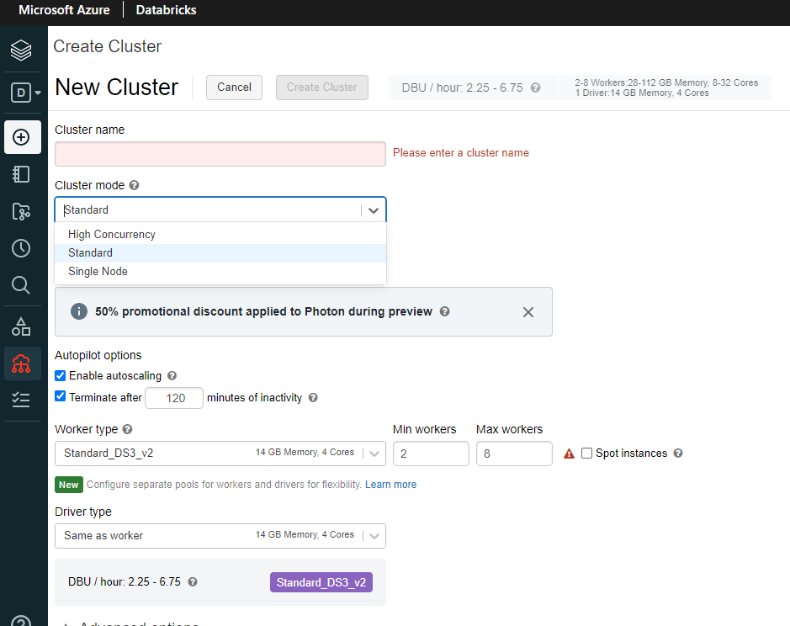

So if you had your machine learning model, for example, working on five point five, which is still not compatible with the later version, you can use one of those clusters. And also, as you can see, you've got different types of clusters. So you've got the database runtime cluster. That's what we talked about. That is the default one. And then we've got the ML GPU enabled clusters here. And then you've got the ML clusters in my subscription. I'm not allowed the genomics are the light clusters. That's why I'm not seeing them. But if your subscription can have those clusters, then you will be seeing those as well.

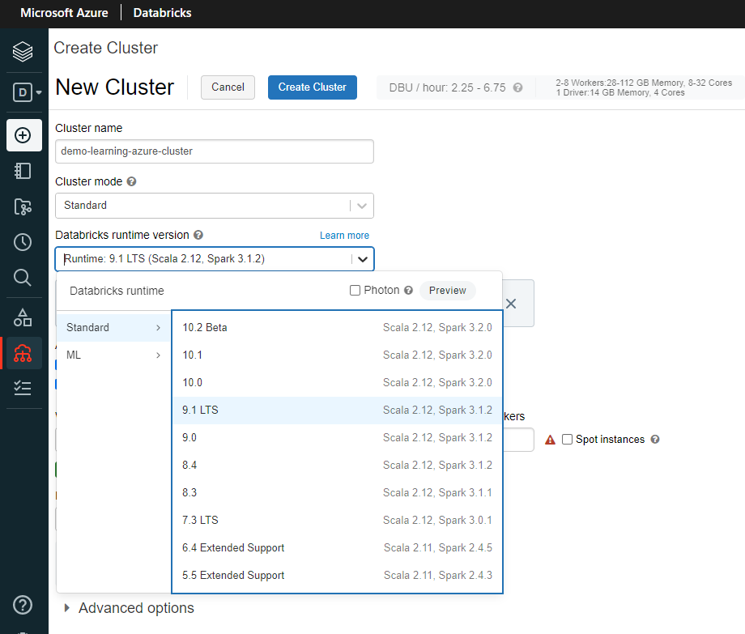 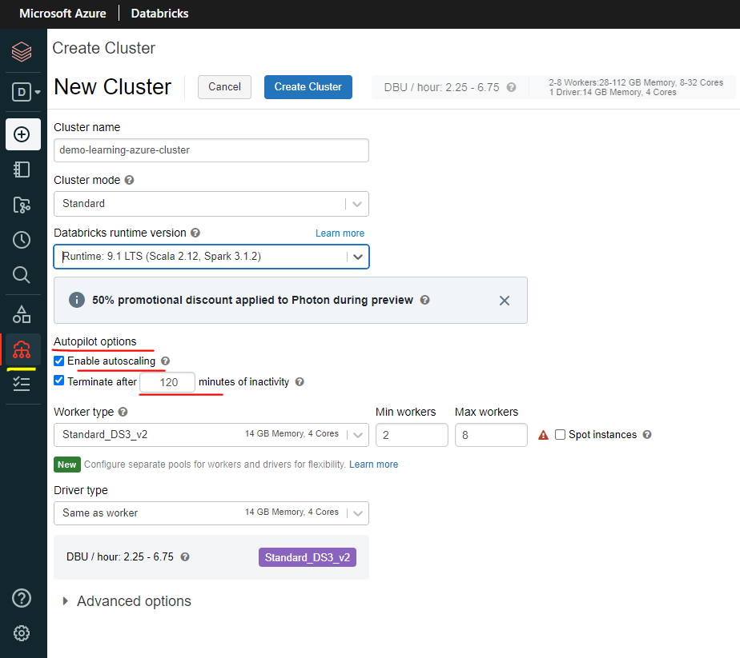

So let's pick the 8.0 for our purposes. We're not doing any ML work. The next thing you've got here is a note from database to say that the runtime 9 uses Delta Lake as the default format. The default format used to be parque, but that's been changed to Delta Lake from 8. Delta Lake offers additional capabilities on top of Parque, such as ACID transactions, time travel and also a faster execution engine. So it is a better format to have. Autopilot options by default, actually, they're both ticked, enabling auto scaling as well as the termination after 120 minutes. But you can change this. You can go from 120 to, for example, 30 minutes, the accepted values that 10 to 10000. So if I put 9, it's going to probably tell me. Yeah, it's it's it's not allowed. So it must be between 10 and 10000 minutes. So let me put that at 10, for example. And then you've got the worker types and the driver type. So here we specify the VM sizes. As we said before, we got a wide variety of VM sizes available. So we got the general purpose and then that's on the HDD. And then you've got the memory optimized, you've got the storage optimized, compute optimized and CPU accelerated.

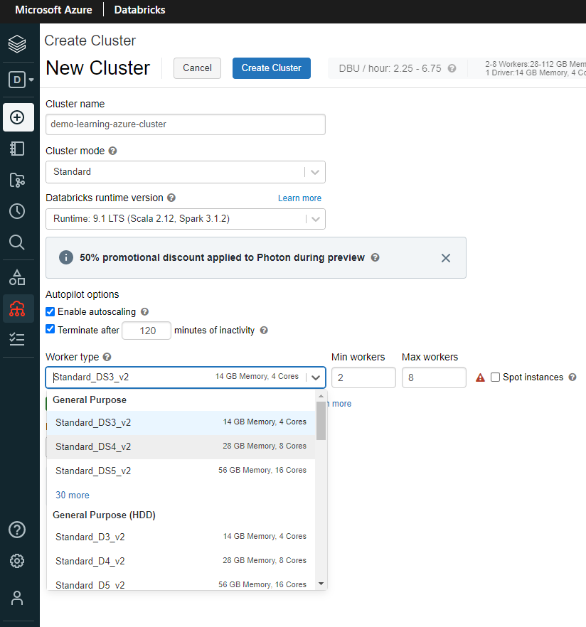 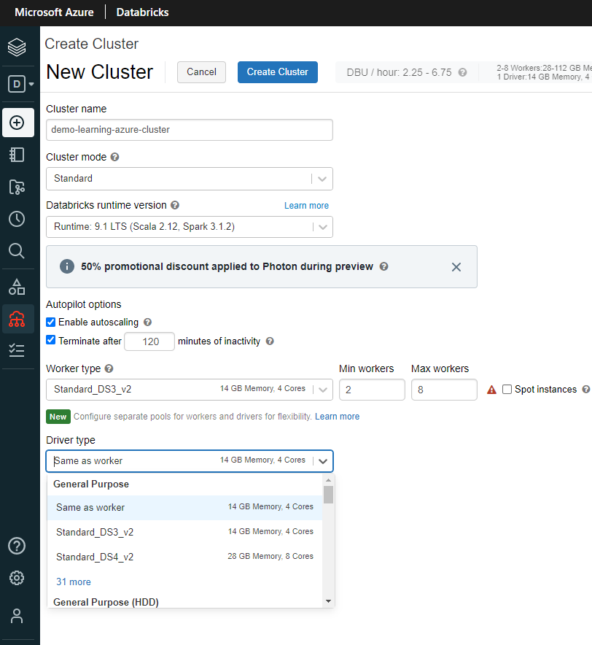

You'll see what's allowed on your subscription. You wont to see everything, but these are the options which are available. Let's pick the smallest one so that the Standard_DS3_v2 14 GB memory and 4 core and I'm going to specify my minimum work as one and maximum workers as 2. So what that's saying is because we got the auto scaling enabled when the cluster is open up, you're going to start with one worker and then if your workload requires more worker nodes, then it increases to two. You can also specify spot instances. So if there are any spot instances available in Azure, then you will get them. Otherwise you'll get the standard ones. But spot instances will save you money. But the risk is actually you could get evicted from this spot instances any time, really. So you wouldn't want to specify that for any of your critical workloads. But if you're doing some development, obviously, to save some money, spot instances will be really handy. The driver type itself, you can have a different type.

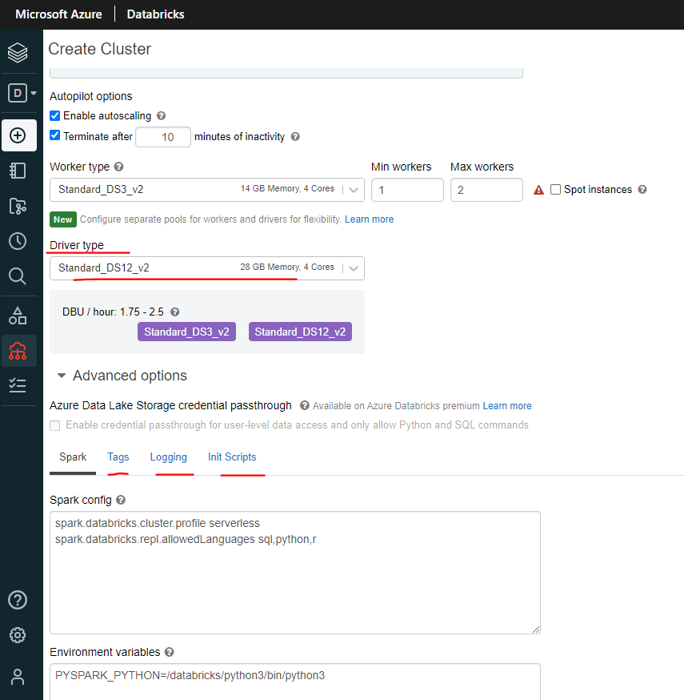

So it's by default, it's picked up the same as the worker type. But you can specify a bigger node or you can specify a totally different type of node. For example, you could go for a memory optimized node as well as other things you've got here is advanced options. You can specify your spark configurations. For example, if you wanted to change your default format from Delta Lake to Parque, you can set up our config in here. You can set your environment variables in here as well and tags. You've got a few tags already created for you, but you can't specify any additional tags you want to create on the cluster.

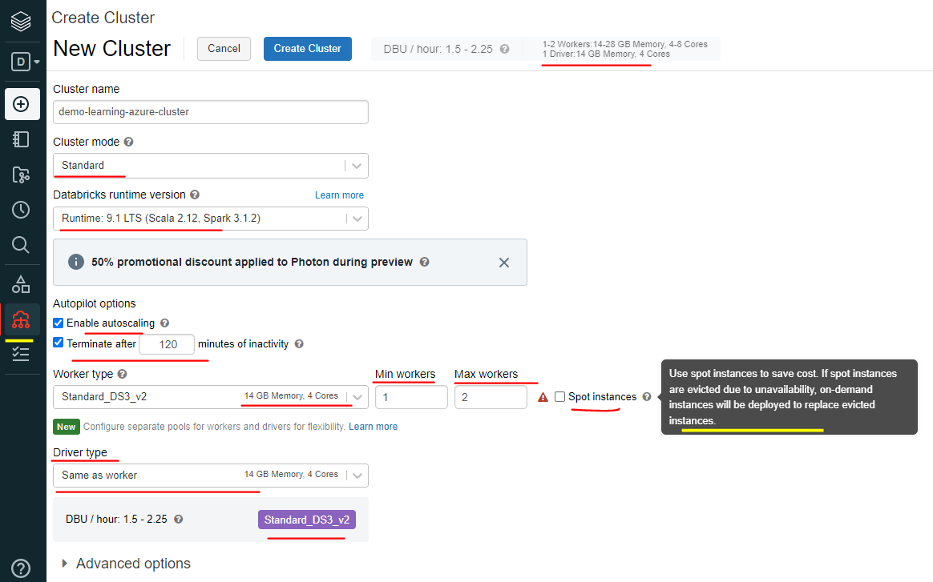

So that'll be quite handy when it comes to billing and things like that. And logging, logging by default is not saved anywhere. But if you wanted to save it into a DB first location for long term storage, you can just do that. I'm going to put that back online. And if you have any init scripts, for example, you want to install some python packages as soon as the cluster starts up, then you can do all of that so consistently all your developers will get the same environment for them to work on. So they're quite handy. So you can specify cluster specific scripts here, but there is a workspace specific in each script as well, which you need to go into here. And then from admin console, you can you can do that as well. So we talked about these to cluster here. I'm going to now talk it through the high concurrency. So when I click on high concurrency, certain things are going to change, as you can see.

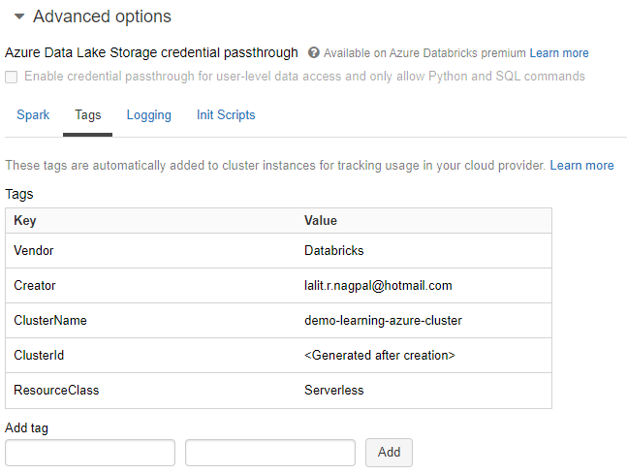

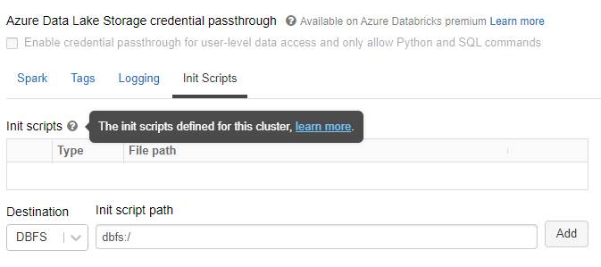

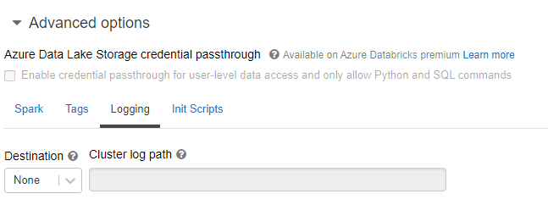

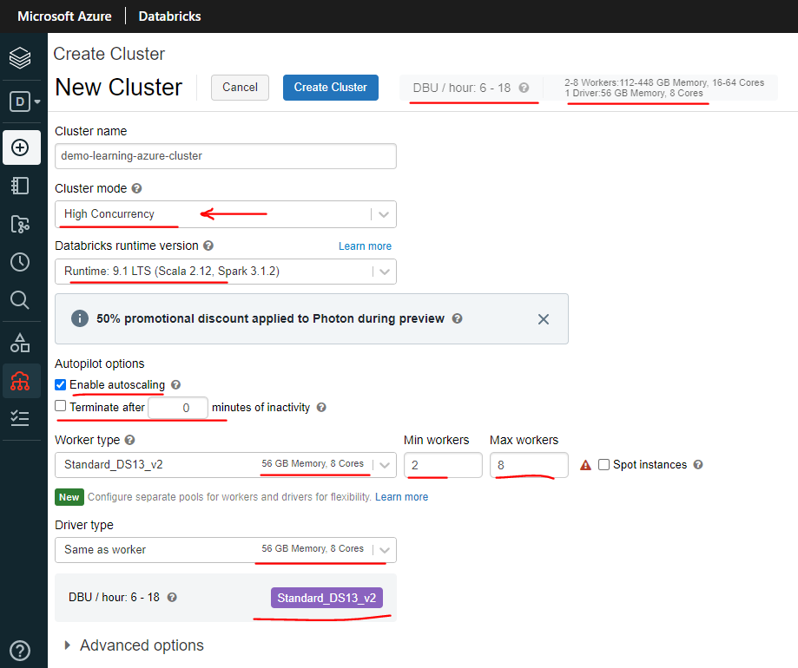

So if I click confirm, one of the things you may have noticed is the default for the terminate after 30 minutes has been disabled rather than enabled. But you can still specify you can say you can say you want your cluster to terminate after 7 minutes. That's still acceptable. But by default, that's not ticked. And also, you may have noticed the cluster sizes have changed as well. So for a high concurrency, because normally it's worked on by more than one person or more than one process. Data Bricks is suggesting a bigger cluster. So it's a cluster for that. And the minimum and the maximum workers are two and eight in this case. And nothing else would have changed. Or the other options you've seen here are exactly the same for both. One more thing is, if you untick, enable auto scaling, the minimum workers will disappear because there is nothing to auto scale. As soon as it starts up, you're going to have eight worker nodes. And that's where it says, I wouldn't recommend that. Apart from using further streaming workloads for the standard workloads, having the auto scaling definitely helps you scale your cluster up and down depending on your workload. And you can save cost.

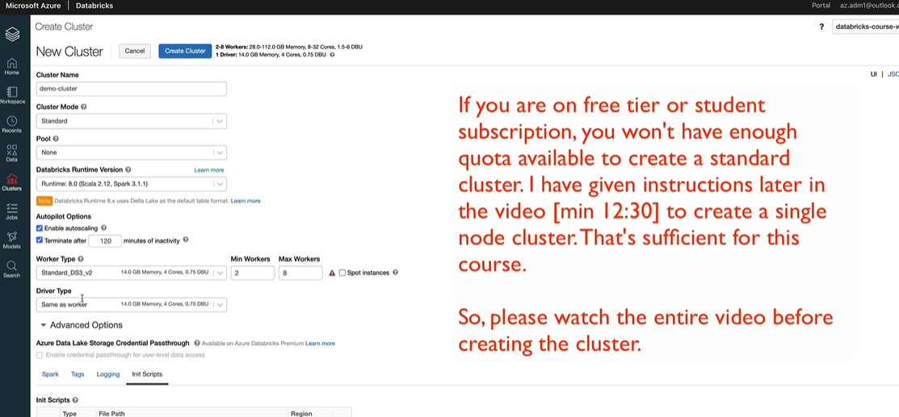

So let's go back and put it on standard and then we're going to create a cluster, so I'm going to terminate after ten minutes because it's just for demo purposes. I'll be deleting it afterwards and I'm going to put the minimum cases, one and max as 2 and I'm going to try and see if I can get some spot instances as well. So once you've done that, you just have to click on Create Cluster.

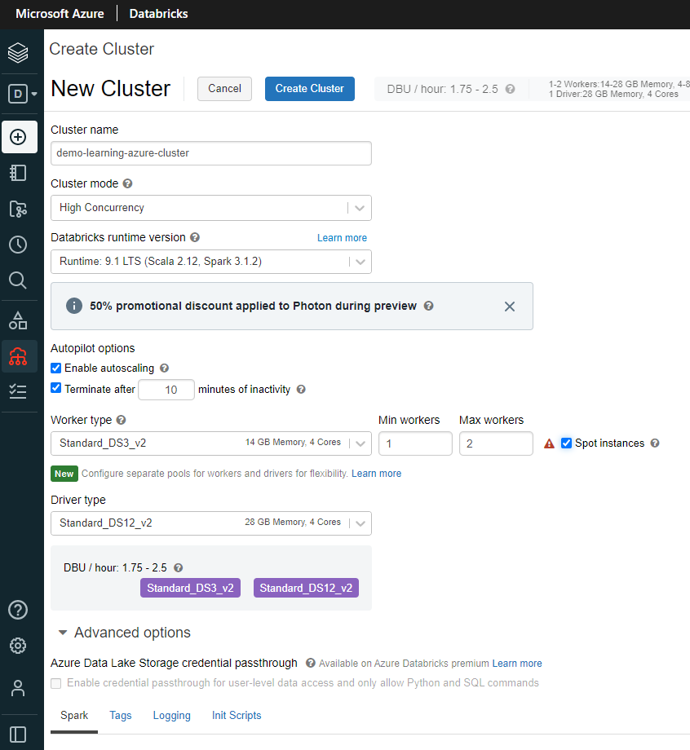

And now this will take about 5 to 6 minutes to create the cluster, so I'll come back.

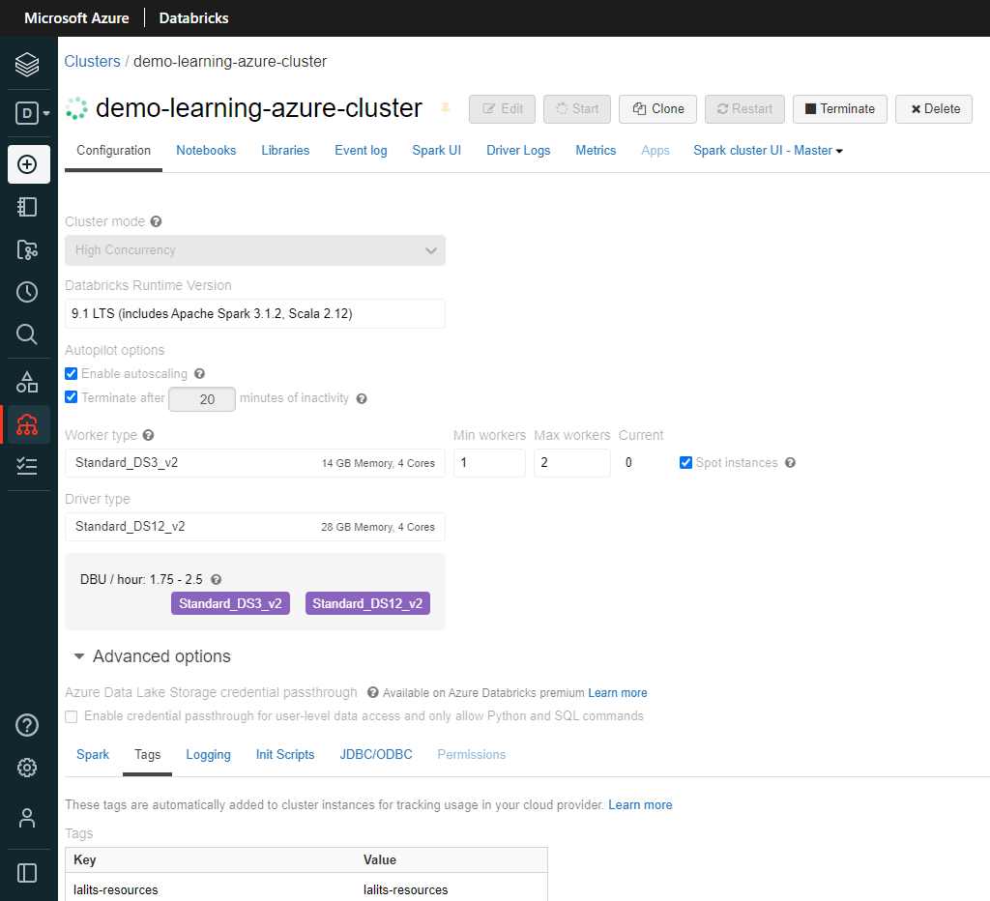

As you can see, the cluster is now up and running. It took about five minutes. The green dot here denotes that the cluster is running, but you can also see in the event log and see what's happening. So as you can see, we started the creation of the cluster at 15:33 and the cluster started up and running at 15:37. And also we got a message that the driver is healthy. So if the cluster had any issues, you would see them in here as well. And going back so here, if you had any notebooks attached to the cluster, you will see them in here and you've got the option to detach them from the cluster and libraries gives you the option to install any new libraries so you can install MAVEN libraries for MAVEN coordinates or you can do Pi, Pi or Python egg or Python Whi or anything like that. So let's quickly install Maven Library. So I want to, for example, get the Microsoft ML Spark Library. So that would be ML Spark library.

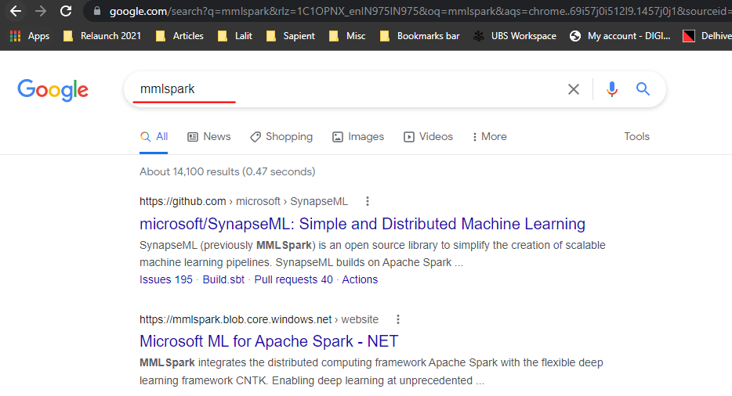

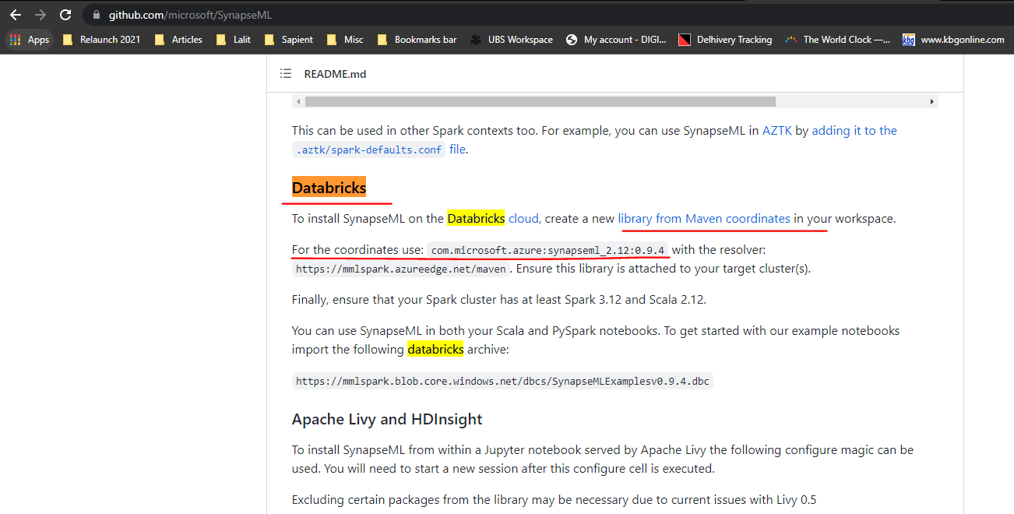

So if I go to GitHub, I can find the coordinates for that. So let me search for database. So these are the coordinates I should be using in order to install that library. So if I come back to my cluster and then specify the coordinates here and then click install, it should install the library for me on the cluster and I would be able to use or use this library in my machine learning models.

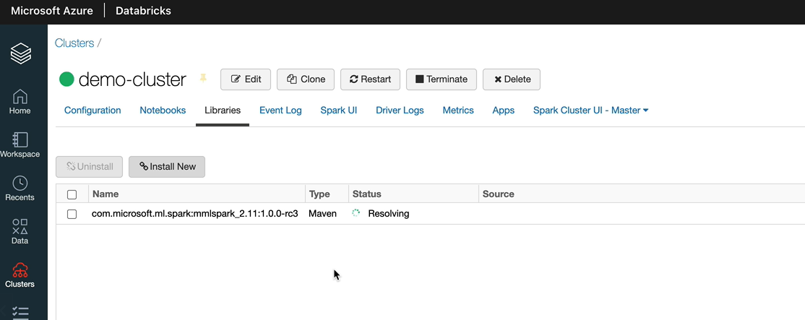

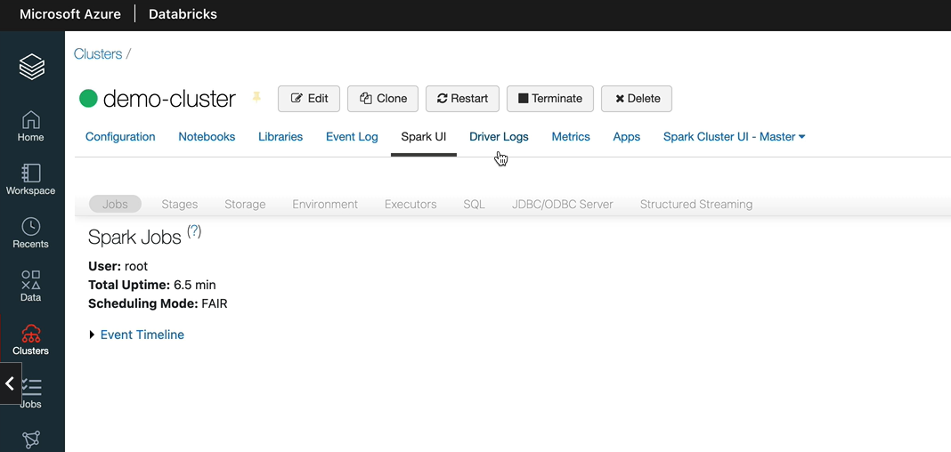

We talked about the event have already you've got the Spark UI as well and also you can navigate to the driver log. So if there are any issues, you can come and have a look at the logs for the driver and you can see the metrics.

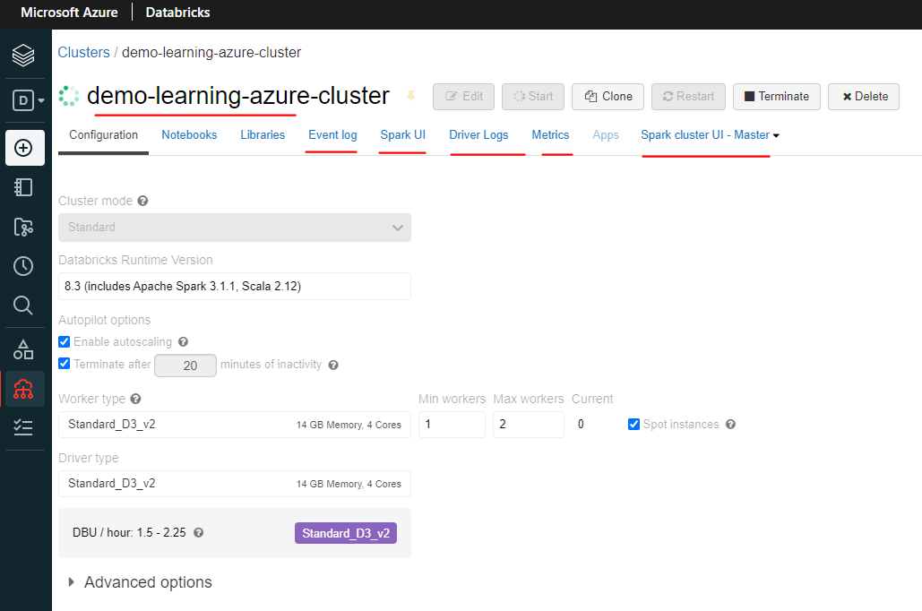

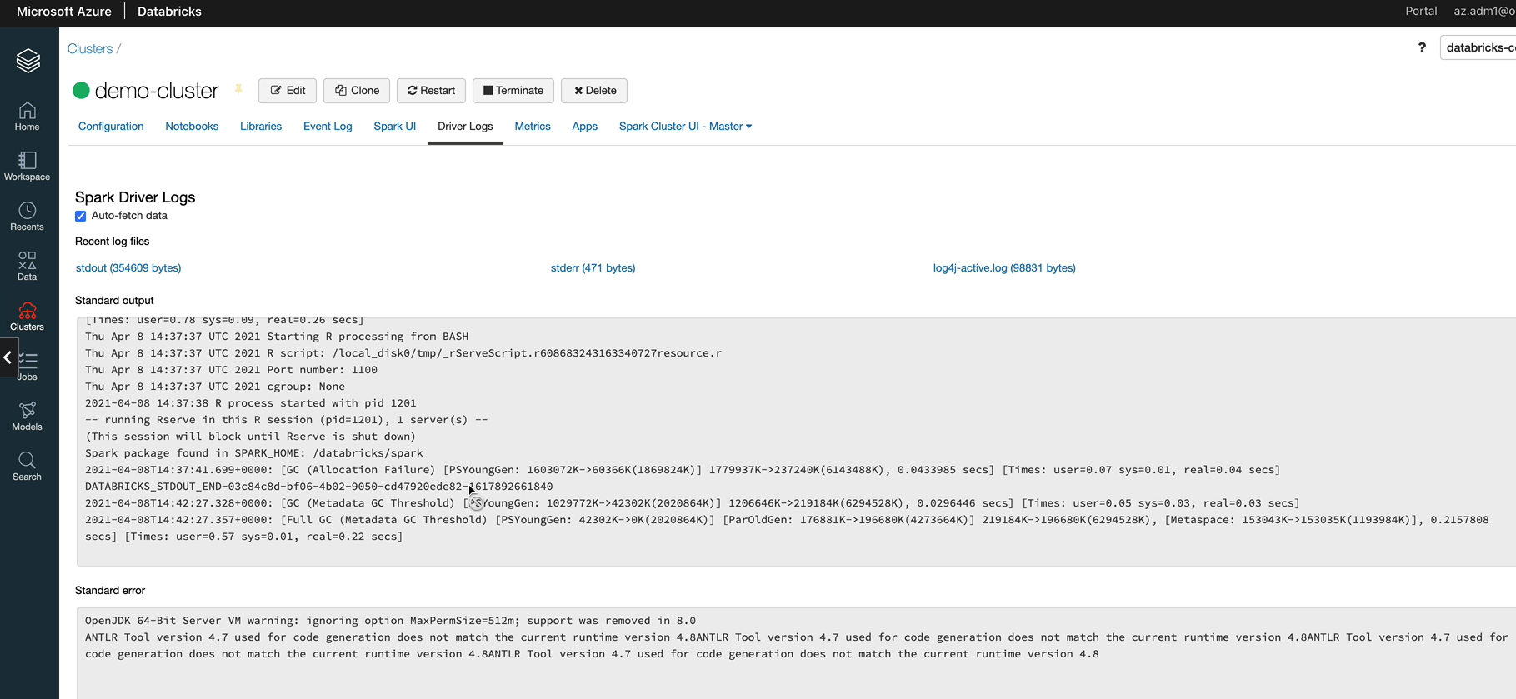

So you got the Ganglia UI. You can go in there and have a look at the CPU usage, network usage and all of those network traffic, I should say, and all of that in here. And as you can see, we got to worker nodes and they're both healthy. So they are OK.

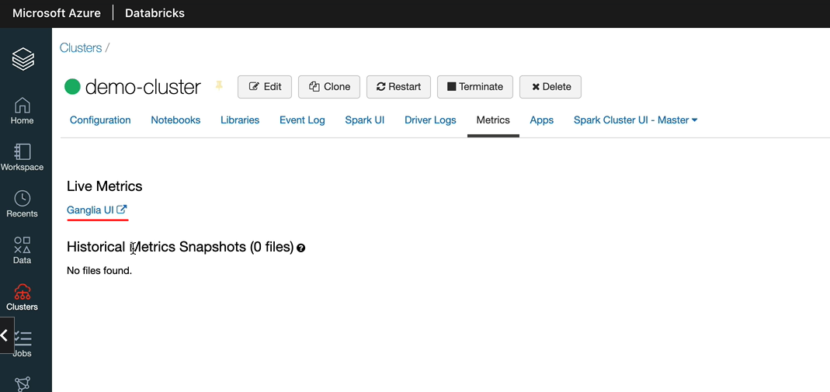

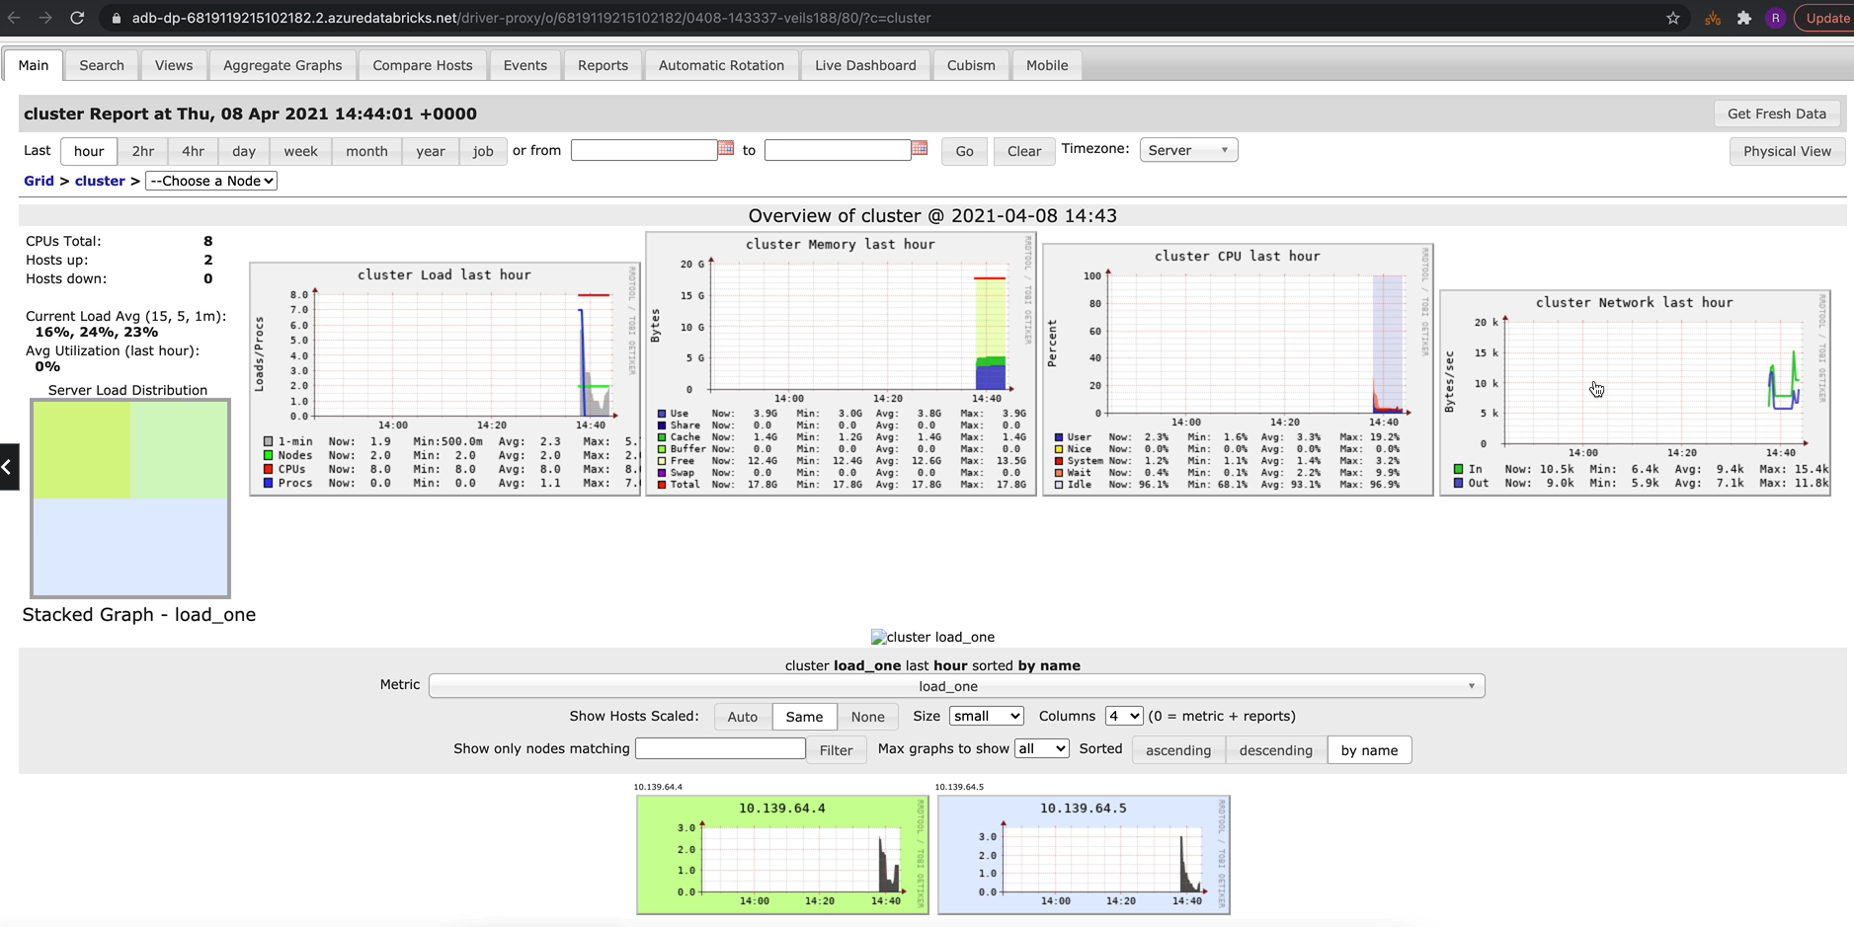

And if one of them is overworking, then you would see them yellow or red. All right. So if you click on the legend, you'll see the user. So if they use usage is for over 75 percent, then it would be orange or it would be red. Let me go back to the cluster. So that's everything about the cluster details. The other thing you can do is you can still edit the cluster and change any of these things. So depending on what you change, it will reprovision the cluster again. For example, if you change the worker types or the driver types, then obviously it needs to reprovision the cluster. But if you just change one of these parameters, it'll just apply the changes there and then and let's cancel from here. And the other thing you can do is you can clone and create a cluster with another name, but the same configuration parameters. You can restart this cluster if there are any issues. For example, the driver is just not performing as you would expect, then you can restart the cluster. And the option, the other option you've got here is terminate as well. Let's now terminate the cluster, so let's click on terminate and then click confirm it should terminate fairly quickly, to be honest. OK, that's how you create a cluster and terminate it once you've cleared the cluster, you can delete that as well. Unfortunately, students who are on 3-tier won't be able to create a standard cluster, so you'll have to create a single node cluster. So what I'm going to do is I'm going to delete this cluster and create a single node cluster and I'll be using that throughout the lesson so that actually I'm using the same cluster most of the students are going to be using. So let's click a cluster and I'm going to call this as darabricks course cluster. And now, instead of standard, we are going to create a single node cluster and we still don't have a pool, that's OK. And I'm going to leave the runtime as 8.0. As you can see, the outer scaling has disappeared because on a single node cluster, you only have a driver. There is no work in order to scale up and down. And I still want to terminate after ten minutes of inactivity because I don't want to be paying for the time. I'm not using it and I'm going to leave this one as the DS-3V-2. You can look for a cheaper alternative. I think there was one, which probably is a 8 Gig Memory for course and that is in 0.5 DBU as opposed to the 0.75 DB you that will be slightly cheaper, but not significantly. So I'm going to leave it as destry to the four core here. And let's click create cluster and this will take about five minutes to spin up the cluster as well. So we'll be back once that's done. OK, the cluster is now up and running,

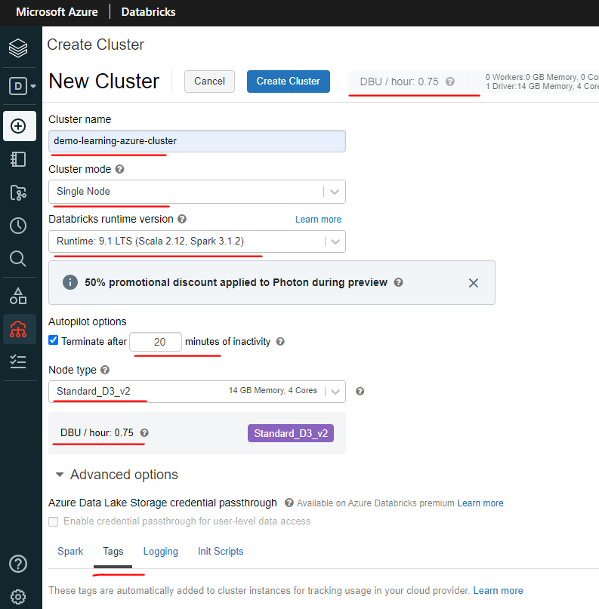 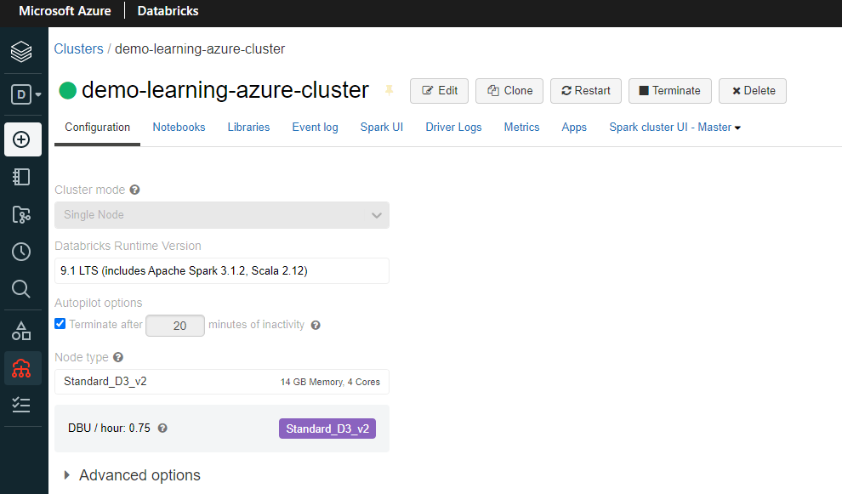

### Azure Databricks Cluster Pool

We are going to look at cluster pools. Clusters, usually take time to start up and to scale, in order to minimize the time we can use pools. Pool is basically a set of ideal, ready to use virtual machines that allow us to reduce the cluster start and auto scaling times, for example, let's assume that we have created a pool with a minimum of 2 ideal instances and 5 maximum instances. What this means is the pool will always keep at least two instances ready for clusters to consume until it reaches the max limit, which is five in this case. Let's say cluster one comes along and request for the 2 nodes. The pool gives the two instances to the cluster and spin up another two more instances ready. If Cluster two comes along and requests for the two nodes, then it can give the two nodes which are ready, which is VM three and four in this example. But if the cluster two requests for 3 more nodes, then give these two nodes, which are VM three and four, and also spin up a new one, which adds to the time. Whereas if the cluster two requested for 4 new nodes, then it'll fail to start with the added that there are enough instances available to allocate. Hope that's given you an understanding about cluster pools now, so let's switch over to the Azure Darabricks workspace and see this in action.

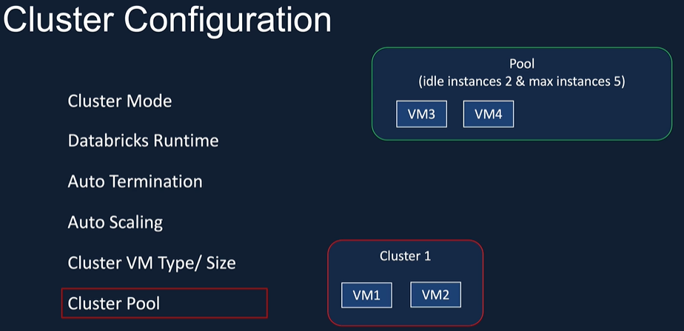

OK, here we are in the data workspace. Let's go to clusters and pools and create a new poll. So let's call this demo pool and I'm going to specify my minimum as 1, rather than the example we saw in the slightest 2 and 5. But I don't have enough cota available within my subscription. I only have 10 codes available, so I'm going to go for a minimum of 1 and max of 2. And I'm going to specify that actually I want to terminate after 10 minutes of inactivity. So one thing to remember is the ten minutes we're specifying is not going to be applicable for the minimum ideal instances. So the minimum ideal instances in this case is 1 that will always be up and running for the 2nd instance, when that's been used by a cluster and returned to the pool. If it's inactive or that means it's not been acquired for another cluster for the next 10 minutes, then that gets terminated. So the 10 minutes won't be applied for the 1st one. So if you have a pool, that doesn't mean that you're not using it. If there are no clusters attached to it, you'll still be charged because that VM is still going to be up and running. So we're going to go for the same instant types that we used previously, and you can also preload Databricks runtime version to that cluster. So that will speed up when I say that cluster, that VM. So that means it will speed up the cluster creation as well. So if I say I want 8.0 on my instance to be installed, then it'll install runtime 8.0 on this VM and make it available for the cluster immediately. And we can specify the spot instances and we can specify tags as well. Let's ignore them for now and click create.

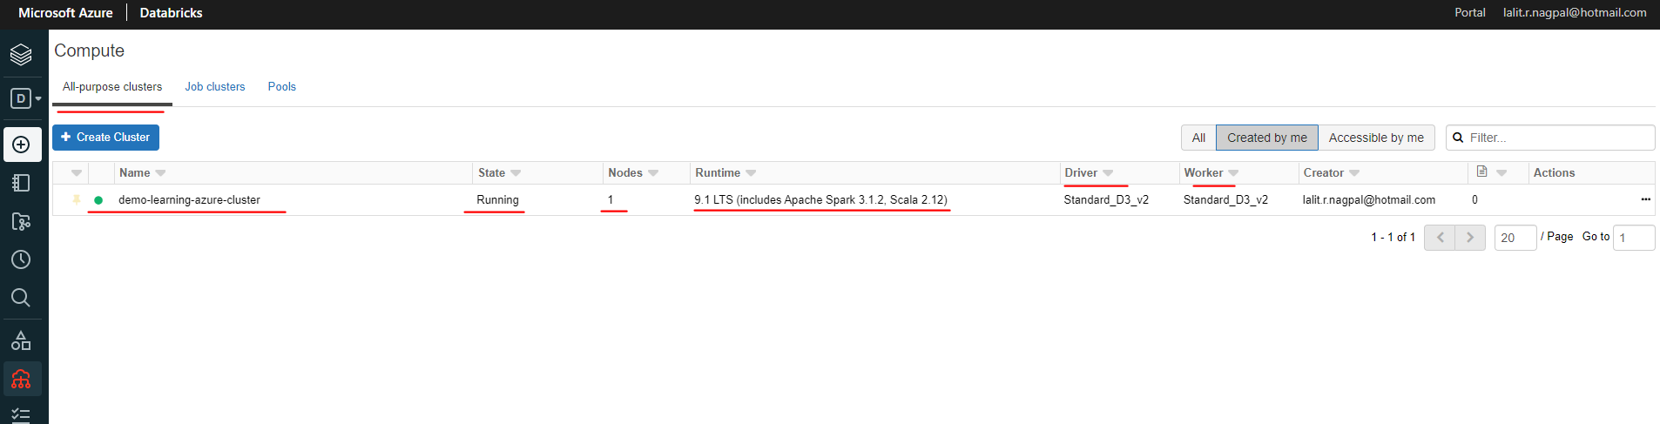

Lets go to pools and create a pool

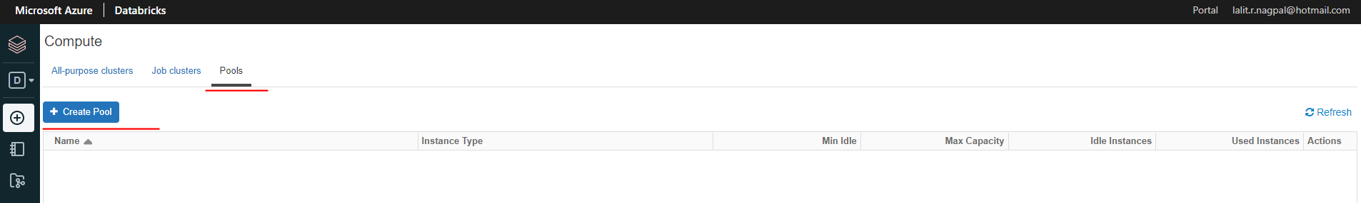

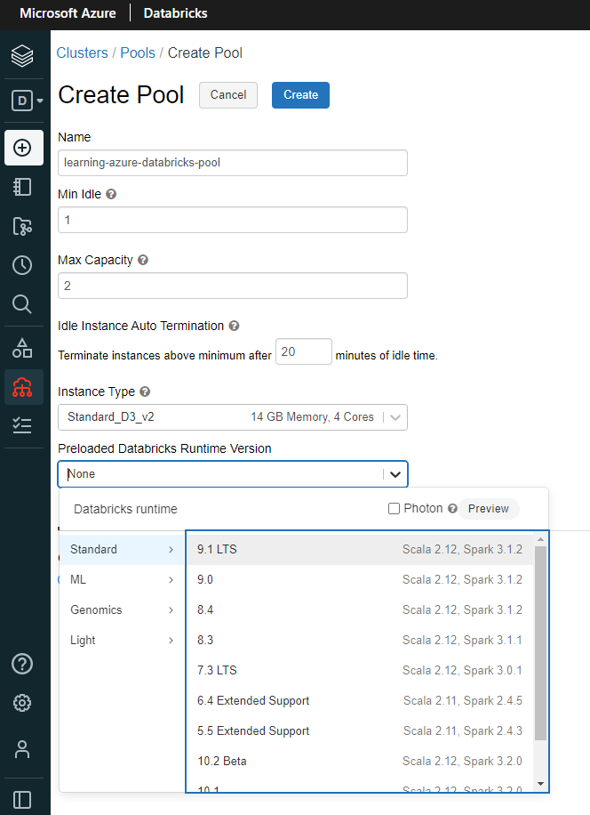 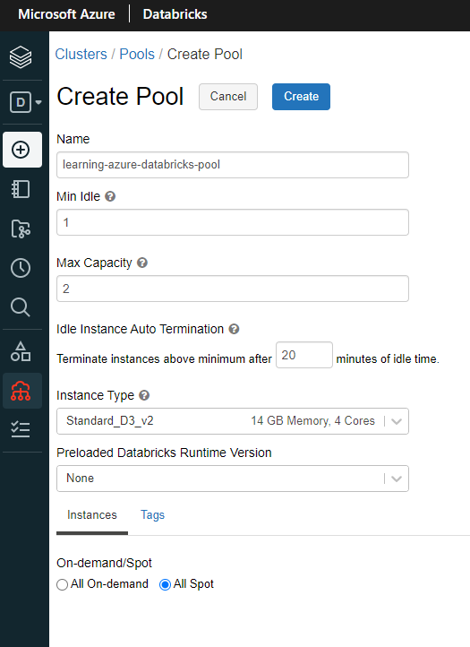

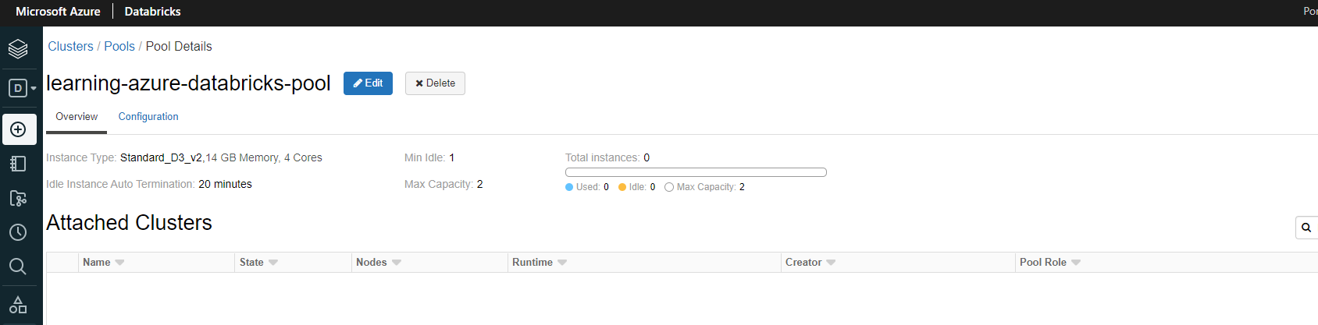

And it's going to take a couple of minutes to make that VM available, so let's wait for that. OK, as you can see here now, it's got one node waiting for us.

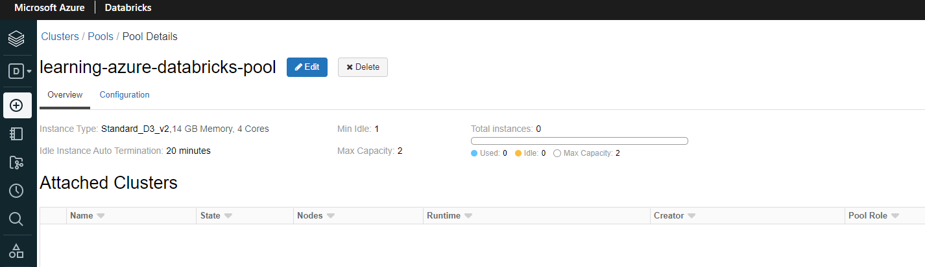

So let's go to Cluster's again and let's create a new cluster, which is going to be a single node cluster. So I'm going to call this a demo cluster. We're going to delete this once we've used it. And as I said, let's go for a single node cluster and we can specify the pool now.

|  |  |
| --- | --- |
|  | So the Demopool is now become available here. So that pool has been specified so we can leave the runtime version as itself. So that means it will not try and install the runtime version one more time and we can terminate after ten minutes. So let's do that.  And I'm going to click create cluster and let's see how long it takes to spin up the cluster. It should be quicker than before, but it'll still take a bit of time.  OK, as you can see, the cluster has now been provisioned, let's have a look at the event log to see how long it took, as you can see, to about just under 3 minutes, which is not great, which is still slower. |

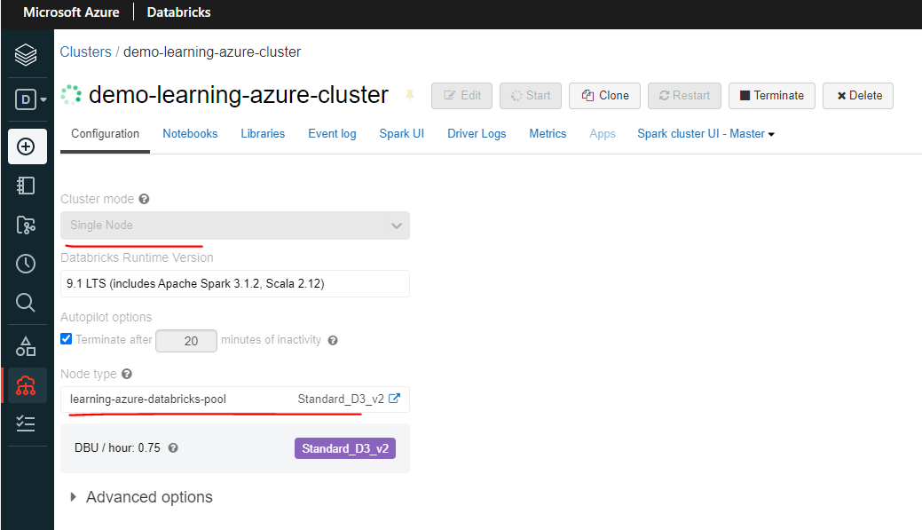

|  |  |
| --- | --- |
|  |  |

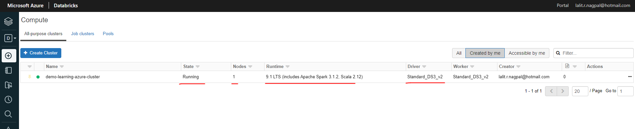

But having said that, in this case, actually, we only had 1 or 2 provisioned. But if you had multiple nodes, then it'll it'll all add up and it'll be significantly different. So it's a case. That's all we can do with the court. We got I couldn't show you provisioning multiple nodes in this case. But now let's switch over to my cluster pool. So let's go to cluster pool. And if you look here, that would tell you that actually it's used one of the instances for our cluster and the other one is now being provisioned and attached to clusters. As you can see, this one is using one of the nodes, so that's very good. Before we delete it, I want to tell you something.

If you are on a free tier subscription, you won't have enough kota to be able to try cluster pools. Maybe you can try with minimum as 1 and maximum 1, but you'll only have 4 cores available within free tier subscription. You'll have to either upgrade to a basic or a subscription or your work subscriptions to be able to do this lapsation. So that's the end of this lesson. I'm going to delete the cluster pool so that I'm not charged for that one extra node. And also I'll go ahead and delete my cluster as well. So that would be in here. And that's the demo cluster. Let me delete that cluster as well. So that's been deleted.

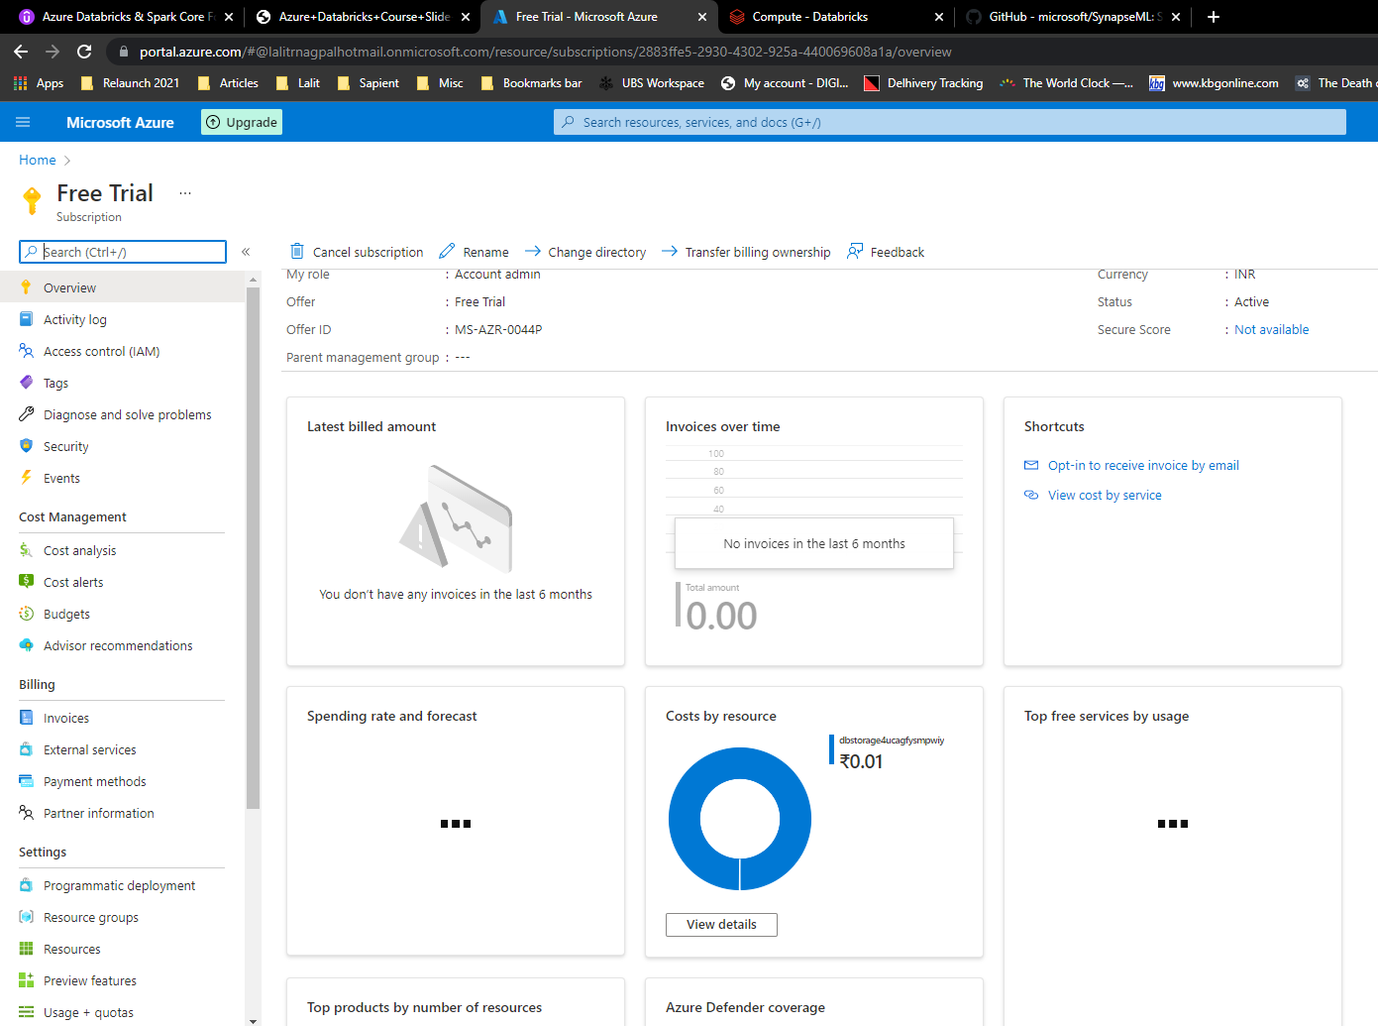

## Databricks Notebooks

## Mounting Data Lake Container to Databricks

|  |  |
| --- | --- |
|  | As you can imagine, we need to mount our data storage to databricks so that databricks can access the data securely and efficiently. In this section of the course will first define what a databricks file system RDBMS is, will then describe what amount is in databricks terms. Then we'll put these concepts into practice by mounting the data lake storage to databricks. During this stage, I'll also take you through the process of creating Azure Service Principal as well as Azure Data Lake Storage Gen 2 service. I'll then take you through how we can use Azure Key Vault and Data Bricks Secret Scopes to make access to the most more secure. |

### Databricks File System ( DBFS )

We're going to talk about the Databricks file system or otherwise known as DBFS. Databricks file system is distributed file system mounted on the Databricks workspace. This can be accessed from any of the Databricks clusters created in the workspace. It's just an abstraction layer on top of the Azure Objects Storage solutions such as Block Storage, Data Lake Gen 1, and Data Lake Gen 2. You can access the DBFS file system from your Databricks notebooks, Databricks CLI or the Databricks API.

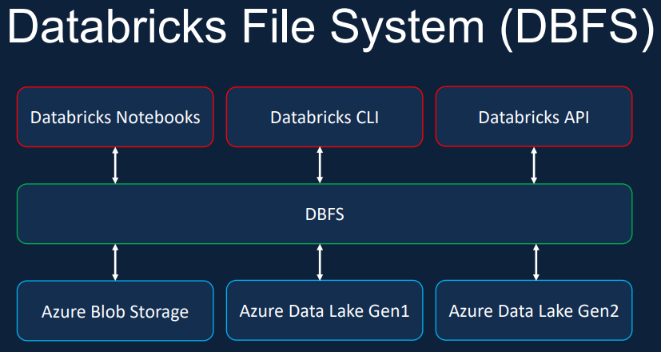

Databricks file system offers some important benefits to the storage solution in Databricks. Once the Azure Object Storage Solution such as your Data Lake or the Blob storage has been mounted onto the workspace, you can access them on points without specifying the credentials. This allows for accessing the Azure storage from Databricks using file semantics rather than the long storage warrants. You can trade them on point as the same as mapping unaided. Try to use a network computer, for example.

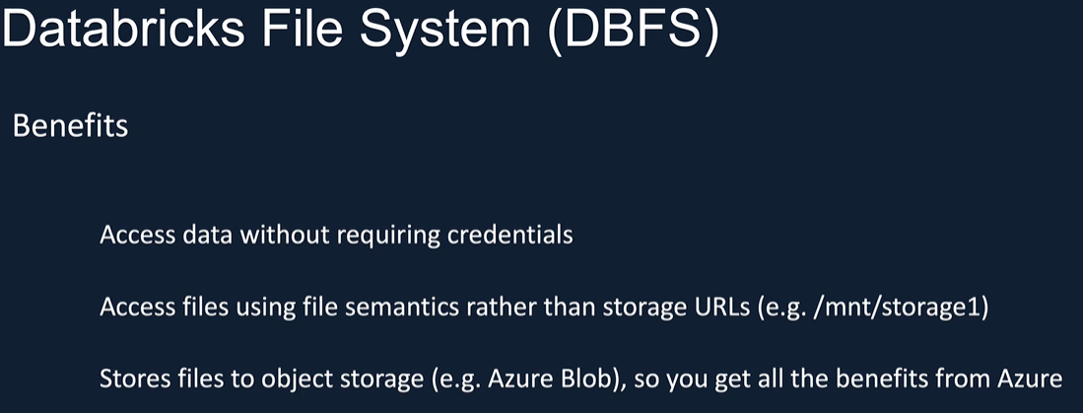

DBFS is just an abstraction layer and it's tilted towards the files, to the storage, so you get all the benefits, such as different performance tiers, replication, massive storage, etc., as you would normally get from Azure storage. The defaults to rage in DBFS is called DBFS root.

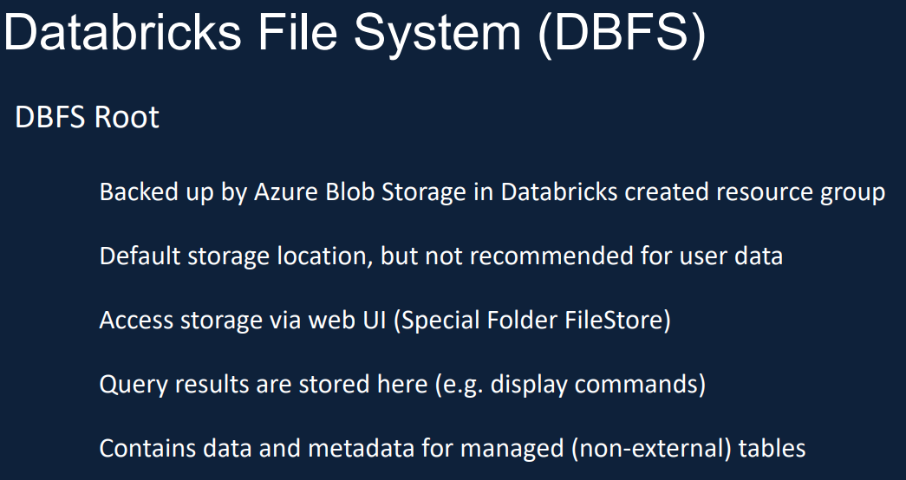

It's created as soon as the Databricks service has been provisioned, Databricks created as part of the deployment. We've already seen it. But I just want to quickly go through this as this is a lesson on DBFS. DBFS root is backed by Azure Block Storage in data created research group. Even though this is the default storage, but later it's recommended not to use this to store user data, when you drop the Databricks service. This storage also gets dropped. You can access one of the special folders within DBFS through called File Store via the web UI. You can use this as a temporary storage, for example, to save images to be used in notebooks or some data to play with quickly. Databricks stores query results from commands such as display in Databricks root as well RDBMS root.

Similar to Hive Database, also allows us to create both managed and unmanaged external tables. If you create a manage table, that data will also be stored within DBFS. Hope this gives you an understanding about Databricks file system. Now I would like to quickly show you the Web UI that you can use to interact with DBFS root and in the forthcoming lessons we will talk about mounting other Azure Storage solutions to Databricks as well. So let's switch over to a Databricks workspace and get started. OK, here we are in the Databricks workspace, so let's create a new notebook and I'm going to call this one as . And attached to the same cluster we created previously, so click create on that one and let's see what folders we can access on root.

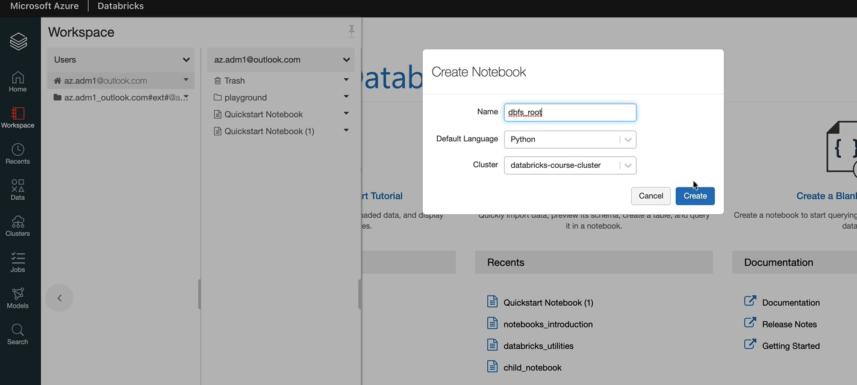

So if we do %fs, the magic command and then ls should give you all the available directories.

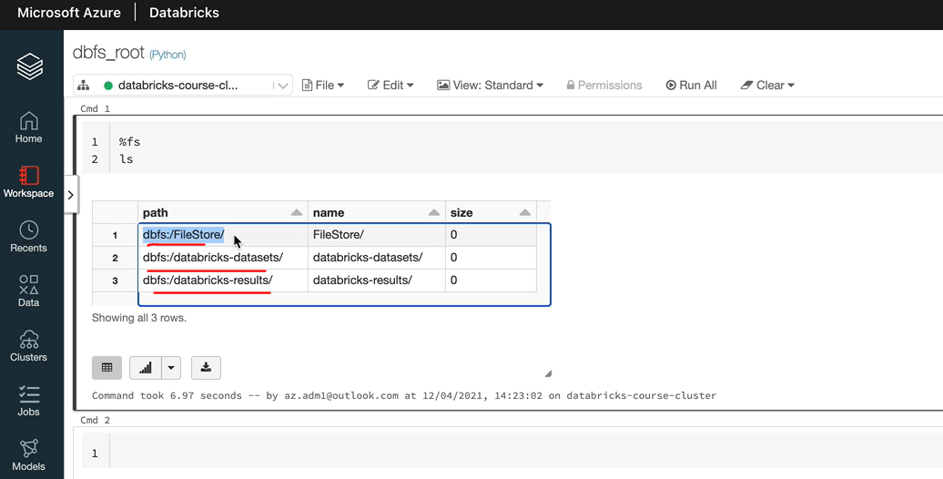

OK, so the these are the three parts available. As we said, this one is the special folders where we can add content which we'll be doing in a minute, but this one is data breaks provided data sets for us to explore and this one would normally have the results of display commands and things like that. So what we're going to do is we are going to import a file. So let's go to the home screen. I'm going to open it in another tab. And I'm going to import a file from my downloads folder.

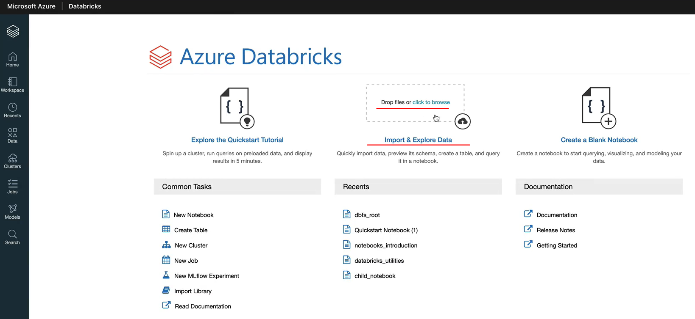

Let's click on Browse and I've got a file called circuit.csv, so let's upload that. I'll make this available as part of the course material so you can do the same thing. And now that file has been uploaded to the special folder and files to match tables.

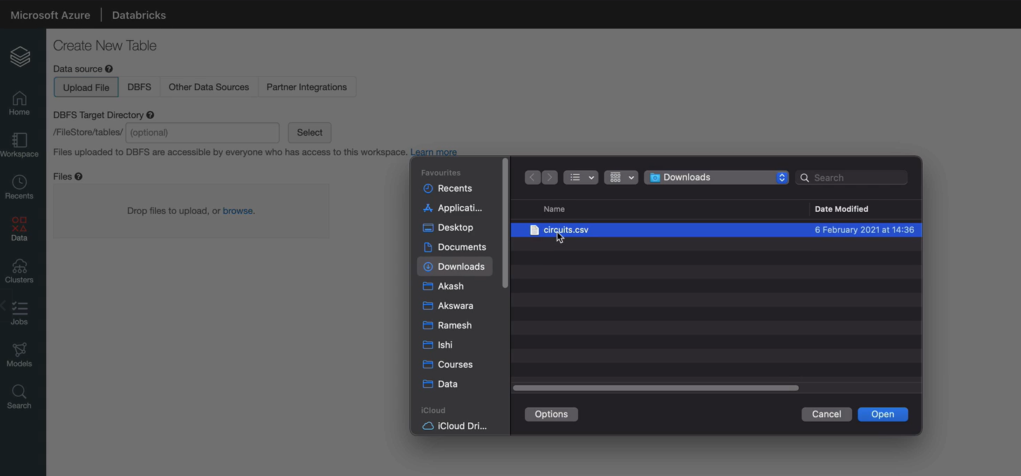

So that's the only one we've got access to so we can create further folders. So if you wanted to create the folder, you would just type in the folder part here. And one interesting thing this UI gives you is once the files have been uploaded, it'll ask you whether you want to create a Databricks table as well.

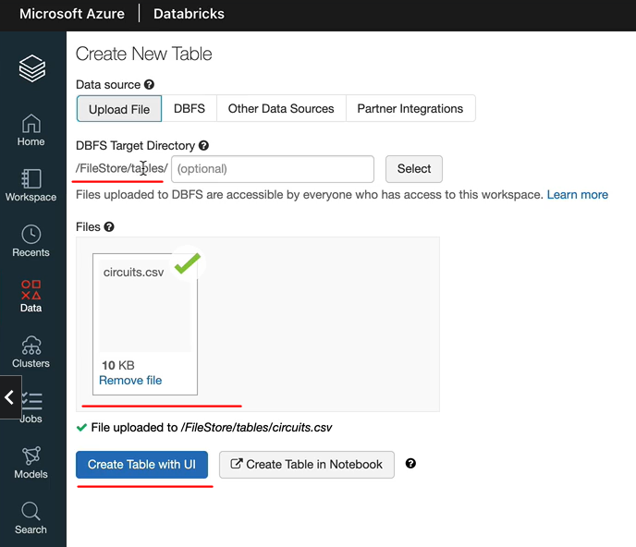

So let's try that as well. So I'm going to do create a table with user interface and we need to select a cluster. Let's select our cluster and we can click preview table to see the data. So it's going to pick the top 20 records. So I'm just going to display that. So this is the data, as you can see, we got a header and then a few data records, 19 of them, so 20 lines in total, but it hasn't identified this as the header.

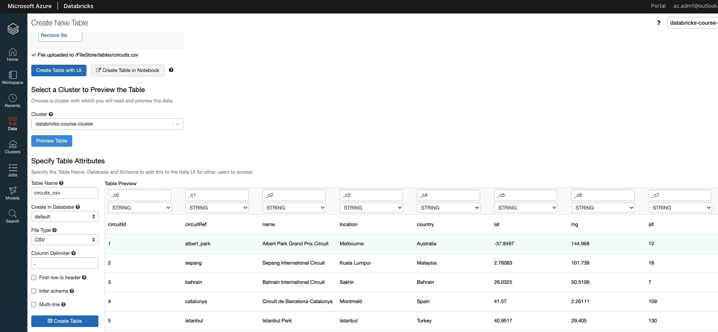

Let's ask it to do the click on this one. So that would be the first to release the header. So now that's been identified as the header and it still hasn't identified the data types here. As you can see, this is supposed to be an integer, but it shows us strength. So let's click on Infer schema and that's done. So now let's click create table and it should clear the table for us. OK, as you can see, the tables now been created and it showed us some sample data as well. So if you go to the data tab, you can see that under the default database, because we didn't create a separate database, we put that under the default database.

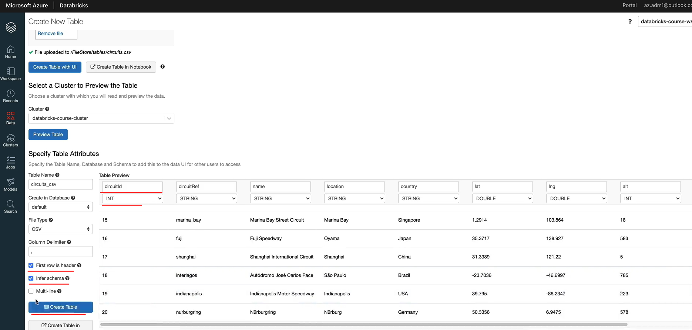

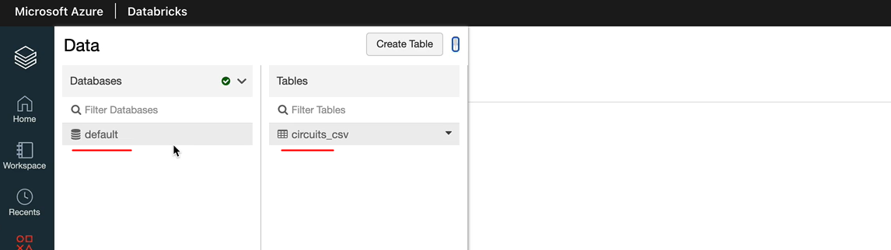

So you've got a csv called ciruits.csv as the table name. We could have given a different name, but that's what we did. One last thing I want to show you is the file that we uploaded into the file, store a special folder. You can just do ls on this folder to go look at the file.

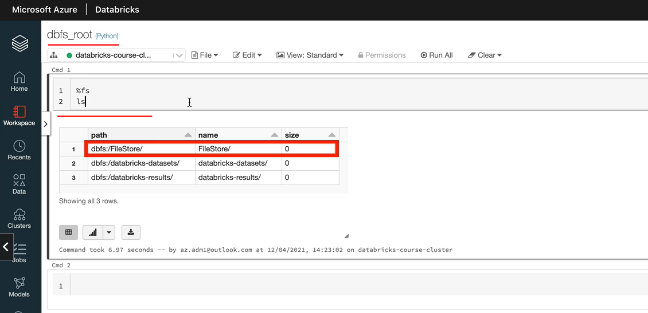

But the other option you've got is to go back again to the import wizard and they can look at DB first. And then when you click on Files Store, you've got tables. That's where we put the file. So you can see that as well. Actually, that's why I wanted to show you in terms of the best route in the next lesson, we'll look at how we attach an external storage to the Databricks workspace.

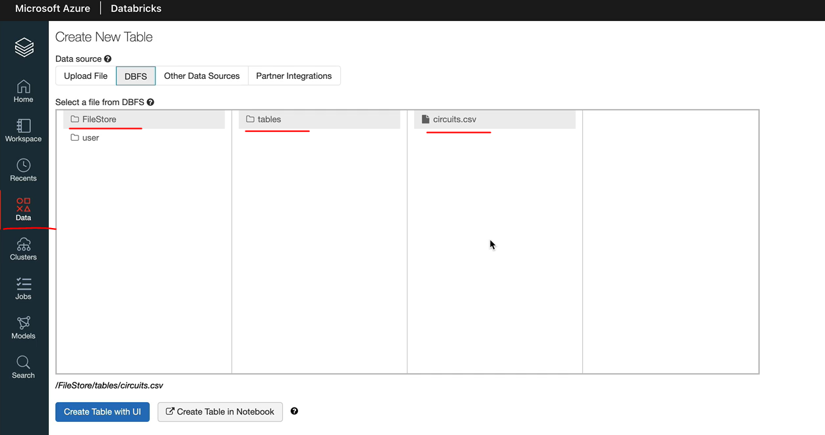

### Databricks Mount Overview

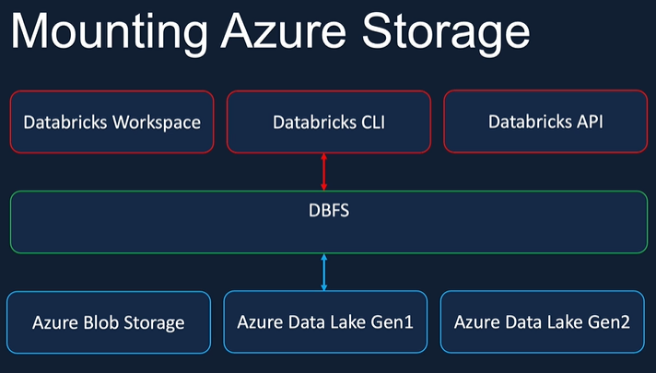

Let's now look at how to mount the Azure storage to a database so that it can be accessed from a database using file semantics and also without specifying credentials. In order to create a mount, we need a service principal storage account to access key SAS token.

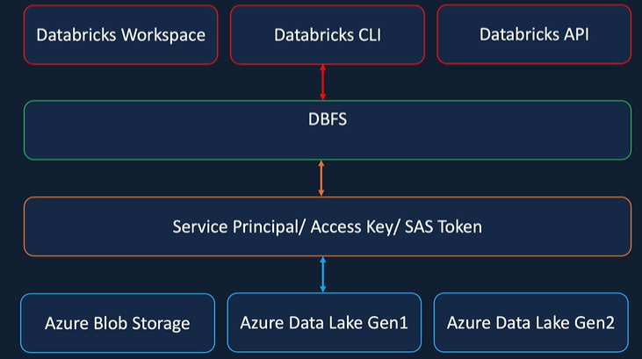

Amongst these, using the service principal to mount the storage is the most secure. And also the recommended approach will be using that in this course. Once you have the service principal, we need to give access to the storage account, to the Service Principal. We can then create the mount points in DBFS using these credentials.

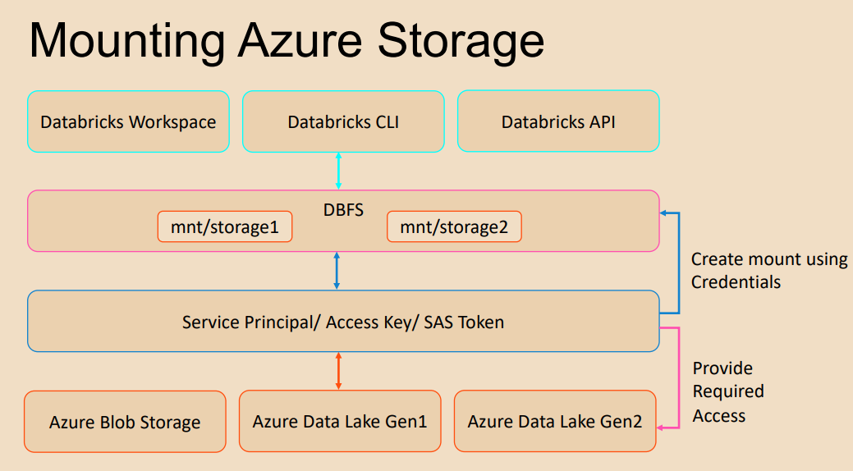

The mount points we create provide access to the storage without requiring credentials.

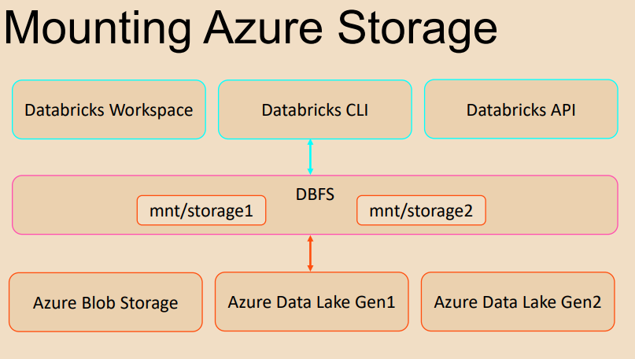

Also, we'll be able to use the storage using the filesystem semantics, such as mnt/storage1 and mnt/storage2 as we've seen in our examples. Hope you now have an idea of how to create a mount point for a Azure Storage. In the coming lessons we will create the Azure Data Lake Storage Gen 2 account required for our project and also the containers required. We will create another service principal and a secret which will need to mount the storage. Also will provide the required access to the storage account for the service principal and finally will create the mount using the service principal and test the mounts.

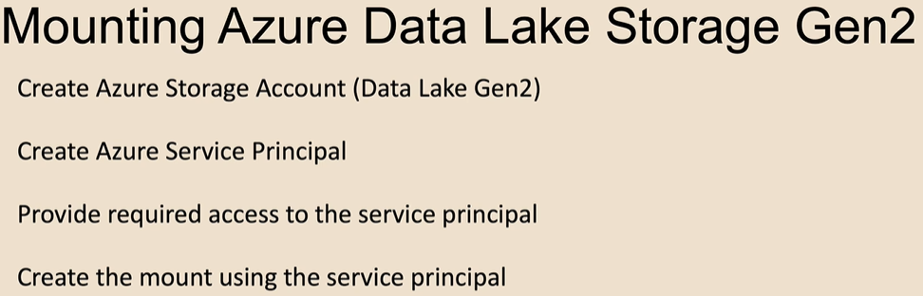

### Creating Azure Data Lake Storage Gen 2

First, let's create the Azure Data Lake Storage Gen 2 storage account. In order to create the storage account, you come to the portal and then from the top left menu, you click, create resource and then look for storage account.

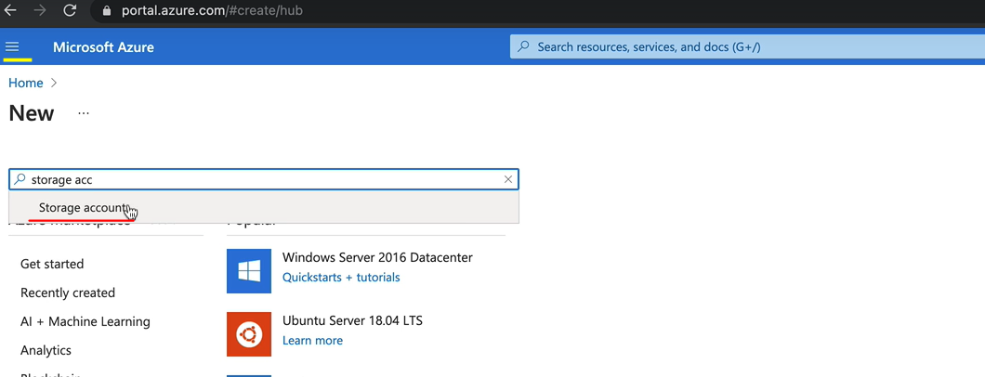

And click create here. And from the research group Pictou Research Group that we created, we called it Database Coast Oggi.

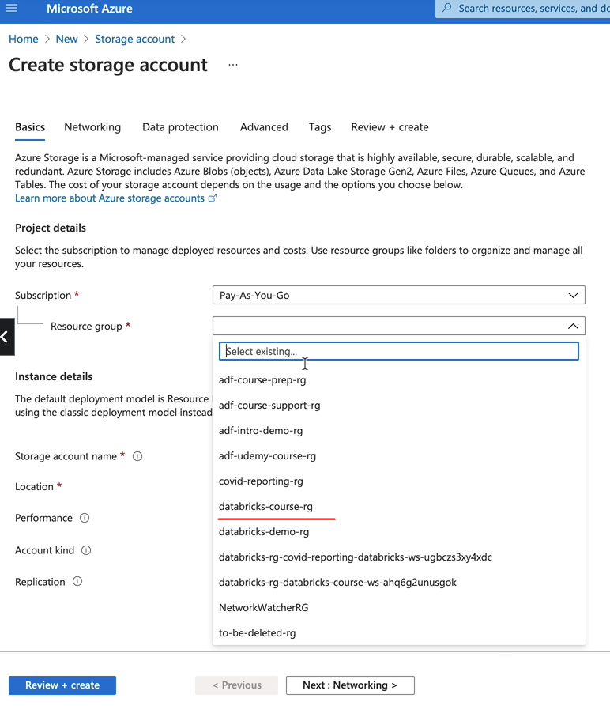

And then from there, we need to give the Stroage account a name, I'm going to call this one as formula1dl, because it's for the Formula One project to be a going to do and they'll transfer like. So you're not likely to be able to get the same Storage Account name because it has to be unique. So you'll have to give a slightly different name. And I'm going to pick the UK South, which is my closest region, and then Standard is good enough for performance. And I'm going to go for this Storage V2 ( general purpose v2 ) kind

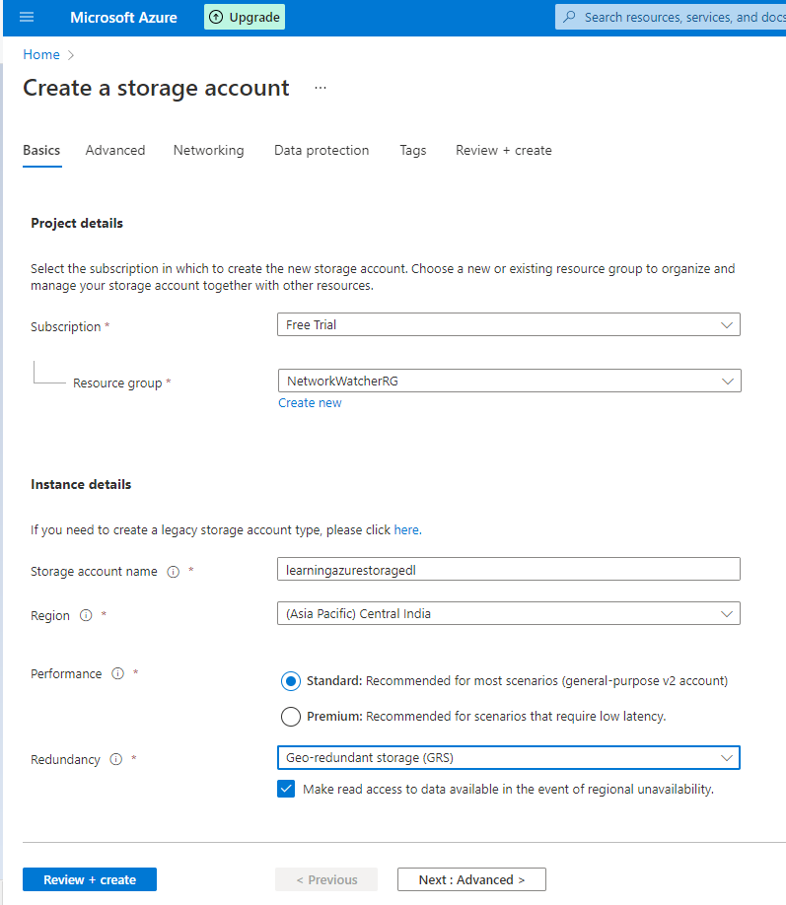

|  |  |
| --- | --- |
|  |  |

For the replication I'm going to go down to locally redundant, It's just for the coast. So we don't need any additional redundancy here and that we can save some money by going for the locally redundant storage. So click next to networking. We can accept the defaults here next for the data protection, again, accept the defaults there and in the advanced in order to get a data storage. And two, we need to enable the namespace. So let's click on Enabled and then click through to tags and then review. Plus create. So it does serve you validations and the validations passed and everything we're seeing here is what we expected to see. So let let's create and it takes a couple of minutes to deploy the service.

|  |  |
| --- | --- |
|  |  |

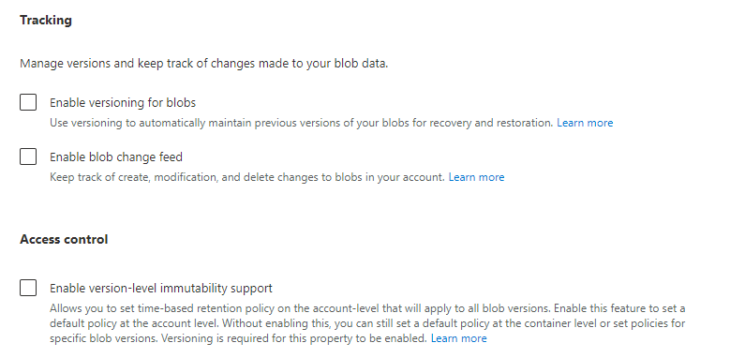

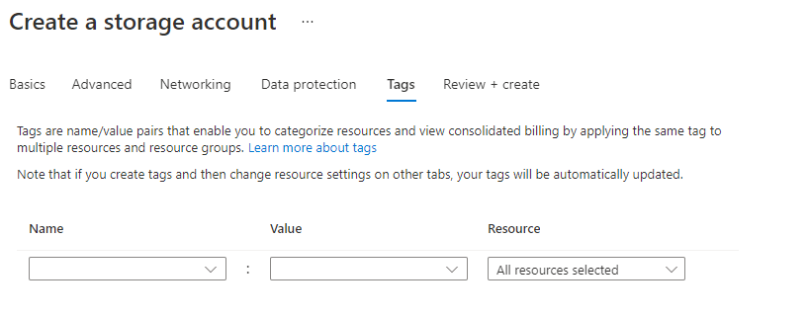

|  |  |
| --- | --- |
|  |  |

OK, so the deployments now complete, take about a minute and let's click on Go to the source and this is your Storage Account main screen. So from here, you can give access control. You can you can you can look at the access key. So I've got the key one of the key to and you can rotate the access keys as well. And also you can create new containers, for example, so you can go to containers and then click create a new container.

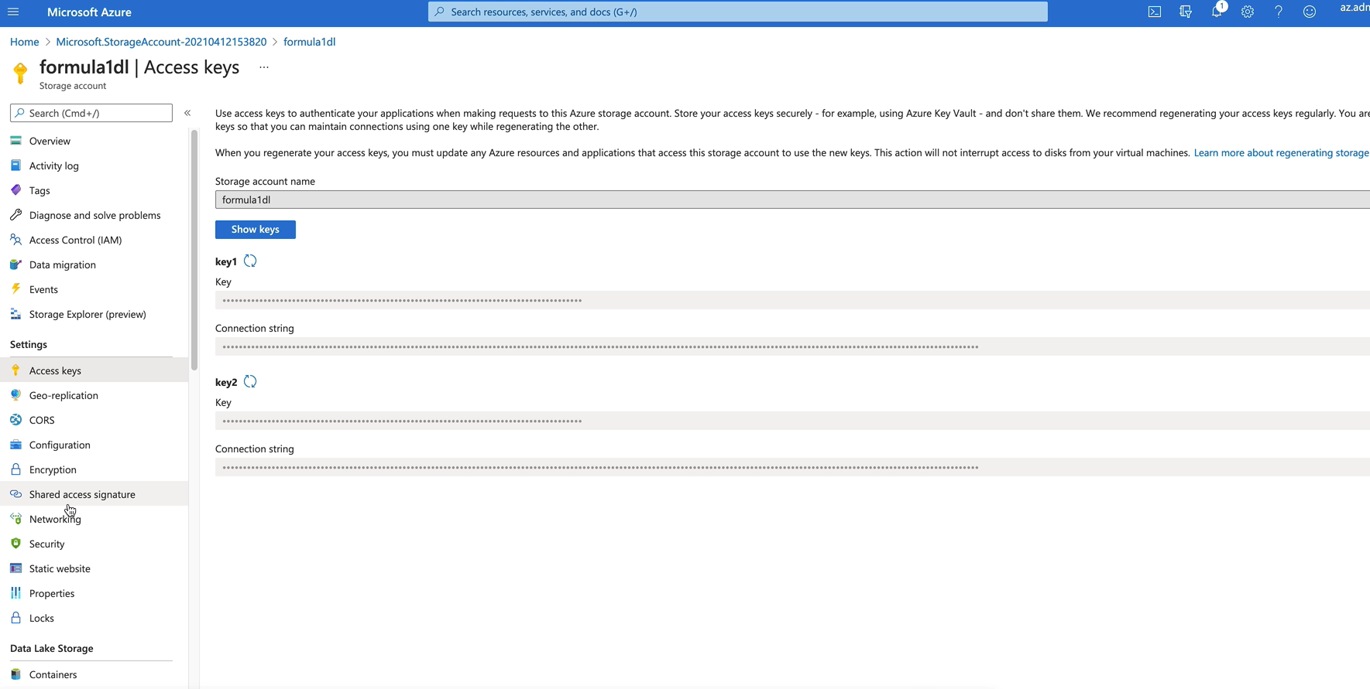

But one thing I would recommend is to download the storage explorer. It is available on both Windows as well as Mac in order to download the storage explorer. Either you can go to Google and search for Azure storage explorer and download that, or you can come to the web of your tab here. And then if you click on Open an Explorer, this link here you can download as you storage explorer, if you have not got it yet, will take you to a page where you can download it from.

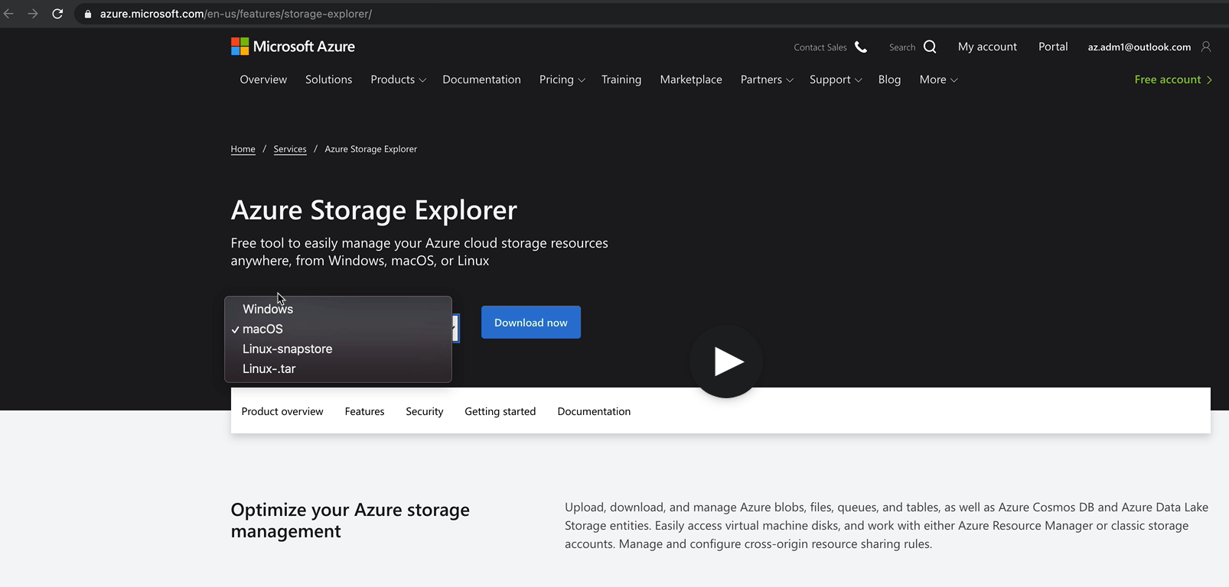

You can have it for Windows or Linux as well. So I would strongly recommend it to download it because it's very easy to work with the storage explorer then working on the portal UI here. So let me show you my storage explorer. So this is the storage explorer, you will come here when you open it first time, so you've got a few taps here, click on the little man here and that will give you the option to add an account.

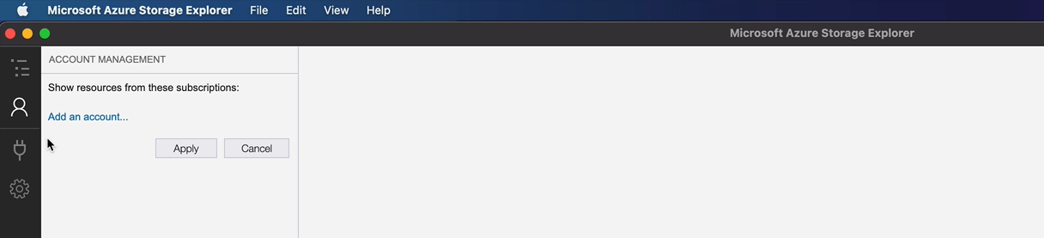

So if I just click add account and then select as your account and then click next. And just log in using your Microsoft has your credentials here. OK, here you click on Apply. So that means it will show you everything you've got available within that subscription. So that is my subscription on that account. And as you can see, I've got a number of storage accounts, but the one we just created is the Formula One here.

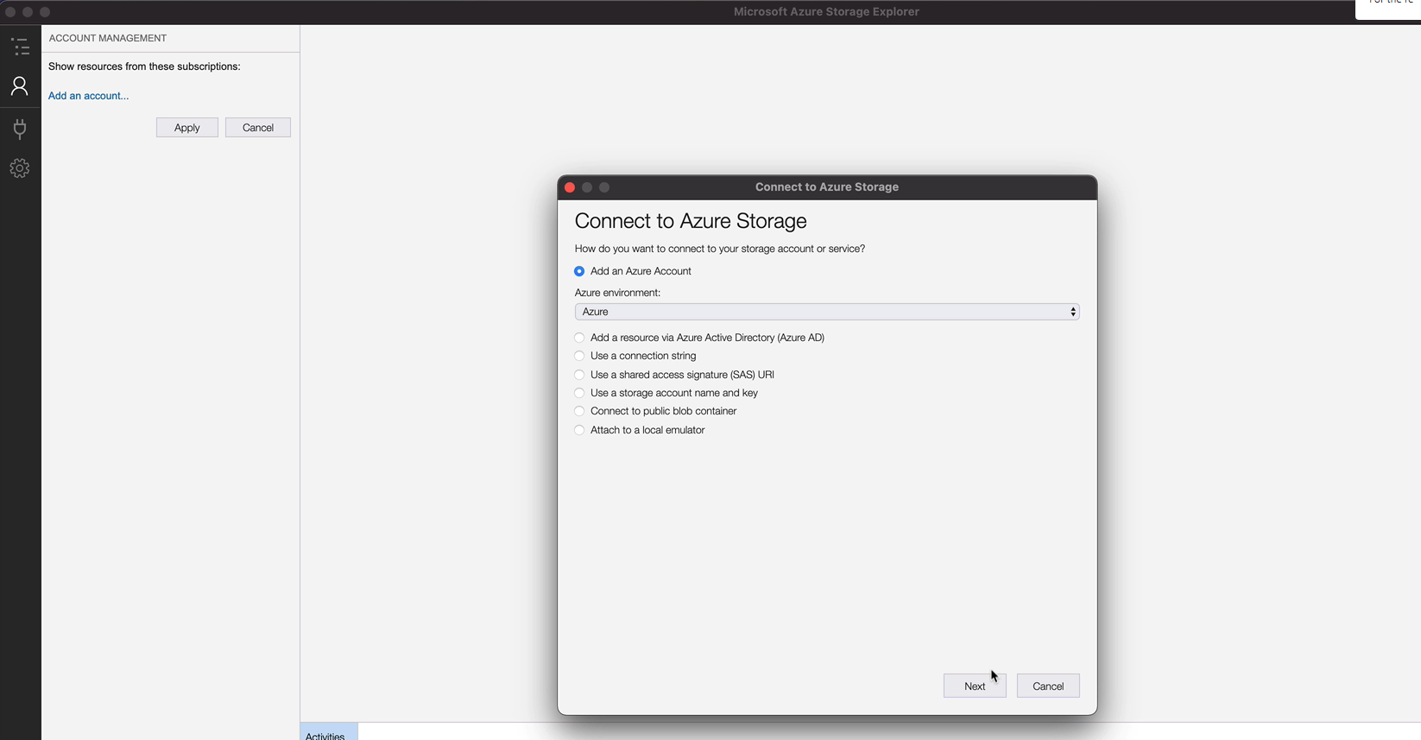

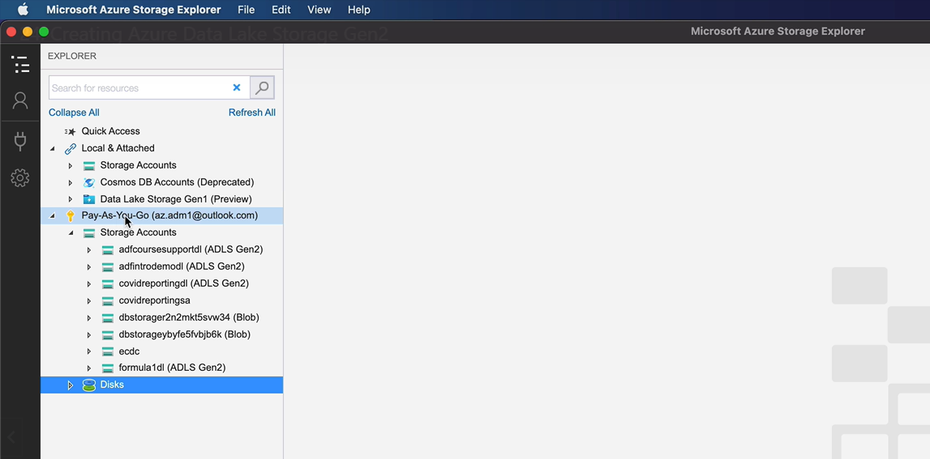

And this gives you a nice window to explore a kind of interface for you to navigate and work with the storage account. So in order to create a container, you can just right. Click here and then create a block container. I'm going to call my first one as well. And we can create another one, let's call that one as processed. So the idea is that actually RAW would have the raw files we are going to use, which is our inputs for the process. And then once we process them, actually we are going to put it under processed.

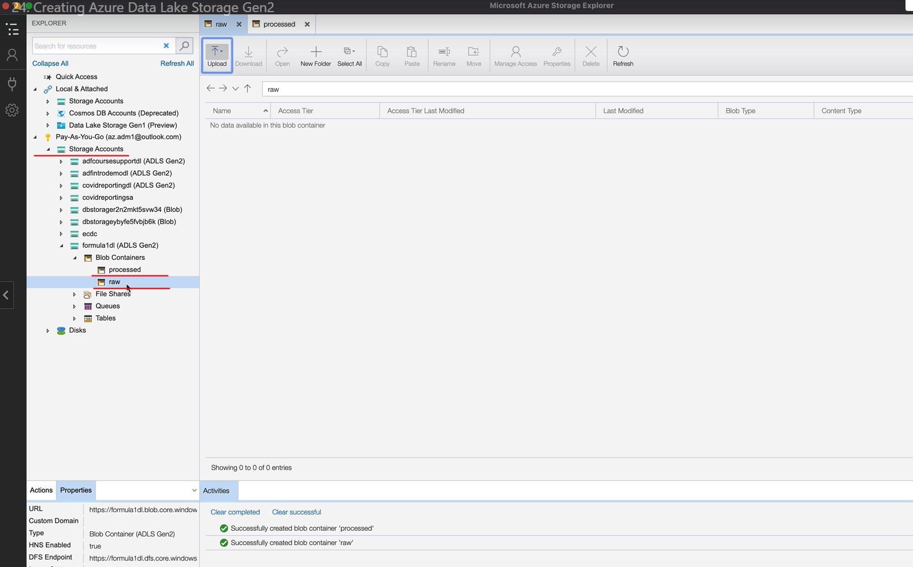

If we needed additional ones along the way, we create them as well. So let's now go back to the idea of Portal and let's pin this storage account to our dashboard, because we did that with the data service as well. So let's do that. So we want to pin it to the data dashboard.

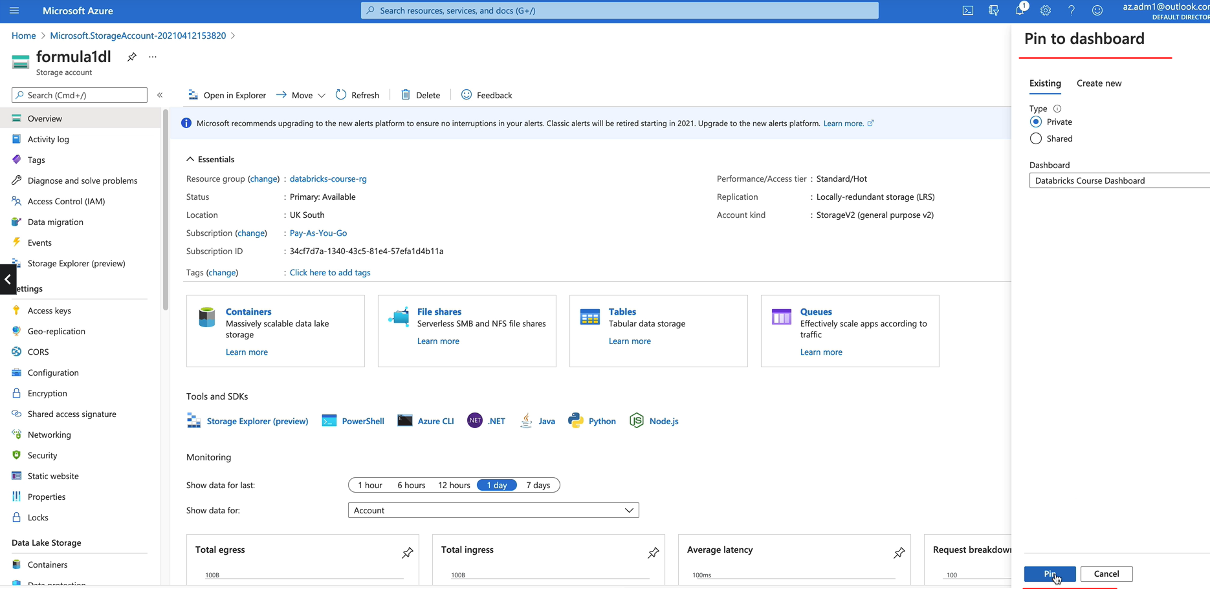

For those of you who are new to Azure, pinning to the dashboard will help you group every service you've got for this project under one dashboard, and it'll be easier to find it when you need them. So I'll show you how to go to the dashboard. You come to the top left panel and then you can click on Dashboard here. It will show you all the dashboard. So this is from one of my other projects.

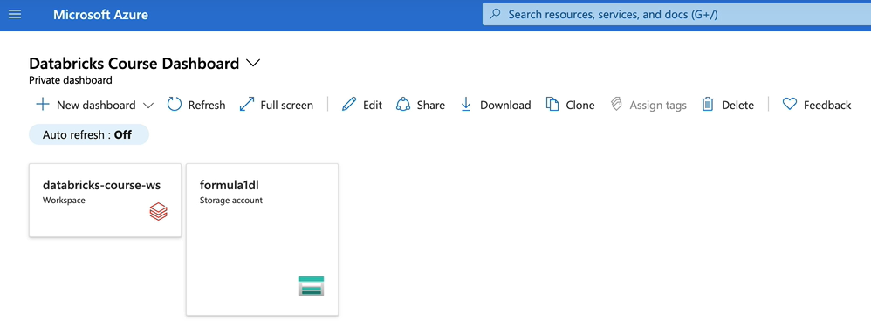

But if you want to look at the darabricks course dashboard, you click on the dropdown and then we got the two services. So the idea is we will keep everything together here so that it's easier to navigate. So in order to go to the Formula One vehicle storage account, I'll click on that. That will take me to the storage account.

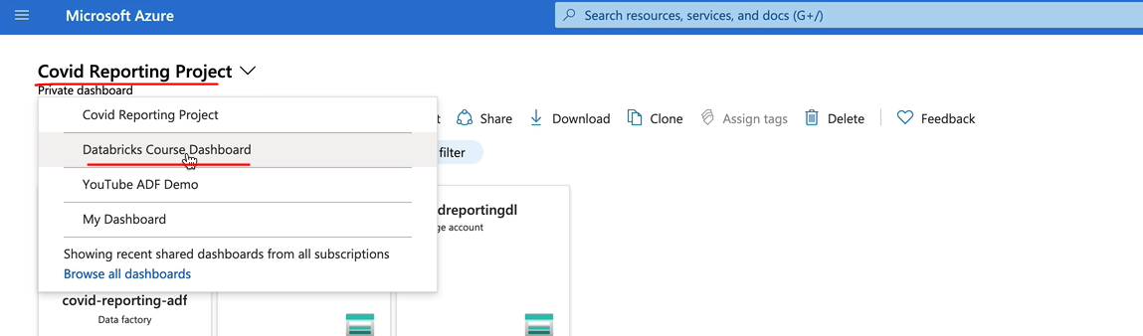

### Creating Azure Service Principal

We are going to create a Azure Service Principal and as you say, responsible and give that access to our storage account. So if you're not familiar with service principles, you can consider that as a service account for which we normally give access to the services we want to use, and our applications can access the resources via the service principle. So let's switch over to the Azure portal and get started. In order to create the Service Principle, you come to the top left and then click on Azure Active Directory and click on app registrations here and now click on new registration and let's give it a name.

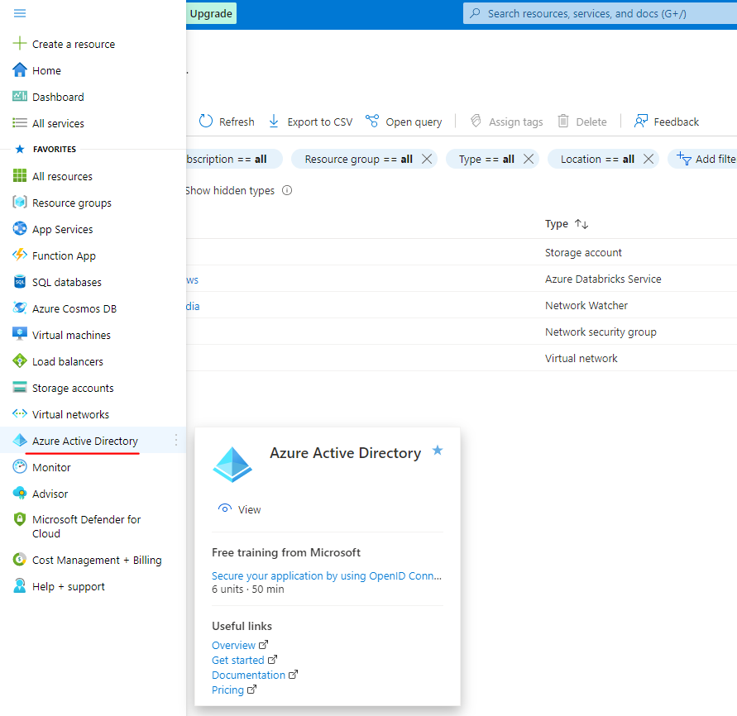

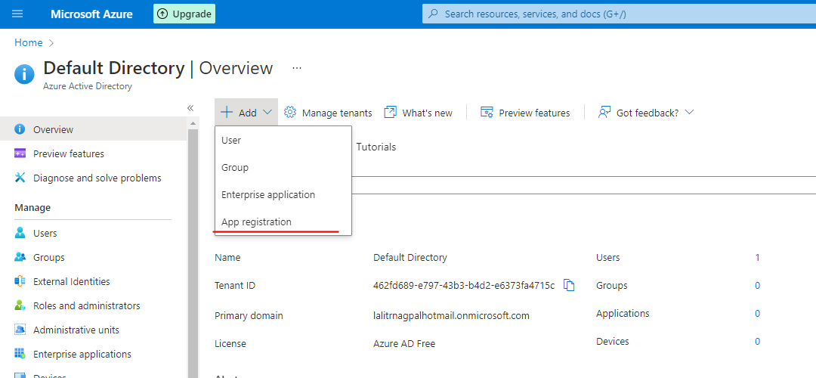

I'm going to call this one as data database service type and now click on Register to register the application.

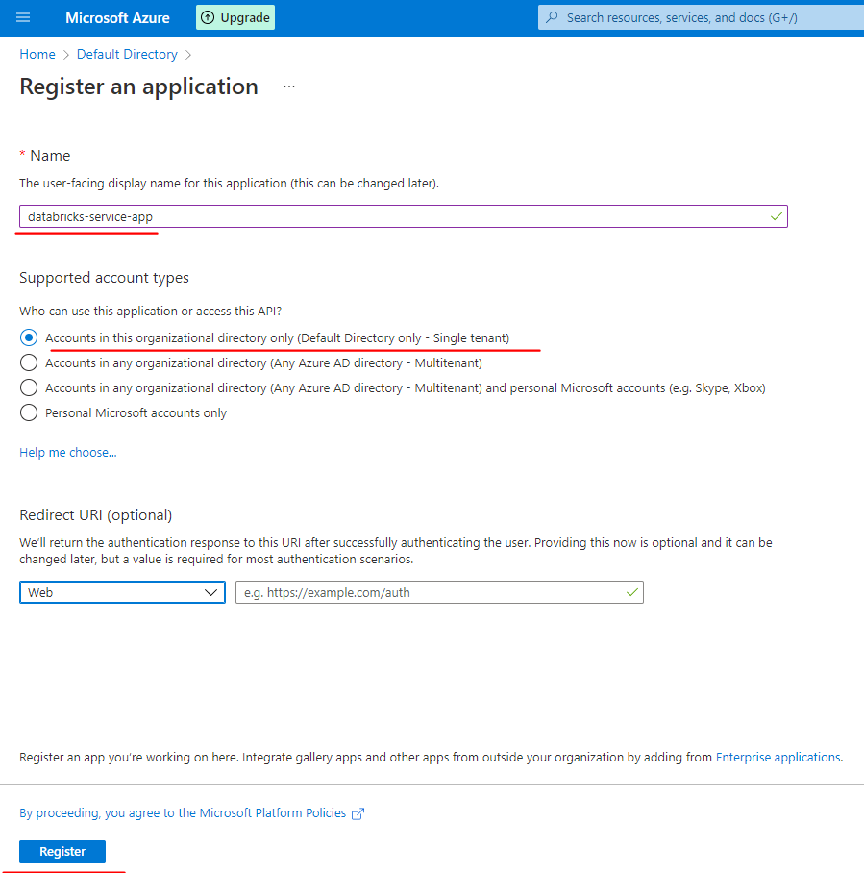

But the apps now registered. But we need to copy some of the information which we will need when we come to the storage account in database. So we need the application of the client ID and the directory of the tenant. So I'm going to just copy that and put it in a notepad so I can use it later.

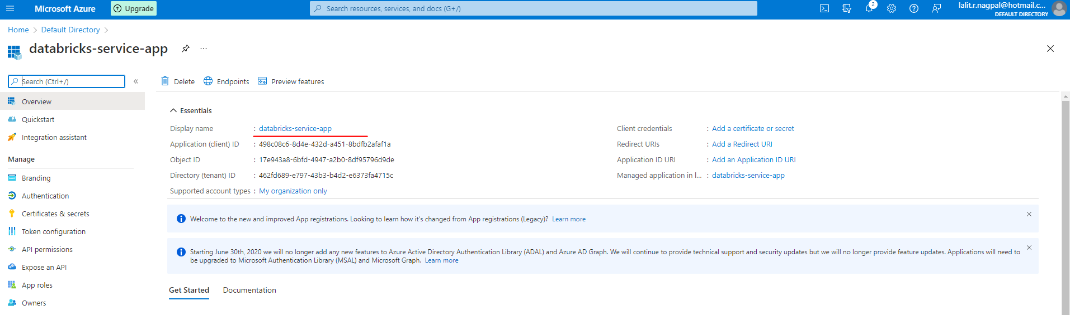

And also, one more thing we need to do is to create a secret. So in order to create a secret, you come here to certificates and secrets and then click on New Client Secret. And I'm going to call this one as databricksaccesssecret.

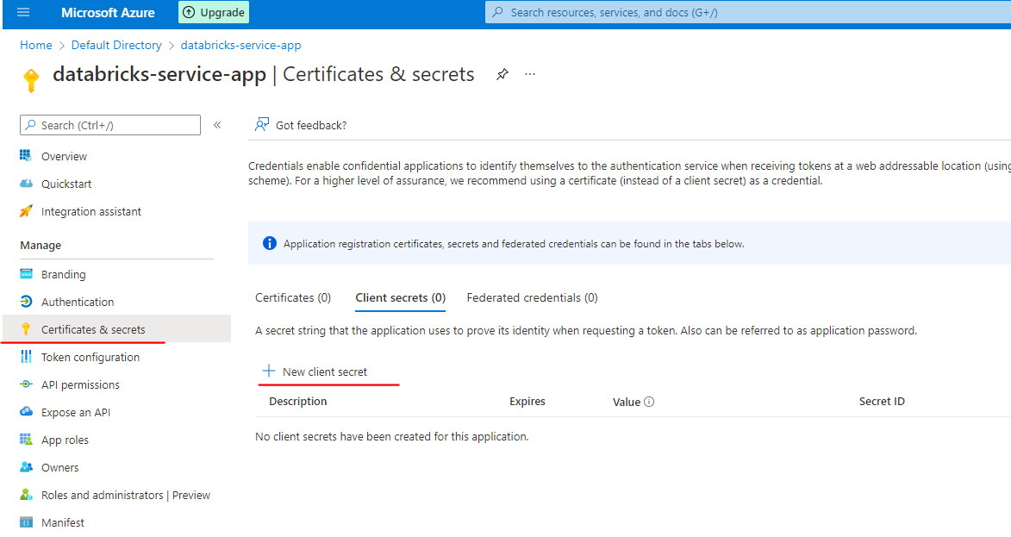

You can choose how long it stays before expiring. I'm going to go for just three months and click add.

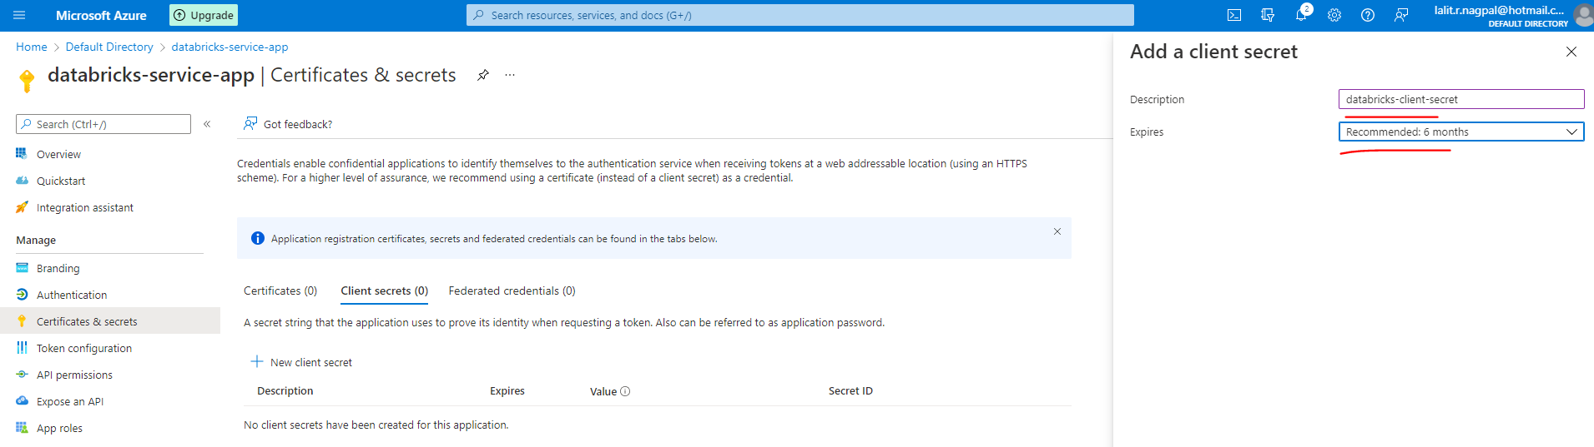

So now the secret has been created as well. Now, this is very important because once you come out of the screen, you won't be able to get the secret value. So copy the secret value and keep it in a notepad as well. We'll be using that later on.

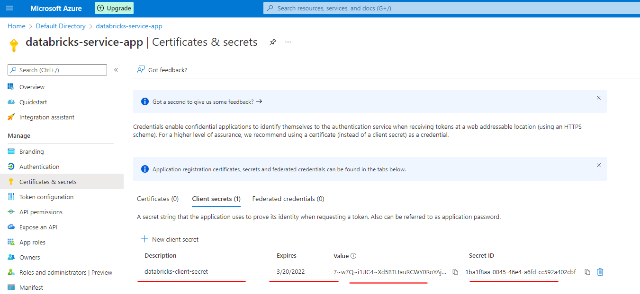

But keep that in a notepad so you can use that when you need it. So the one last thing we want to do is we want to give access to the storage account for this, service principle that we've created. So in order to do that, let's go to our dashboard and let's click on the Formula One Storage Account and come to an which is access control. And we need to add a new role assignment from here, select the role storage block data contributor that should be sufficient for the service principle and we can search for the service principle here.

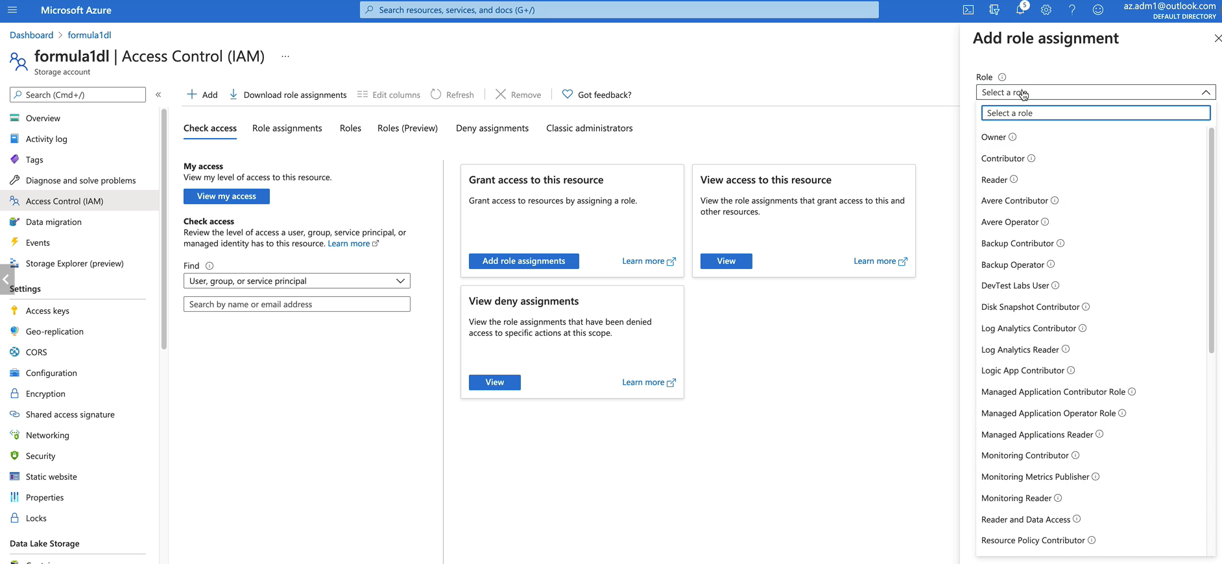

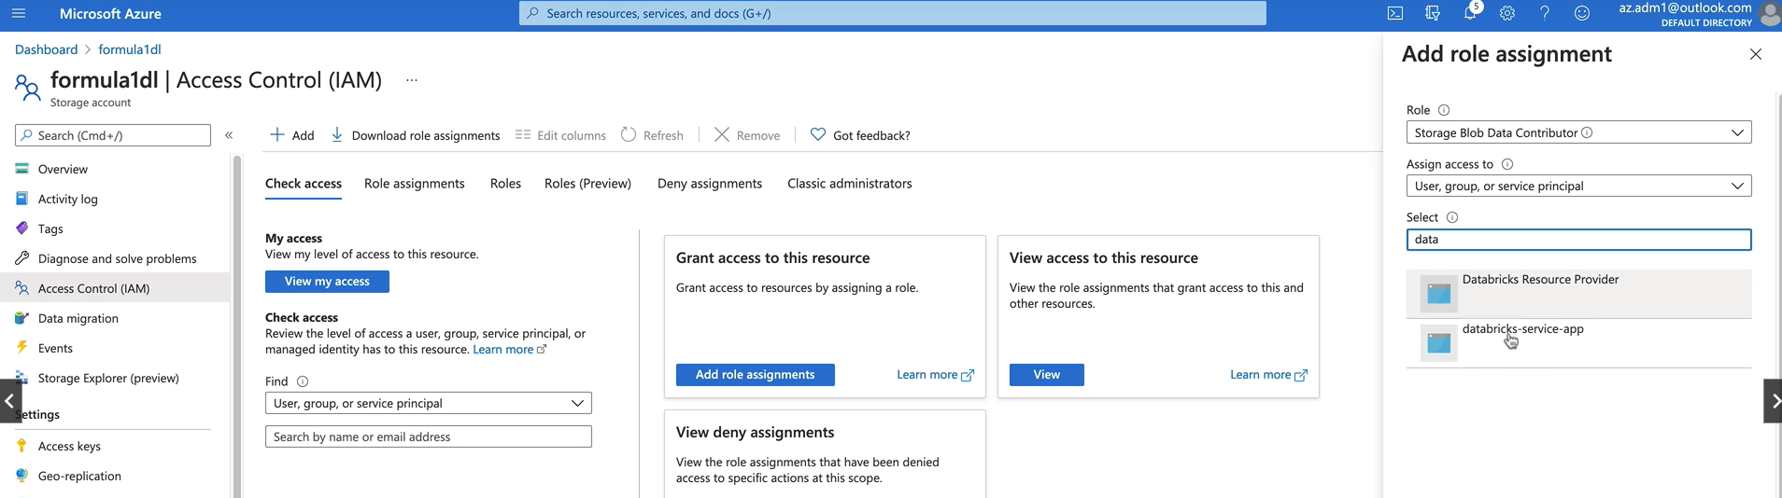

So the one we created this data breaks service app. So let's click on that one and click save. So what that means is now the app has got storage data contribute to roll on the storage account. So what that means is that the service principle that we've created now has access to the storage account and the role we've assigned is the storage data contributor. So it'll be able to create and delete resources within the storage account. So that's what we wanted.

### Mounting Azure Data Lake Storage – Gen 2

Now that we created our storage account and the service principal and also we've given access for the storage account to the service principal, we are ready to mount the storage accounting database. So let's get started. OK, let's ensure that the cluster is up and running for me, it's running.

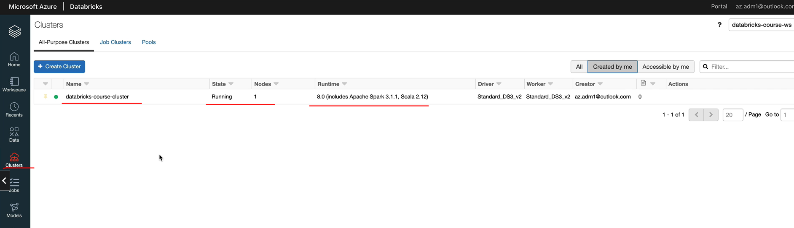

If you have your cluster terminated, please go in and restart your cluster and we want to go to the workspace. We finish playing around with the databricks, Notebooks.

**Created the pool again**

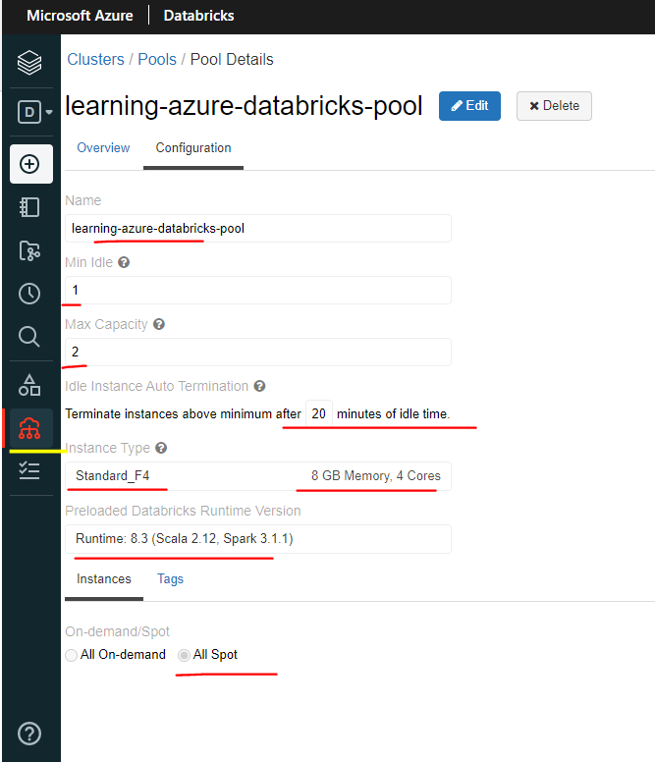

**Created the Cluster using the Pool**

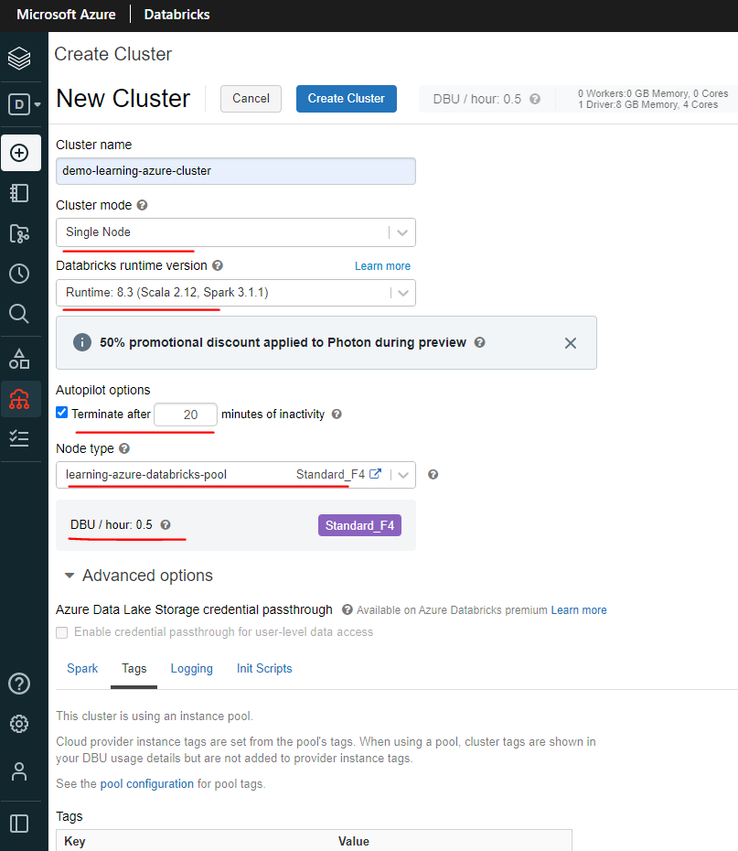

So let's create a folder for a project now. So I'm going to create a project here and I'm going to call this one as a Formula One. Within this folder, I'm going to create another folder. I'm going to call this one a set up and keep all the setup related notebooks in here.

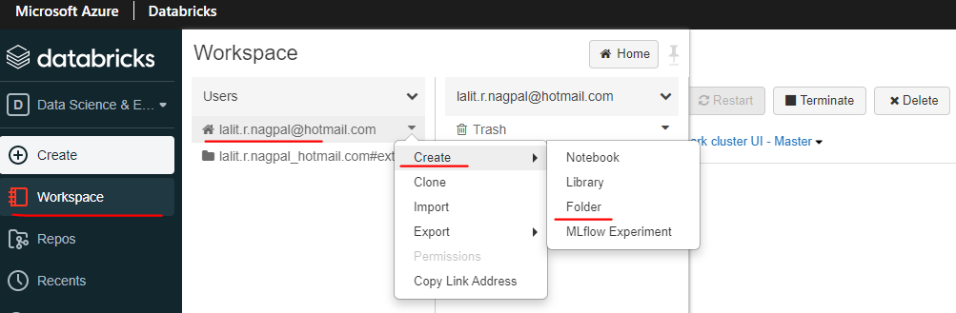

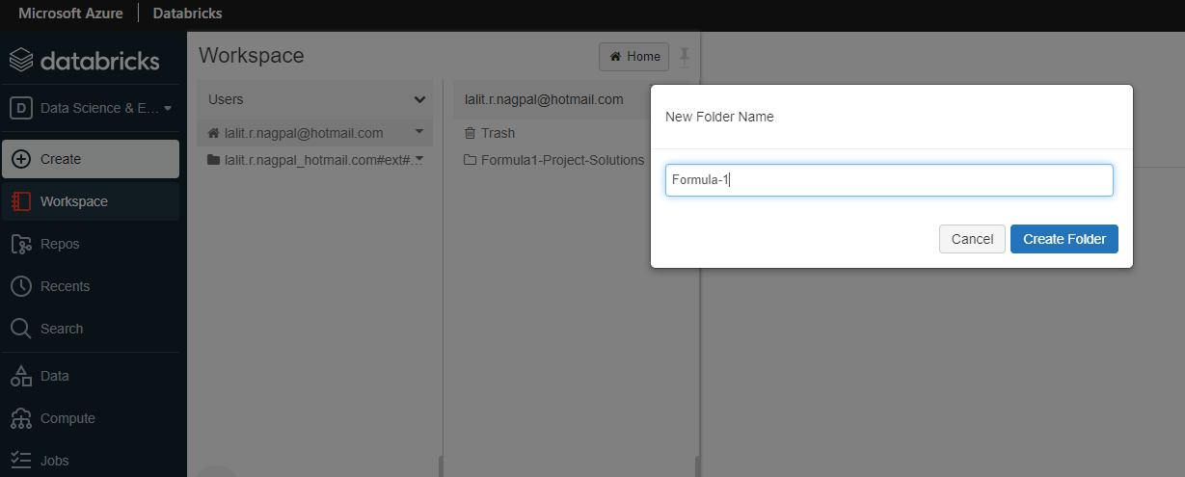

So for the first one, what are you going to call this? A small setup storage? That's what we do. Let's do that quickly.

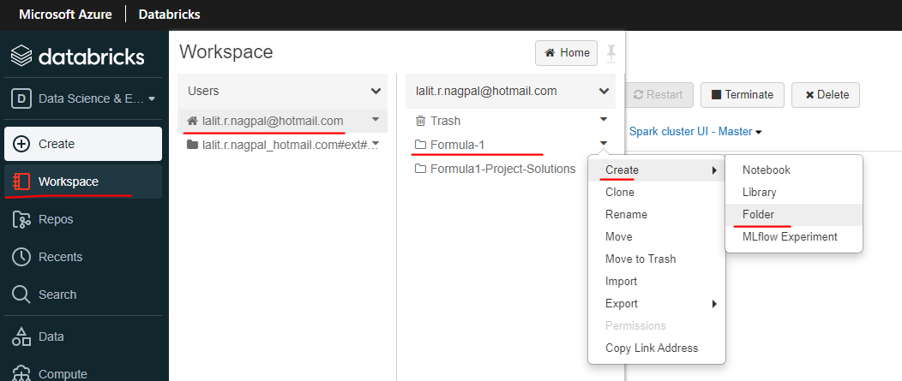

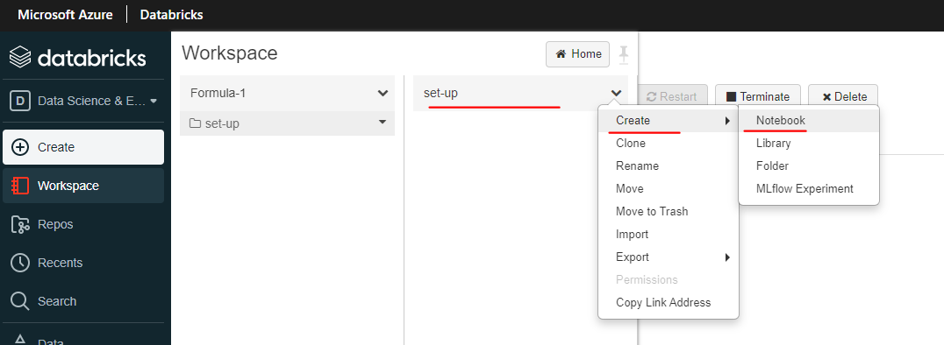

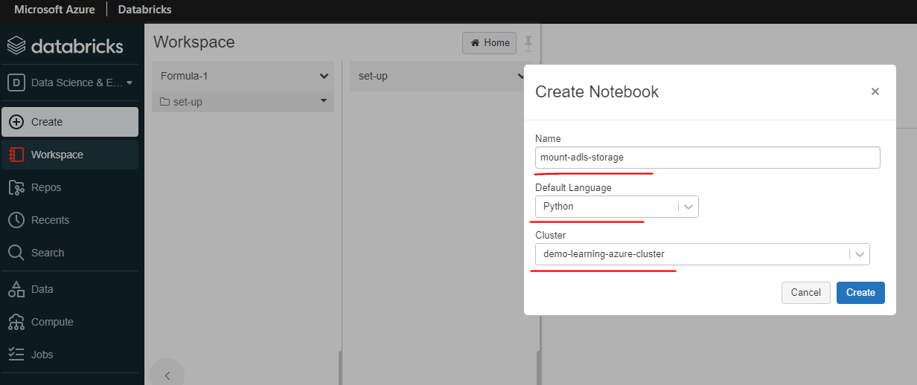

So the first thing we want to do is set up all the variables. Let's start with the storage account name. In my case, I call this one as Formula One. Then if you have a different name, please use your name. And we need the client id, tenant id and the secret in the last lesson be copied, all of them to a text pad.

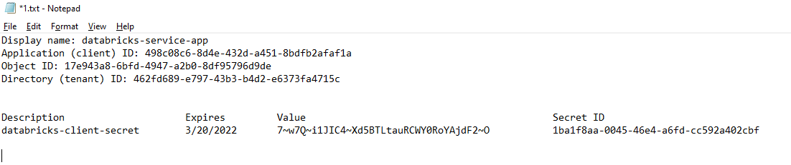

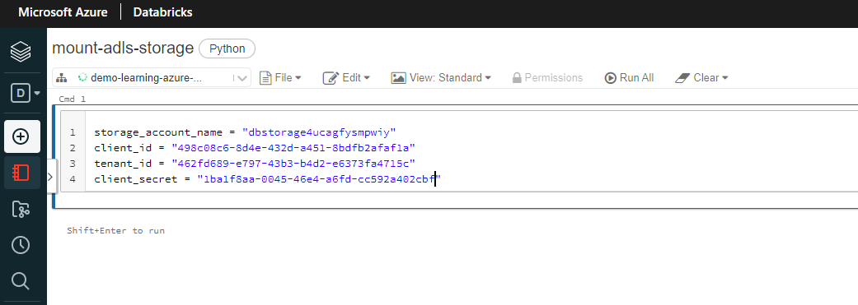

storage_account_name = "dbstorage4ucagfysmpwiy"

client_id = "498c08c6-8d4e-432d-a451-8bdfb2afaf1a"

tenant_id = "462fd689-e797-43b3-b4d2-e6373fa4715c"

client_secret = "1ba1f8aa-0045-46e4-a6fd-cc592a402cbf"

configs = {"fs.azure.account.auth.type": "OAuth",

"fs.azure.account.oauth.provider.type": "org.apache.hadoop.fs.azurebfs.oauth2.ClientCredsTokenProvider",

"fs.azure.account.oauth2.client.id": f"{client_id}",

"fs.azure.account.oauth2.client.secret": f"{client_secret}",

"fs.azure.account.oauth2.client.endpoint": f"https://login.microsoftonline.com/{tenant_id}/oauth2/token"}

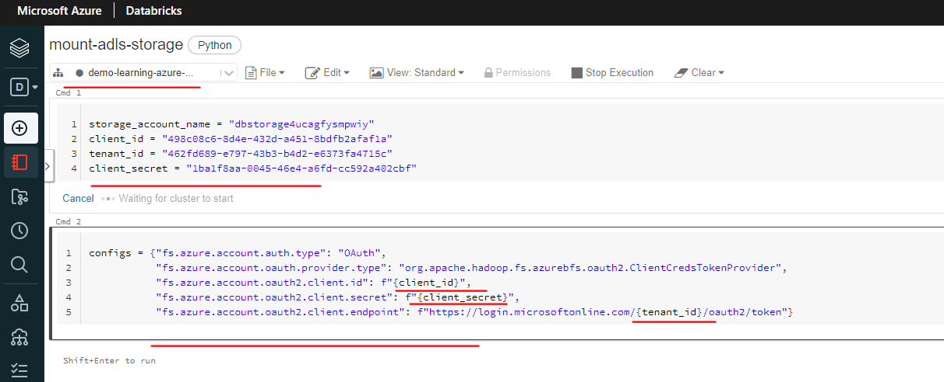

So I'm going to call I'm going to copy and paste it here, make sure actually you've got no spaces around this. And the next thing is we need to set up some config parameters. So I'm going to create another cell for that. And here we take in the client ID. As you can see, we've set the client ID here. We take in the client ID for a lot. And also we get the client secret here. And then in order to create the endpoint, we need the tenanted here. So we use the client identity and the secret, as you can see here, and let's execute this. So that's done on the second one is done as well. And the next thing is we want to mount storage. So in order to mount, you need to use the DB utils, uh, f”abfss mount. And here, as you can see, fabss the storage account name from here. But we want to mount our raw container first and then we got the processed container. So I have hardcoded the raw container name here. But if you want to use a variable, you can use a variable. So let me do that container name and I'm going to call this one Raw, the first one, and then you can use the container name here. So let me copy and paste it here. And also I can do that here. So if you did it this way, you don't need to have another statement to execute your process container. So let's execute this.

container_name = "raw"

dbutils.fs.mount(

source = f"abfss://{container_name}@{storage_account_name}.dfs.core.windows.net/",

mount_point = f"/mnt/{storage_account_name}/{container_name}",

extra_configs = configs)

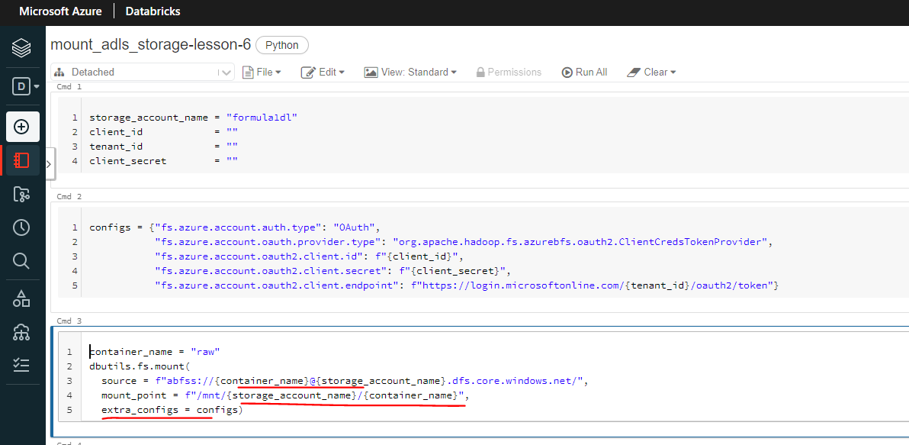

So it should create the raw container. Sorry, the mount point for the Raw container. OK, so the come out to Mount a Storage has now succeeded, if it returns it through, that means it succeeded. But we can do a couple of other things to make sure that actually it's definitely OK. So the first thing you can do is you can use the dbutils dot fs dot ls command to list the files in our mount.

dbutils.fs.ls("/mnt/formula1dl/raw")

So that'll be /mnt/forula1dl/raw. As you can see here, it'll be the Storage Account name. So let's use Formula One dl, in my case and then raw. So let's list that there won't be any files, but it's just returned empty string here. But if it, if it gave you an error, that means it hasn't succeeded. The other thing you can do is you can again use the dbutils.fs.mount to list all the mounds in our workspace, so that should be mnt. Yes, it should list all the mounts in our workspace. As you can see, we got the default, the root ones, which are the database datasets and email flow and results and everything. But we can see our own point here.

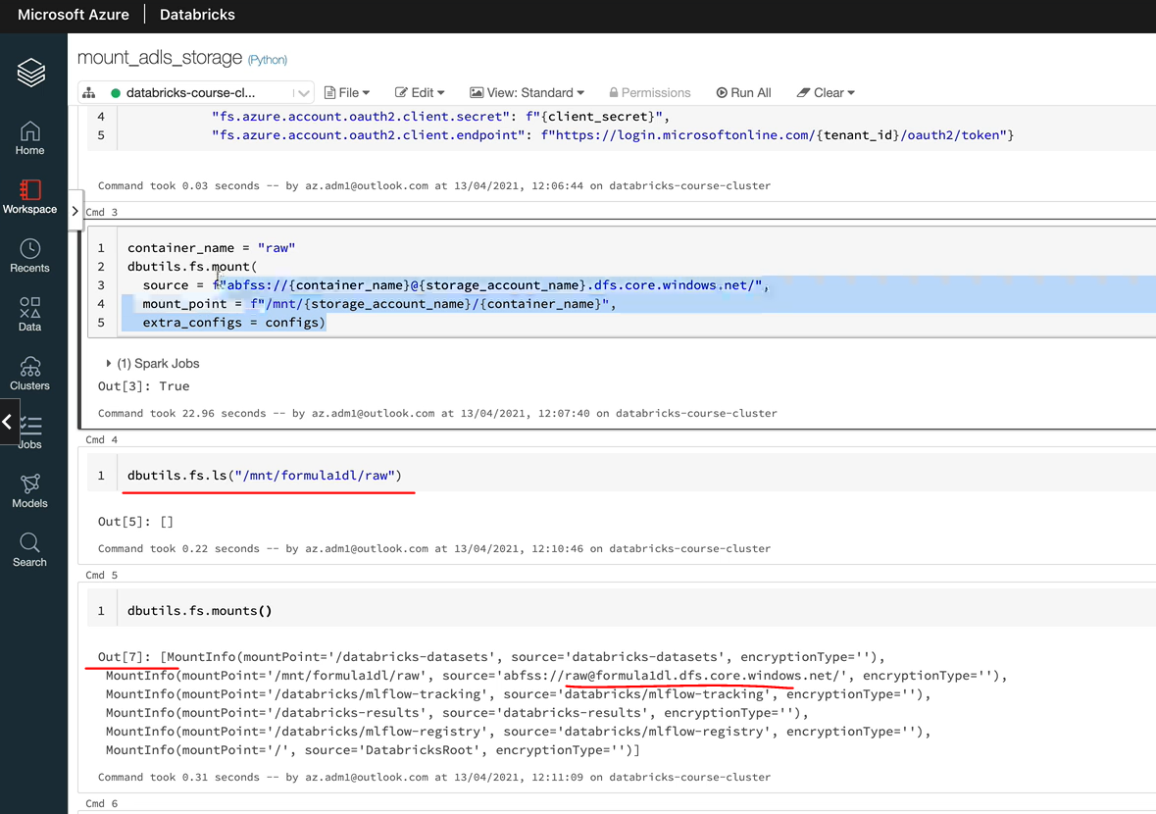

And as you can see, its been mounted on the storage account with a container and the storage account name is Formula One DL. So everything looks OK to us. So let's do the next one, which is the processed container as well. So I'm going to just change the container name to processed. In a real project, you would be creating a function for this and then passing the container as the parameter so we could do that. So let's let's do that. I'm going to create a function. And I'm going to pass in the parameters the container name, so let's copy those and then I'm going to create the function.

def mount_adls(container_name):

dbutils.fs.mount(

source = f"abfss://{container_name}@{storage_account_name}.dfs.core.windows.net/",

mount_point = f"/mnt/{storage_account_name}/{container_name}",

extra_configs = configs)

mount_adls("processed")

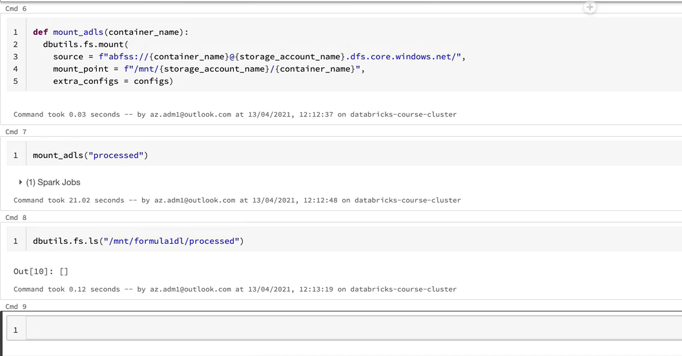

So that is our next container we want to mount and this should now mount the process to contain as well. OK, so that succeeded. Let's do exactly what we did for the other container, just to make sure that everything is OK, so the process should give me an empty string. So that's OK. And also, let's list all the mounts. If I to execute that one, it should list the new mount that we've created, which is the flat, empty Formula One / processed. So we've successfully mounted both of the containers we wanted to mount. But there is one issue with this, which is this we got the credentials exposed in clear text, which is not good. So accidentally somebody could get all of it. For example, you might check it into Git repo. And if you open up the permissions on the file, somebody else can read your files and that will be exposed as well. So we don't want to have any credentials exposed in clear text in production project. So what we are going to do is we've got something called a secret within data and also we can use as key vault to keep our secret. So that's what we'll be looking at the next.

### Secret Scopes Overview

Let's understand what a Secret Scope is. So secret Scope in Databricks is basically a collection of secrets identified by a name. Secret Scope helps store the credential securely and reference them in notebooks as well as in jobs when required. There are two types of secret scopes in your database. The first one is the databricks backed secret scope. In this case, a secret scope is backed by an encrypted databricks database, owned and managed by database. We can create and alter the encrypted database using the Databricks CLI are the API. It cannot be done via the graphical user interface.

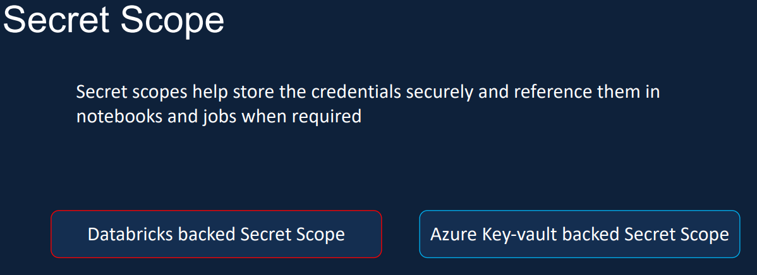

The other type of secret scope is the Azure key vault backed secret scope. In this case, the secrets are created and managed in Azure world. This is a recommended approach when using data because. This is mainly because by keeping the secrets in Azure Key Vault, the secrets can be shared amongst the other Azure services. And Key Vault can be the one place where we keep all our secrets and maintain them. So we'll be using Azure Key Vault backed secret scope for our project.

|  |  |
| --- | --- |
|  | So let's see how that works, we need to create an Azure KeyVault and then add the secrets to the Key Vault. We then need to create the Databricks secret scope and link it to the Azure Key Vault. Now that the secret scope is linked to the Key Vault, we will be able to use the notebooks or jobs to get the secrets using the secret database utility called dbutils.secrets. I hope you got a better understanding of secret scopes now, so let's see them in action in the next lesson. |

### Creating Secret Scope and Secrets in Key Vault

OK, here we are in the Azure Portal, let's clear the Key Vault first. So in order to create the Key Vault, click on the create resource and then look for Key Vault and click create here and we need to choose a resource group. I'm going to go for the same one we've used before, which is the database course rg and we need a name for a Key Vault. So I'm going to call this one this Formula One Key Vault. And we need a region I'm going to pick the UK South because that is my closest region and pricing to your standard is good enough for us.

|  |  |
| --- | --- |
|  |  |

Access policies so we can add new access policies. If you had other team members, you can add them here via the ad access policy. But as a creator, you get the permissions you need. So we should be OK for the cause

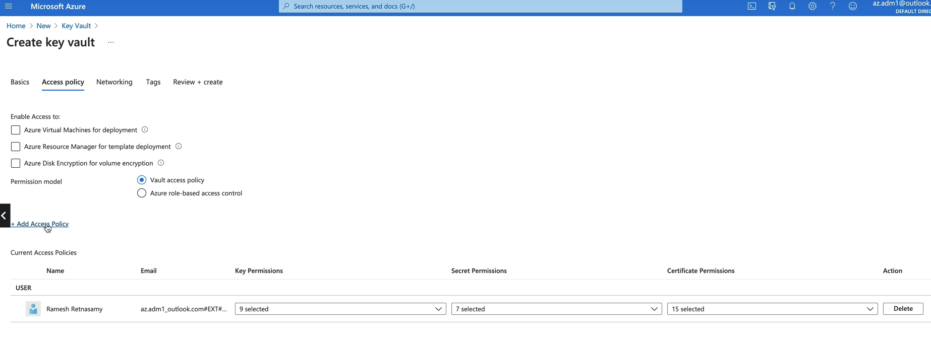

And click through to networking. If you wanted to restrict access to the public end points, then you can do that. And let's click on tags and review plus create.

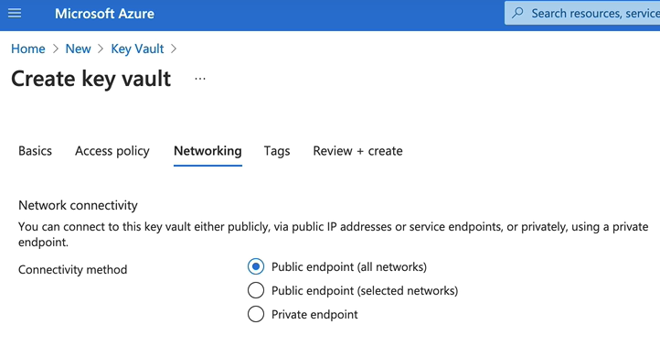

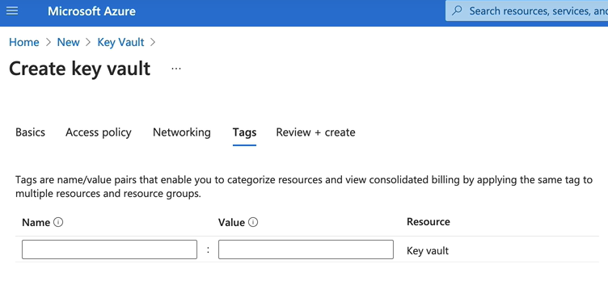

OK, the validation is now past, let's click create to create the resource. It'll take about a couple of minutes to deploy the resource. Okay, that's done now, so let's go to resource, and that is a key world

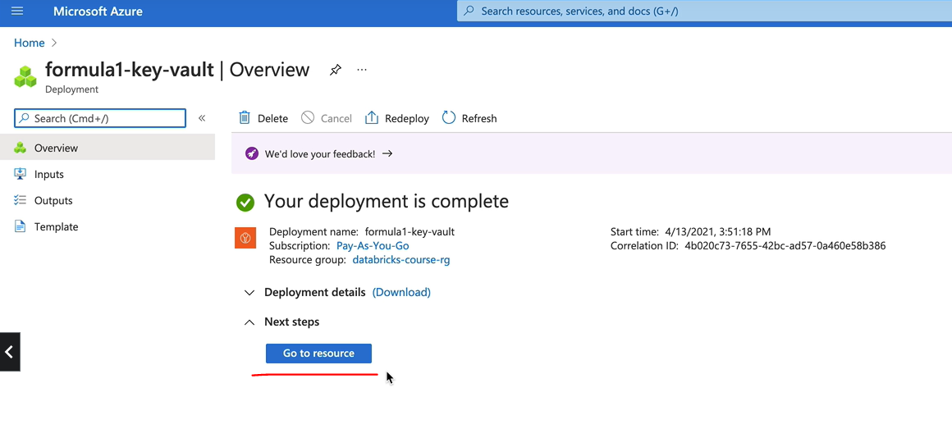

So let's pin the Key Vault first to our dashboard. So that goes to the databricks dashboard. So that's done. Click on pin.

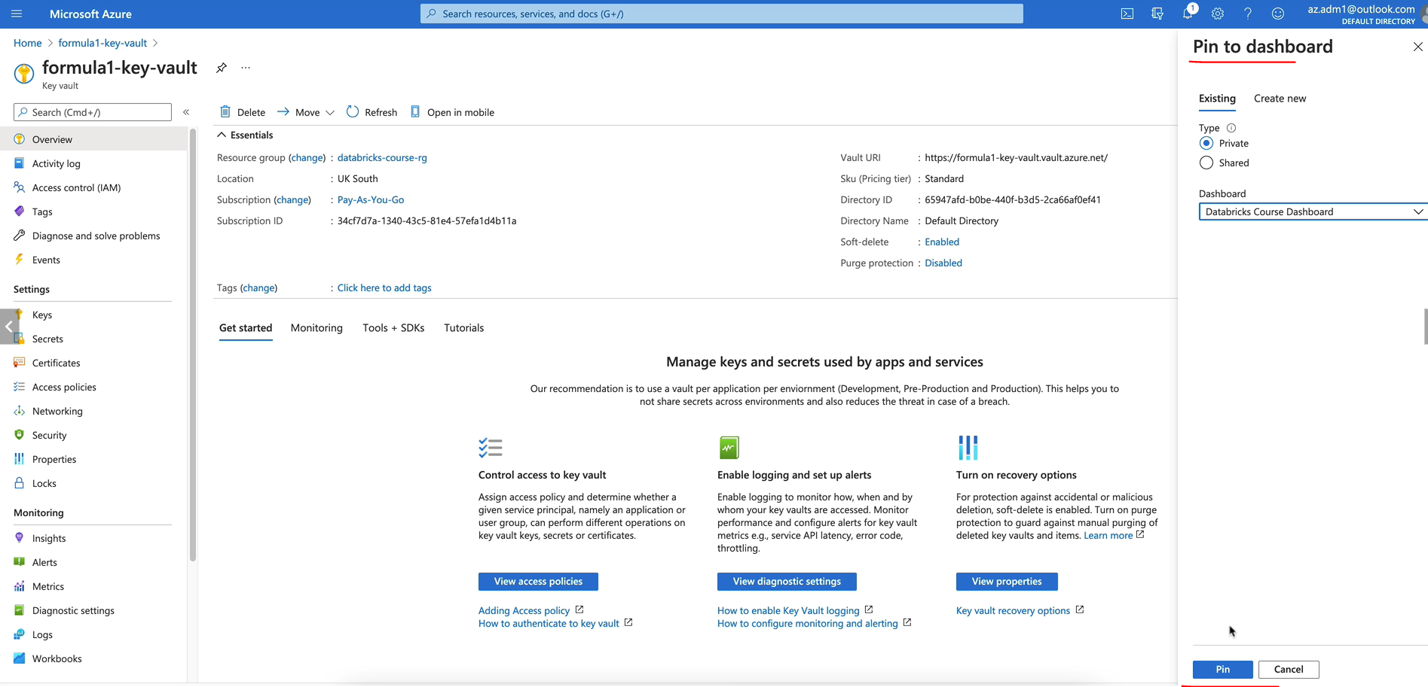

So that's there for us actually when we need it. But we need to now create the secret. So if you come over to here under the settings, the second one is the place where you create the secrets so you can click on generate an import to create a new secret.

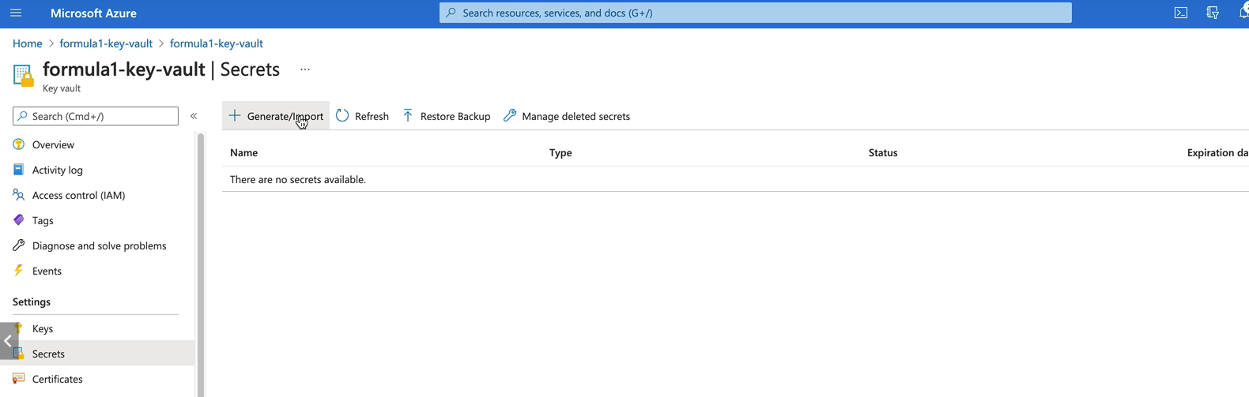

But we're going to create manual secrets. But you can use certificates to upload, uh, secrets as well. So let's go for manual. So we need we need to give a name for our secret. But if we switch back to a notebook, as you can see, we've got three secrets we need to create. So the client id, tenant id and the client secret. So let's do one at a time.

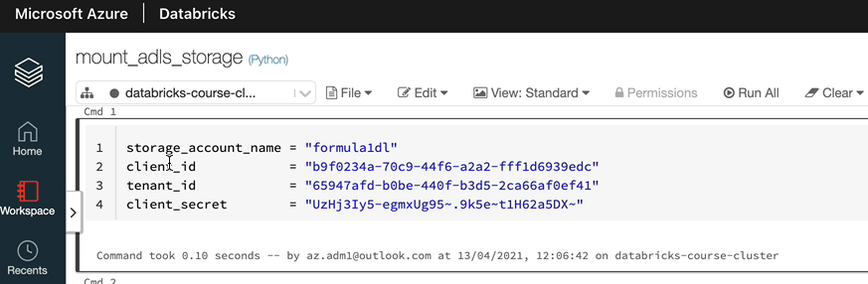

So I'm going to call the first one. Data Bricks App Client Id.

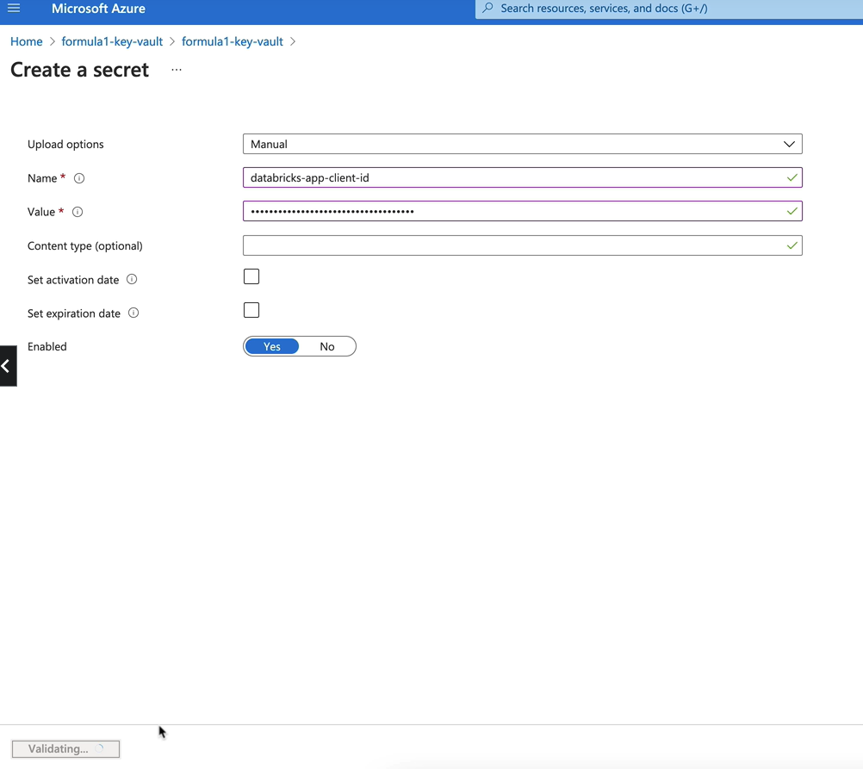

And we need the value for the secret, so let's copy that from here as well. So that would be the string here. And click create, so that should create the first one, so that's done now, so let's create the next one. So we need to name this secret. So let's get the name of the secret from here. So that's the tenanted. So I'm going to call this database app tenanted. So it doesn't except underscore, so I'm going to turn that into a hyphen and then we need the value as well. So that would be this here have. And click create. So we got one more to create, so that would be the client's secret. So let's copy that and click generate an import and then that would be data brings up client secret. And again, I'm going to turn the underscore into hyphen, and I want the value of the secret from here. So let's copy that and I'm going to put it in here. So click create. So now a key vault has been set up with the three secrets we need.

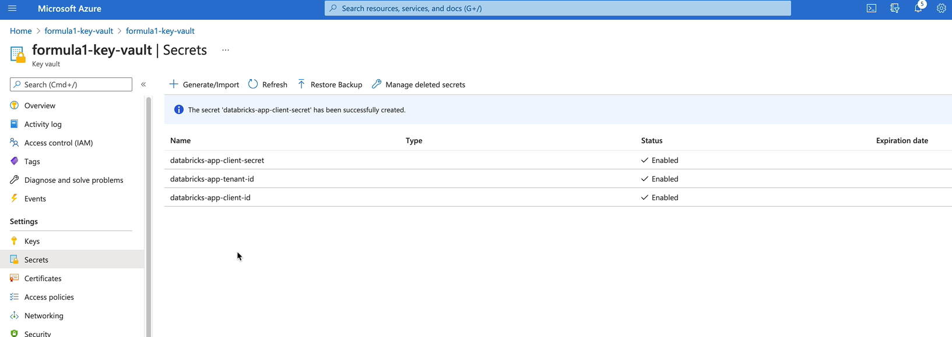

So we need to create the secret scope in the database as our next step. In order to do that, you come to the data database homepage. So we are in the workspace now. So go to the home screen here by clicking on the database logo here.

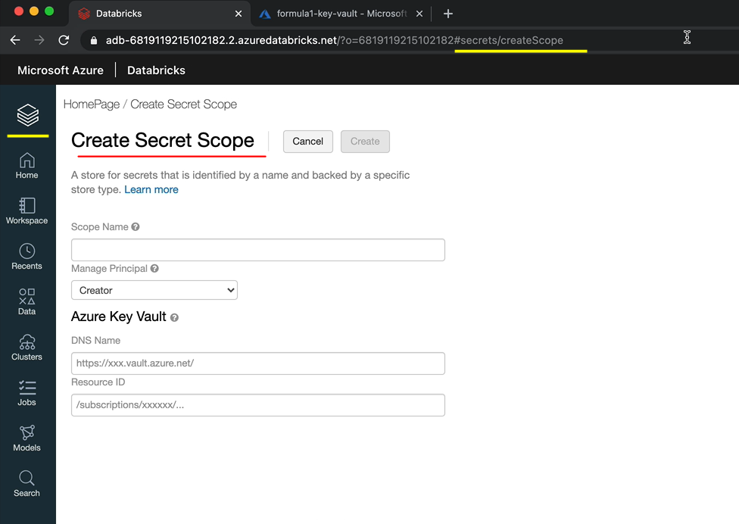

So here by typing #secret/secretScope, you can reveal a hidden UI. Notice the camel case used for the scope, S is capital. So make sure you do that as well. And then when you click create, you will be given with this user interface. So here we want to call the scope name as something, so I'm going to call this a Formula One Scope. And managing principle is created. So that means I've got full access to this, but not all users and we now need to details from the keyboard, which is the DNS name and the resource. So let's switch to the keyboard and go to properties. And here you can see the vault. You are right. So copy that vault. You are right. That is what is called the DNS name here. So paste that one and we want the resource side. So let's click on copy here and then come over to date breaks and then paste that. So that is the resource side and click create.

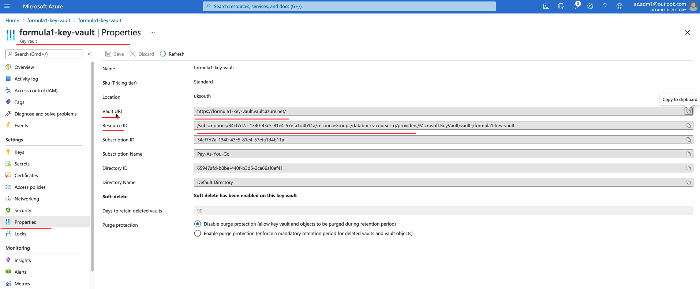

So that should create the Formula One Scope.

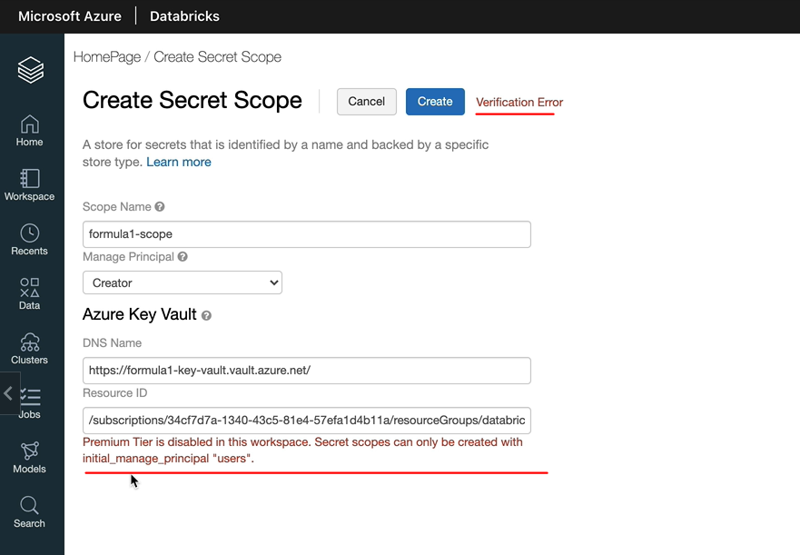

So we got an error here, payment here is disabled in this space. Secret scope's can only be created with the initial manage principle users. So that's because we are on a standard tier database workspace rather than a premium tier so we can manage access for users. So the option is to change the manager principle from creator to all users. So what that means is all users would have access to the secret code, which is OK in development or a demo kind of purpose. But in a production environment, you would want to restrict the access.

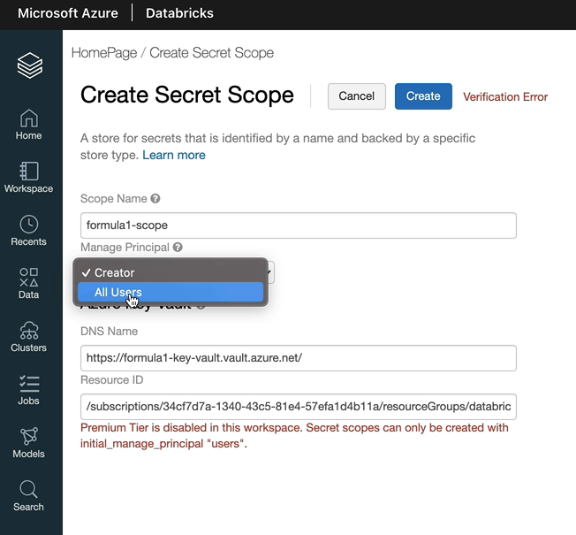

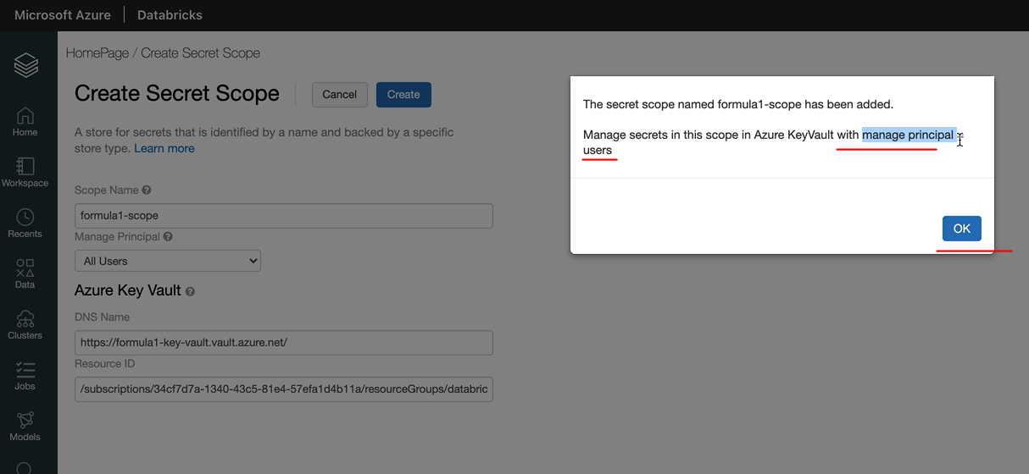

But for us, let's turn it into all users and then we can click create and that should create the secret scope for us. So it's created it now with the managing principal as users. So let's click. OK, so now we've got the key world and the secret scope being set up. We can switch to our notebook and we can make the corresponding changes we need. Let's do that in the next lesson.

### Mounting Data Lake using Secrets

First, I'm going to walk you through the database, Utilities for Secrets, so let's do dbutils.secret.help. And as you can see, we got four methods available

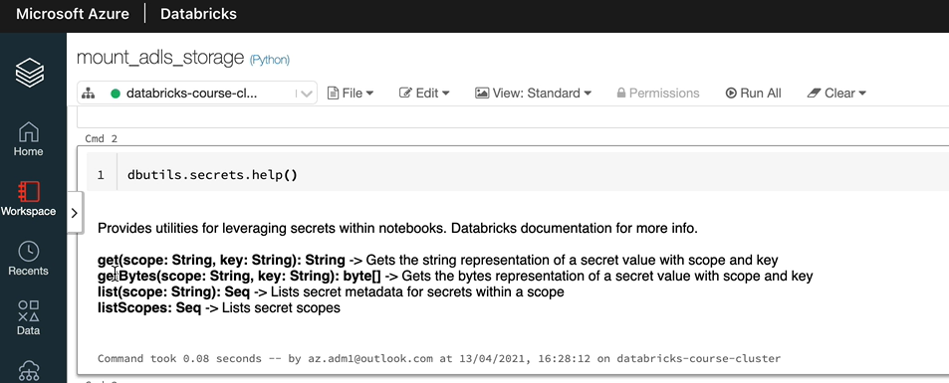

So get will get the string representation of the secret value and get bytes, get the bytes representation of a secret value, and then the list will list secret metadata from the scope, which will be like our key name, for example, we will do that in a minute and list scopes will list all the scope. So let's start with the list scopes. So that'll be dbUtils.secrets.listScopes() and as you can see, we've got one only, one scope, so that's the one we created previously

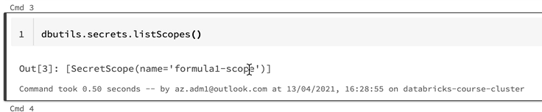

In order to see what's in the scope we can use the dbutils.secrets.list. So let's do that now. And for that, we need to send in this scope name as the parameter, so let's do that. And as you can see, we got three keys that we define, so which is the database, our client Id and the tenant ID in order to get the values of those ones, we like to use the dibutyl start Seacrest or get.

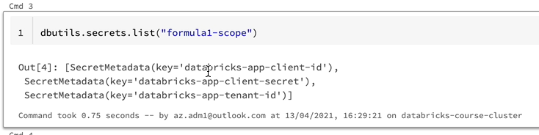

And that takes two parameters, the first one is the scope, so that'll be the scope name. And let's let's give the scope name for us. So that is the Formula One scoop. And let's give the key name as well, so the key name would be let's go for the first one, which is the database app client id. So as you can see, it's got the values, but it's redacted the value, so it's not being printed here, so it's not going to be exposed anywhere.

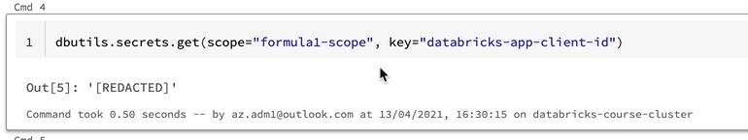

Having said that, if somebody wanted to hold of the secret value, they can still get hold of the secret value by printing the values. In a look, for example, you could do something like this. So this will print the value of the secret.

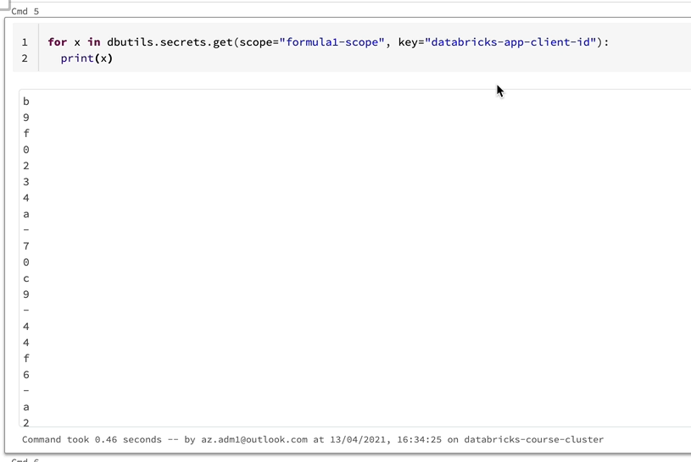

So basically what the dbutils stored secret is letting you do is to help you not have the secret values in the notebook. And when you look at them, actually, they are being redacted. So accidentally, you won't be exposing the values in the Internet, on the public domain, on a GitHub or somewhere else. It doesn't really stop someone who has got access to the database workspace itself to be able to get the values. So you have to have another level of security on the databricks workspace to be able to give the right people the right permissions. I hope that makes sense.

So let's now look at getting the values for our secrets here. We want to replace everything else. I'm going to quickly get rid of these cells we don't need anymore. And let's copy this, and we are going to replace the client now, so that's been replaced and let's copy everywhere and then we can change it. So this is going to be client id. And this is going to be the client's secret. So we got no hard coded values for any of our secrets here, so I'm going to delete that as well now and let's run this.

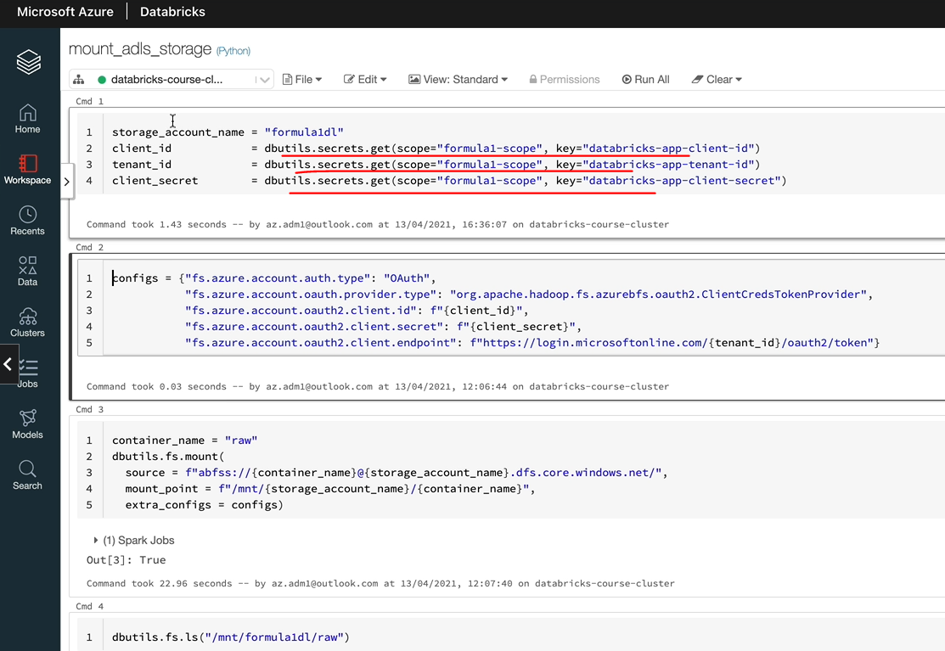

So all our variables have now got the right values, so we can just use them throughout the notebook. I'm going to quickly tidy up the notebook because we've got a function underneath and we've got the hot code that contains the names as well. So I'm going to delete the cell. We don't need it anymore and we can get rid of this one. Because we got another recurrence of that down, so let's do this and we got the function which is going to mount our workspace for the container name. And let's add another line here, and that would be for mounting our overall container as well. So let's list the raw container as well, just about that, just to make sure that we can see the container.

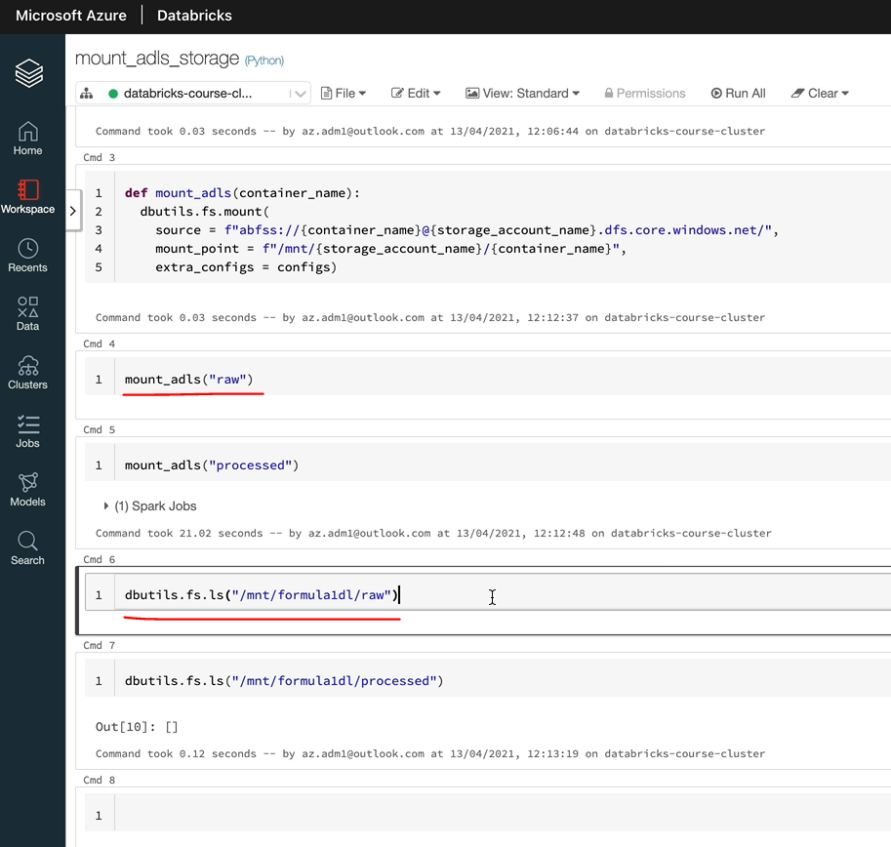

All of this is now going to fail because we've already mounted our storage accounts and the container. So let's unmount them before we can execute those ones in order to unmount. All you do is dbutils.unmount and then you just put them on name. So that's going to unmount the container and we can do the same thing for the processed one that's once that's done. So I'm going to quickly do that as well. OK, both mounts have been unmounted now, so we can delete these cells and then I'll quickly walk you through the notebook one more time just to make sure we are on the same page.

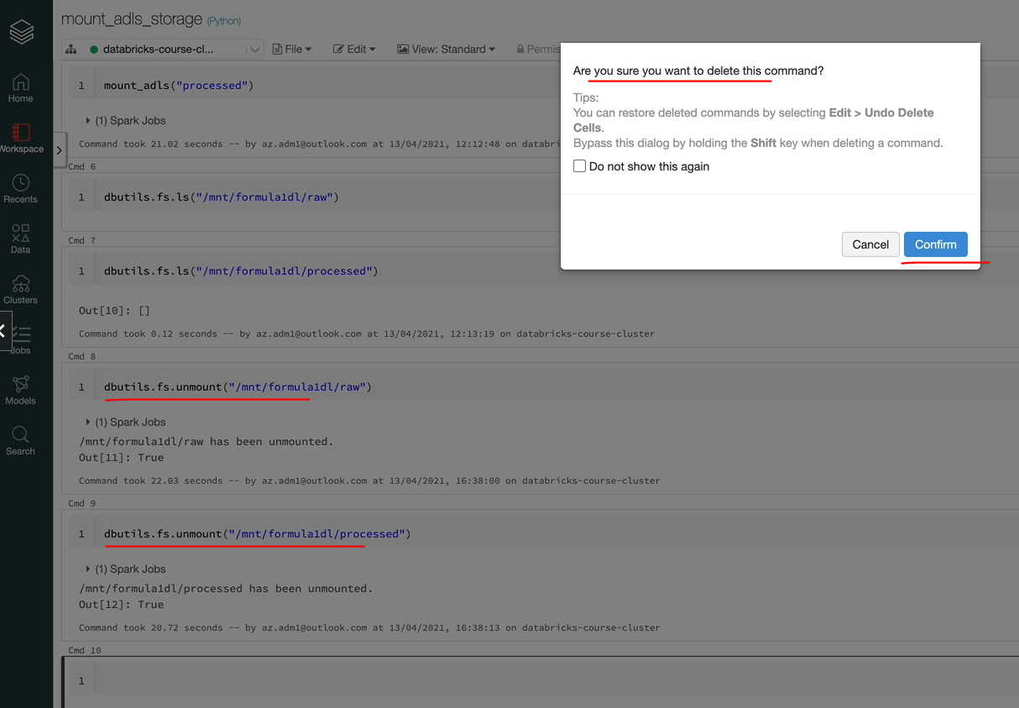

So the first thing what we're doing is we are setting the variables, but now be replaced, the hard coded secrets with the dibutyl state, secrets to get to get the values from Keywood. And then we got to fix. The configs have been set with the client id and tenant id and the client secret being retrieved above. And we got a function which takes in the container name and the amount the storage account in the container. So this is the storage account details with the container name, and this is the mount point that's going to be created.

storage_account_name = "formula1dl"

client_id = dbutils.secrets.get(scope="formula1-scope", key="databricks-app-client-id")

tenant_id = dbutils.secrets.get(scope="formula1-scope", key="databricks-app-tenant-id")

client_secret = dbutils.secrets.get(scope="formula1-scope", key="databricks-app-client-secret")

configs = {"fs.azure.account.auth.type": "OAuth",

"fs.azure.account.oauth.provider.type": "org.apache.hadoop.fs.azurebfs.oauth2.ClientCredsTokenProvider",

"fs.azure.account.oauth2.client.id": f"{client_id}",

"fs.azure.account.oauth2.client.secret": f"{client_secret}",

"fs.azure.account.oauth2.client.endpoint": f"https://login.microsoftonline.com/{tenant_id}/oauth2/token"}

def mount_adls(container_name):

dbutils.fs.mount(

source = f"abfss://{container_name}@{storage_account_name}.dfs.core.windows.net/",

mount_point = f"/mnt/{storage_account_name}/{container_name}", 🄌

extra_configs = configs)

mount_adls("raw") ➊

mount_adls("processed")

dbutils.fs.ls("/mnt/formula1dl/raw")

dbutils.fs.ls("/mnt/formula1dl/processed")

So the mount format they've given is /mnt and then the storage account name and the container name 🄌 and the function here ➊ the call here is going to mount the raw container and this is going to be in the processed container. And once the mount that we are going to just list the list, both of them, to make sure that have been mounted and there are no errors. So let's click on run all and it should just run through top to bottom. OK, both containers have now mounted. There are no errors and as you can see, we got the empty output here because we got no file folders underneath these containers at the moment and we will be adding them later.

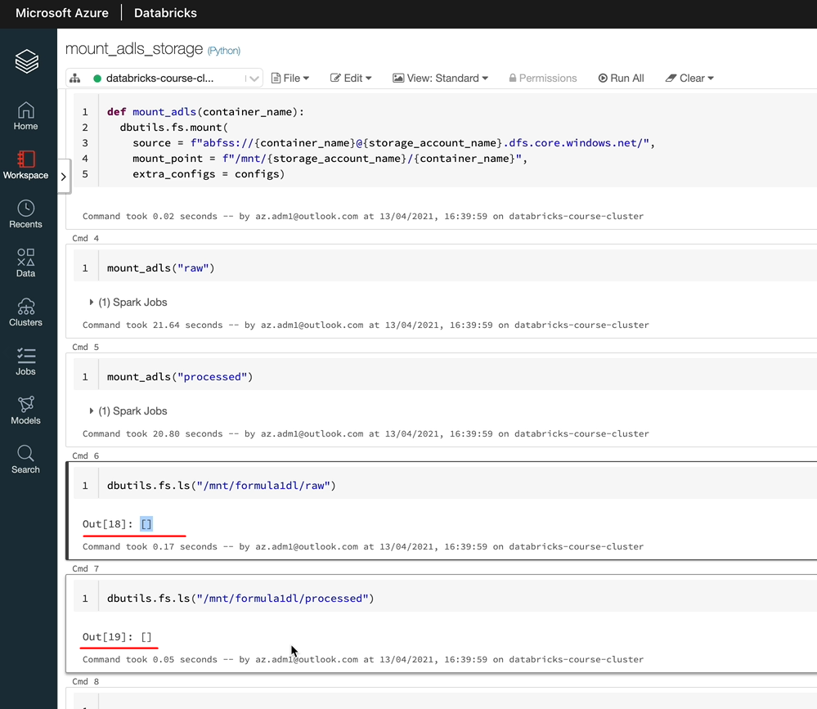

## Project

### Overview

Now that we are familiar with the capabilities offered by Azure Databricks. Let's put the learnings into practice by doing a real world project. We will be using the data from the motor racing sport Formula One for this project. I totally understand. Not everyone will be familiar about Formula One. So I will give you an overview about the sport first and then I'll take you through the source of the data and also the data sets will be using for our project in detail. We will then upload the data to our data ready to be used in our project. Then work it through the project requirements.

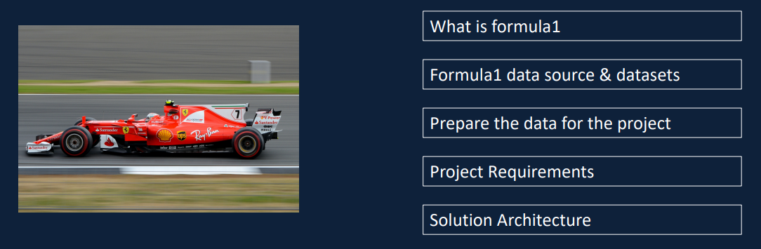

This will be functional requirements such as transformations required, dashboards and reports to be created, as well as non-functional requirements such as scheduling, monitoring and alerting. And then walk you through the solution architecture, stock design that we'll be using to implement our project. I'll also provide references to the industry standard architectures available in Microsoft, as well as databricks blogs and website. By the end of this section, I hope you'll have a good understanding about the project will be developing as part of this course as well as the solution architecture. We are going to be using for the solution.

### Data



In this lesson, I'm going to walk you through the data that we are going to use for this project. First, I'll walk you through the source of the data followed by the entity relationship diagram and also the type the files that we are going to deal with. Just so we can make the learning interesting, I've chosen the project to be based around the sport, which is Formula One motor racing. I appreciate that not everyone's going to be familiar with Formula One and also this might not be your first choice when it comes to picking a sport. I'll take you through all the key concepts in simple terms so you can understand the data better and enjoy doing the project. Similar to IPL cricket, English Premier League football or NFL, Formula One season happens once a year roughly well with 20 races. Each race happens over the weekend. Let's now see who participates in a race.

|  |  |
| --- | --- |
| Obviously, there are various race ciruits. Usually there is only one race in a circuit each year. But due to the current outbreak in 2020, there were more than one race conducted in some of the circuits. There are roughly 10 teams that participate in each season and they are also called constructor's in Formula One. Each team has two drivers and each driver is assigned a specific car. There are also reserve prime drivers in each team, but only two participate in races, and they are the only two we're going to talk about here.  Race weekend spans from Friday to Sunday. There are two practice sessions on a Friday and a final practice session on Saturday morning. They don't count towards any points or achievements. So we won't focus on these. There is a qualifying session on Saturday afternoon and it happens over three different stages. The qualifying results decide the position of the driver as to where he'll start the race. The higher the driver qualifyies the forward, he gets to start the race, which is a massive advantage.  Unlike qualifying sessions, which are decided over a single lap, racers span, multiple laps roughly between 50 and 70 laps, depending on the length of the circuit. Also during the race, drivers make pit stops to change the tires or to replace a damaged car. Based on their race results, drivers and constructors standings are decided, whichever driver is on the top of the standings at the end of this season is the driver's champion. | And similarly, the team that's leading the constructors standings becomes the constructors champion. |

Hope this gives you a good understanding about Formula One and the various terminologies used, we're only going to be dealing with the data that's focused on these concepts. Now, let's look at where to get the data. There is a third party developer, API, called ergast that makes the data available for all races from 1950 onwards. So let's visit the website and explore it a bit further. In order to get to the documentation, visit the you are a .com/mrd here. And that from here, you can look at things like terms and conditions of use and the EPA documentation itself, and also if we didn't want to use the API, we can look at the manual interface or even download the data in a CSV format. So let's start with the terms and conditions. So as you can see here, you can use this API for personal, noncommercial applications and services, including educational and research purposes. So we are OK to use this data from this API or from this website for our educational purposes. So let's get back to the main page.

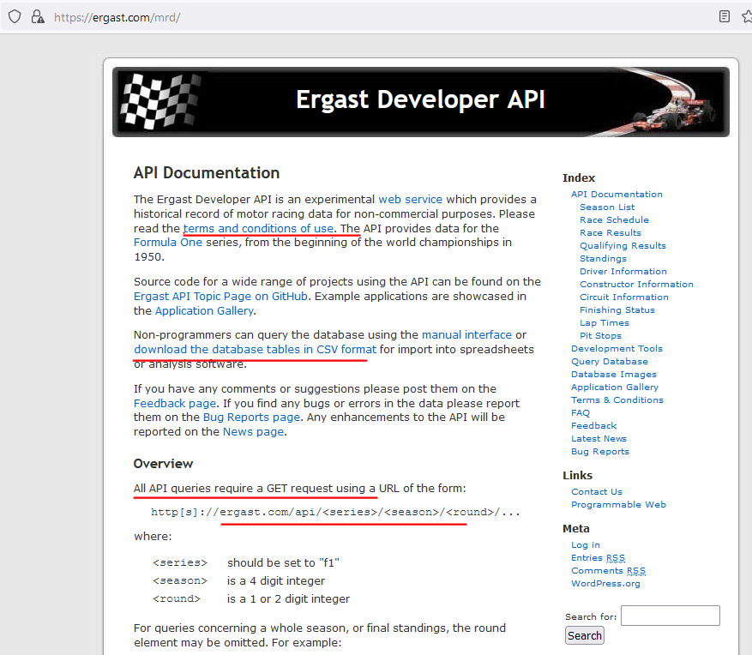

As I said before, you've got the API documentation here and also there is a manual interface, but we are going to be downloading the database tables in kesby format. So let's revisit that one. And as you can see here on this page, there are quite a bit of information, but the zip file contains all the data in CSV format, so that includes all the race data starting from 1950 onwards up to now, like last week. So this is the data I've already downloaded the data for you, so don't worry about downloading the data again. But there are a couple of important things here.

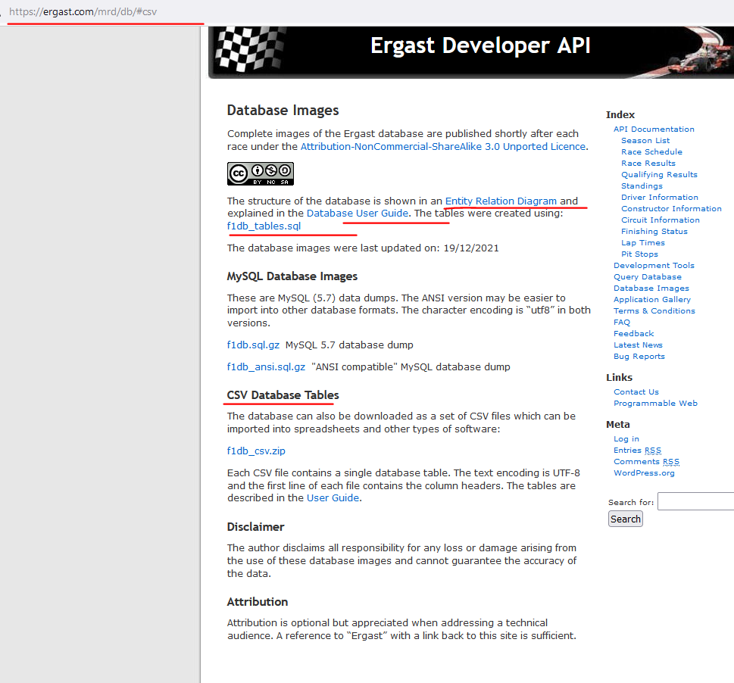

So we got the entity relationship diagram as well as the database user guide. So let's start with the entity relationship diagram. This would be quite familiar for you now because we went through the nature of Formula One and the different entities you will find within Formula One. So as we said before, we got a table here to represent the season. The season is a yearly season. That's why year is a primary game here. And within a season, you've got roughly about 20 races. So each race would be recorded here on this table and race normally happens in a circuit. There are a number of circuits around the world in various countries, and some countries have got multiple race ciruits as well. And from a race, you've got the qualifying that happens on a Saturday to identify which driver starts at what position for the race. So you've got the qualifying. As I said, actually, qualifying happens over 3 stages. So you've got Q1, Q2 to Q3. You don't have to worry too much about these things. And for a race also, we got results. But the results relate to a driver because the driver is driving a car. So you've got the race results, even though this is called results, that relates to the race. So that is race results. So on the race results, you've got the race side related to the race and you've got the driver related to which driver result this relates to and then the constructor, which is the team for which the driver is driving as well. And as we said before, with an arrest, you've got one or more pit stops, that could be to stop to change the tire or to repair damage to car. And also, as we said, there are between about 50 and 70 laps in each of the race. And the LAP times for each of the laps is recorded here as well. And on this side, you've got the similar to the race results for the driver, you've got the constructor results as well, that is basically adding up the results from both of the drivers for a team and then making up the points here. So, for example, if Driver one scored 25 points and the driver 2 scored 10 points, this would say for the construct, the total points is 35.

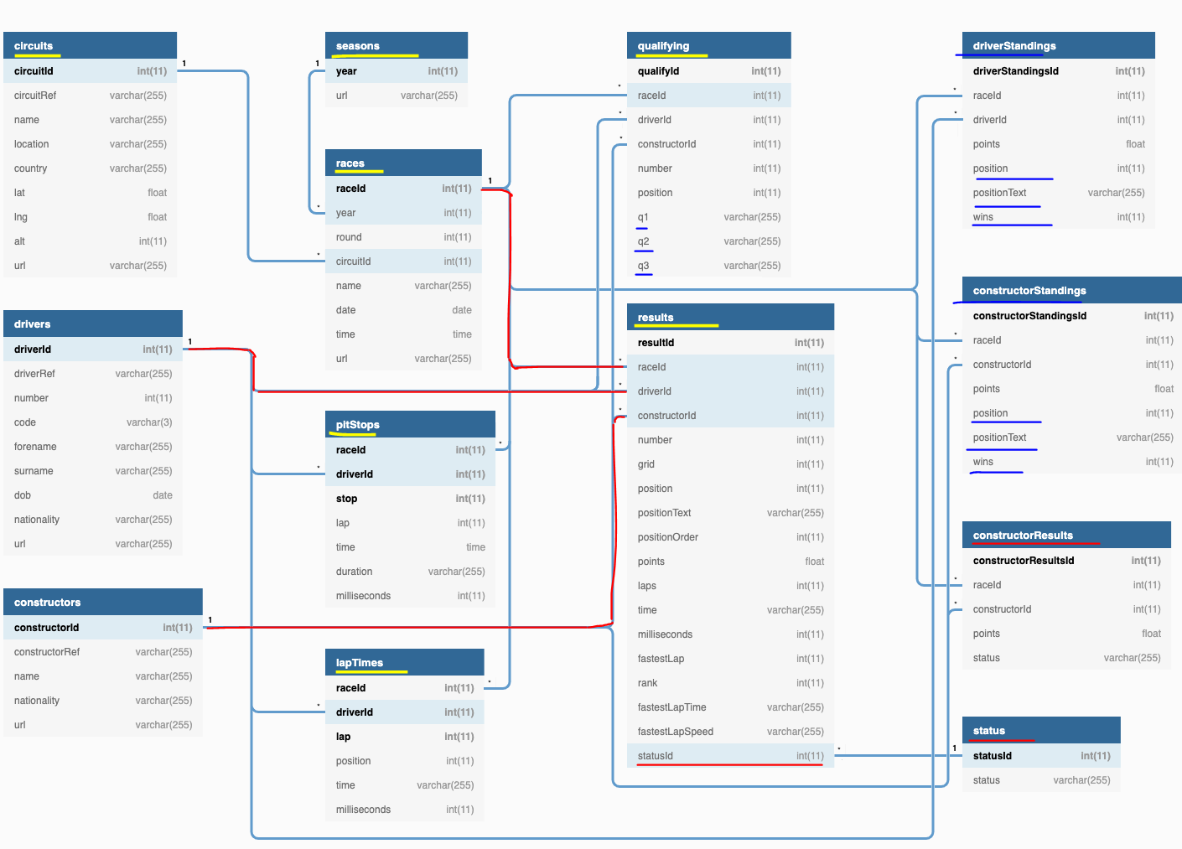

And you've got status field here. That's just a simple look up. So this tells you whether a driver has finished the race or disqualified or he crashed in the race or that kind of information. You've got a numeric number here, so that's a digit. So maybe, for example, one in here indicates that driver has finished the race. So these two tables here, driver's standings and constructors standings, tells you what position the driver or the constructors is within a season. So you've got the position and the position text and then you've got, wins, a number of wins within a season. And similarly, you've got position and position text, as well as the number of wins for the constructor as well.

That's everything about the entity relationship diagram here. It is quite simple. I hope you get it. But if not, you can look at the data to understand it a bit better. And also when we process the data, we'll go through each one of these tables in a bit more detail as well. So let's get back to the database images page again. And the other thing I talked about is the database user guide. So let's open that one up. And that basically has got details about each of the attributes of columns within a table, so, for example, on a circular table, you've got these many columns and these are the data types. And this one, for example, is the primary key.

+----------------------------+

**| Ergast Database User Guide |**

+----------------------------+

| Version: 1.0 |

| Date: 31 January 2021 |

| Author: Chris Newell |

+----------------------------+

+----------------------+ +------------------------------------------------------------------+

| List of Tables | | General Notes |

+----------------------+ +------------------------------------------------------------------|

| circuits | | Dates, times and durations are in ISO 8601 format |

| constructorResults | | Dates and times are UTC |

| constructorStandings | | Strings use UTF-8 encoding |

| constructors | | Primary keys are for internal use only |

| driverStandings | | Fields ending with "Ref" are unique identifiers for external use |

| drivers | | A grid position of '0' is used for starting from the pitlane |

| lapTimes | | Labels used in the positionText fields: |

| pitStops | | "D" - disqualified |

| qualifying | | "E" - excluded |

| races | | "F" - failed to qualify |

| results | | "N" - not classified |

| seasons | | "R" - retired |

| status | | "W" - withdrew |

+----------------------+ +------------------------------------------------------------------+

circuits table

+------------+--------------+------+-----+---------+----------------+---------------------------+

| Field | Type | Null | Key | Default | Extra | Description |

+------------+--------------+------+-----+---------+----------------+---------------------------+

| circuitId | int(11) | NO | PRI | NULL | auto_increment | Primary key |

| circuitRef | varchar(255) | NO | | | | Unique circuit identifier |

| name | varchar(255) | NO | | | | Circuit name |

| location | varchar(255) | YES | | NULL | | Location name |

| country | varchar(255) | YES | | NULL | | Country name |

| lat | float | YES | | NULL | | Latitude |

| lng | float | YES | | NULL | | Longitude |

| alt | int(11) | YES | | NULL | | Altitude (metres) |

| url | varchar(255) | NO | UNI | | | Circuit Wikipedia page |

+------------+--------------+------+-----+---------+----------------+---------------------------+

constructor_results table

+----------------------+--------------+------+-----+---------+----------------+----------------------------------------+

| Field | Type | Null | Key | Default | Extra | Description |

+----------------------+--------------+------+-----+---------+----------------+----------------------------------------+

| constructorResultsId | int(11) | NO | PRI | NULL | auto_increment | Primary key |

| raceId | int(11) | NO | | 0 | | Foreign key link to races table |

| constructorId | int(11) | NO | | 0 | | Foreign key link to constructors table |

| points | float | YES | | NULL | | Constructor points for race |

| status | varchar(255) | YES | | NULL | | "D" for disqualified (or null) |

+----------------------+--------------+------+-----+---------+----------------+----------------------------------------+

constructor_standings table

+------------------------+--------------+------+-----+---------+----------------+------------------------------------------+

| Field | Type | Null | Key | Default | Extra | Description |

+------------------------+--------------+------+-----+---------+----------------+------------------------------------------+

| constructorStandingsId | int(11) | NO | PRI | NULL | auto_increment | Primary key |

| raceId | int(11) | NO | | 0 | | Foreign key link to races table |

| constructorId | int(11) | NO | | 0 | | Foreign key link to constructors table |

| points | float | NO | | 0 | | Constructor points for season |

| position | int(11) | YES | | NULL | | Constructor standings position (integer) |

| positionText | varchar(255) | YES | | NULL | | Constructor standings position (string) |

| wins | int(11) | NO | | 0 | | Season win count |

+------------------------+--------------+------+-----+---------+----------------+------------------------------------------+

constructors table

+----------------+--------------+------+-----+---------+----------------+-------------------------------+

| Field | Type | Null | Key | Default | Extra | Description |

+----------------+--------------+------+-----+---------+----------------+-------------------------------+

| constructorId | int(11) | NO | PRI | NULL | auto_increment | Primary key |

| constructorRef | varchar(255) | NO | | | | Unique constructor identifier |

| name | varchar(255) | NO | UNI | | | Constructor name |

| nationality | varchar(255) | YES | | NULL | | Constructor nationality |

| url | varchar(255) | NO | | | | Constructor Wikipedia page |

+----------------+--------------+------+-----+---------+----------------+-------------------------------+

driver_standings table

+-------------------+--------------+------+-----+---------+----------------+-------------------------------------+

| Field | Type | Null | Key | Default | Extra | Description |

+-------------------+--------------+------+-----+---------+----------------+-------------------------------------+

| driverStandingsId | int(11) | NO | PRI | NULL | auto_increment | Primary key |

| raceId | int(11) | NO | | 0 | | Foreign key link to races table |

| driverId | int(11) | NO | | 0 | | Foreign key link to drivers table |

| points | float | NO | | 0 | | Driver points for season |

| position | int(11) | YES | | NULL | | Driver standings position (integer) |

| positionText | varchar(255) | YES | | NULL | | Driver standings position (string) |

| wins | int(11) | NO | | 0 | | Season win count |

+-------------------+--------------+------+-----+---------+----------------+-------------------------------------+

drivers table

+-------------+--------------+------+-----+---------+----------------+--------------------------+

| Field | Type | Null | Key | Default | Extra | Description |

+-------------+--------------+------+-----+---------+----------------+--------------------------+

| driverId | int(11) | NO | PRI | NULL | auto_increment | Primary key |

| driverRef | varchar(255) | NO | | | | Unique driver identifier |

| number | int(11) | YES | | NULL | | Permanent driver number |

| code | varchar(3) | YES | | NULL | | Driver code e.g. "ALO" |

| forename | varchar(255) | NO | | | | Driver forename |

| surname | varchar(255) | NO | | | | Driver surname |

| dob | date | YES | | NULL | | Driver date of birth |

| nationality | varchar(255) | YES | | NULL | | Driver nationality |

| url | varchar(255) | NO | UNI | | | Driver Wikipedia page |

+-------------+--------------+------+-----+---------+----------------+--------------------------+

lap_times table

+--------------+--------------+------+-----+---------+-------+-----------------------------------+

| Field | Type | Null | Key | Default | Extra | Description |

+--------------+--------------+------+-----+---------+-------+-----------------------------------+

| raceId | int(11) | NO | PRI | NULL | | Foreign key link to races table |

| driverId | int(11) | NO | PRI | NULL | | Foreign key link to drivers table |

| lap | int(11) | NO | PRI | NULL | | Lap number |

| position | int(11) | YES | | NULL | | Driver race position |

| time | varchar(255) | YES | | NULL | | Lap time e.g. "1:43.762" |

| milliseconds | int(11) | YES | | NULL | | Lap time in milliseconds |

+--------------+--------------+------+-----+---------+-------+-----------------------------------+

pit_stops table

+--------------+--------------+------+-----+---------+-------+-----------------------------------+

| Field | Type | Null | Key | Default | Extra | Description |

+--------------+--------------+------+-----+---------+-------+-----------------------------------+

| raceId | int(11) | NO | PRI | NULL | | Foreign key link to races table |

| driverId | int(11) | NO | PRI | NULL | | Foreign key link to drivers table |

| stop | int(11) | NO | PRI | NULL | | Stop number |

| lap | int(11) | NO | | NULL | | Lap number |

| time | time | NO | | NULL | | Time of stop e.g. "13:52:25" |

| duration | varchar(255) | YES | | NULL | | Duration of stop e.g. "21.783" |

| milliseconds | int(11) | YES | | NULL | | Duration of stop in milliseconds |

+--------------+--------------+------+-----+---------+-------+-----------------------------------+

qualifying table

+---------------+--------------+------+-----+---------+----------------+----------------------------------------+

| Field | Type | Null | Key | Default | Extra | Description |

+---------------+--------------+------+-----+---------+----------------+----------------------------------------+

| qualifyId | int(11) | NO | PRI | NULL | auto_increment | Primary key |

| raceId | int(11) | NO | | 0 | | Foreign key link to races table |

| driverId | int(11) | NO | | 0 | | Foreign key link to drivers table |

| constructorId | int(11) | NO | | 0 | | Foreign key link to constructors table |

| number | int(11) | NO | | 0 | | Driver number |

| position | int(11) | YES | | NULL | | Qualifying position |

| q1 | varchar(255) | YES | | NULL | | Q1 lap time e.g. "1:21.374" |

| q2 | varchar(255) | YES | | NULL | | Q2 lap time |

| q3 | varchar(255) | YES | | NULL | | Q3 lap time |

+---------------+--------------+------+-----+---------+----------------+----------------------------------------+

races table

+-----------+--------------+------+-----+------------+----------------+------------------------------------+

| Field | Type | Null | Key | Default | Extra | Description |

+-----------+--------------+------+-----+------------+----------------+------------------------------------+

| raceId | int(11) | NO | PRI | NULL | auto_increment | Primary key |

| year | int(11) | NO | | 0 | | Foreign key link to seasons table |

| round | int(11) | NO | | 0 | | Round number |

| circuitId | int(11) | NO | | 0 | | Foreign key link to circuits table |

| name | varchar(255) | NO | | | | Race name |

| date | date | NO | | 0000-00-00 | | Race date e.g. "1950-05-13" |

| time | time | YES | | NULL | | Race start time e.g."13:00:00" |

| url | varchar(255) | YES | UNI | NULL | | Race Wikipedia page |

+-----------+--------------+------+-----+------------+----------------+------------------------------------+

results table

+-----------------+--------------+------+-----+---------+----------------+---------------------------------------------+

| Field | Type | Null | Key | Default | Extra | Description |

+-----------------+--------------+------+-----+---------+----------------+---------------------------------------------+

| resultId | int(11) | NO | PRI | NULL | auto_increment | Primary key |

| raceId | int(11) | NO | | 0 | | Foreign key link to races table |

| driverId | int(11) | NO | | 0 | | Foreign key link to drivers table |

| constructorId | int(11) | NO | | 0 | | Foreign key link to constructors table |

| number | int(11) | YES | | NULL | | Driver number |

| grid | int(11) | NO | | 0 | | Starting grid position |

| position | int(11) | YES | | NULL | | Official classification, if applicable |

| positionText | varchar(255) | NO | | | | Driver position string e.g. "1" or "R" |

| positionOrder | int(11) | NO | | 0 | | Driver position for ordering purposes |

| points | float | NO | | 0 | | Driver points for race |

| laps | int(11) | NO | | 0 | | Number of completed laps |

| time | varchar(255) | YES | | NULL | | Finishing time or gap |

| milliseconds | int(11) | YES | | NULL | | Finishing time in milliseconds |

| fastestLap | int(11) | YES | | NULL | | Lap number of fastest lap |

| rank | int(11) | YES | | 0 | | Fastest lap rank, compared to other drivers |

| fastestLapTime | varchar(255) | YES | | NULL | | Fastest lap time e.g. "1:27.453" |

| fastestLapSpeed | varchar(255) | YES | | NULL | | Fastest lap speed (km/h) e.g. "213.874" |

| statusId | int(11) | NO | | 0 | | Foreign key link to status table |

+-----------------+--------------+------+-----+---------+----------------+---------------------------------------------+

seasons table

+-------+--------------+------+-----+---------+-------+-----------------------+

| Field | Type | Null | Key | Default | Extra | Description |

+-------+--------------+------+-----+---------+-------+-----------------------+

| year | int(11) | NO | PRI | 0 | | Primary key e.g. 1950 |

| url | varchar(255) | NO | UNI | | | Season Wikipedia page |

+-------+--------------+------+-----+---------+-------+-----------------------+

status table

+----------+--------------+------+-----+---------+----------------+---------------------------------+

| Field | Type | Null | Key | Default | Extra | Description |

+----------+--------------+------+-----+---------+----------------+---------------------------------+

| statusId | int(11) | NO | PRI | NULL | auto_increment | Primary key |

| status | varchar(255) | NO | | | | Finishing status e.g. "Retired" |

+----------+--------------+------+-----+---------+----------------+---------------------------------+

This work is licensed under a Creative Commons Attribution-NonCommercial-ShareAlike 3.0 Unported License

To view a copy of this license, visit: http://creativecommons.org/licenses/by-nc-sa/3.0/

And there is description for each one of them as well. So you can read through this one to understand the data better as well. But as I said before, I'll walk you through the data as we go through the project. That's everything about the data I wanted to talk about. So let's now switch back to the presentation and I'll take you from there. As you saw, there are two files that we can download from the ergast API, but out of the 12 files we're going to be processing just the eight files listed here as part of our project.

|  |  |
| --- | --- |
|  |  |

As I said on the files downloaded WSP files, but I have converted them, as you see here, in different formats so that I can show you how to deal with different file types. I've left the top two, which is the circuits and races files as csv files. I've converted the constructors and results to a single line JSON files with simple structure. Drivers file is also a single line, json, but it has a nested object in it. Pit stops will have multiline json lap times and qualifying have been split into multiple files and they are CSV and multiline JSON respectively. Hope you have an understanding about what kind of data we're going to be dealing with and what type of files we are going to be dealing with. We will delve deeper into each one of these files when we come to process them.

### Upload Raw Data to Data Lake

In this lesson, we're going to upload the data that we downloaded from our ergast API into our Data Lake. Let's get started. I have already downloaded the data into my laptop and the data is available in the raw folder here. So let's take a look at that within the raw folder. I've got a number of files, so it's six files in here and there are a couple of CSV files and the rest are all a JSON file. And also we got the two folders and the folders relate to the split files we talked about. For example, lap times has been split into five different files and similarly qualifying has been split into two different files.

|  |  |
| --- | --- |
|  |  |

So what we're going to do is we're going to upload this data into our Data Lake. So let's switch over to the Storage Explorer and upload the data to the data lake. So here we are in the storage explorer and that's my subscription I'm working on. And if I go in under the storage accounts, I've got a number of storage accounts, but this is the one we're using for our project. And we've already created the two containers raw and processed and we want to put our data in Tehran. So let's click on the raw container and then come to upload to start with let's click on the upload files and that let us upload the files.

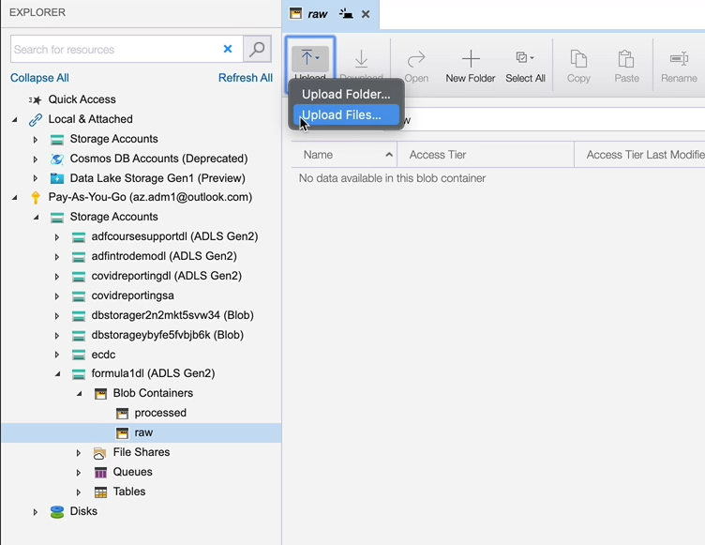

So click in here and then that's my real folder and I've got these six files, so I'm going to upload them. So click open and then click upload.

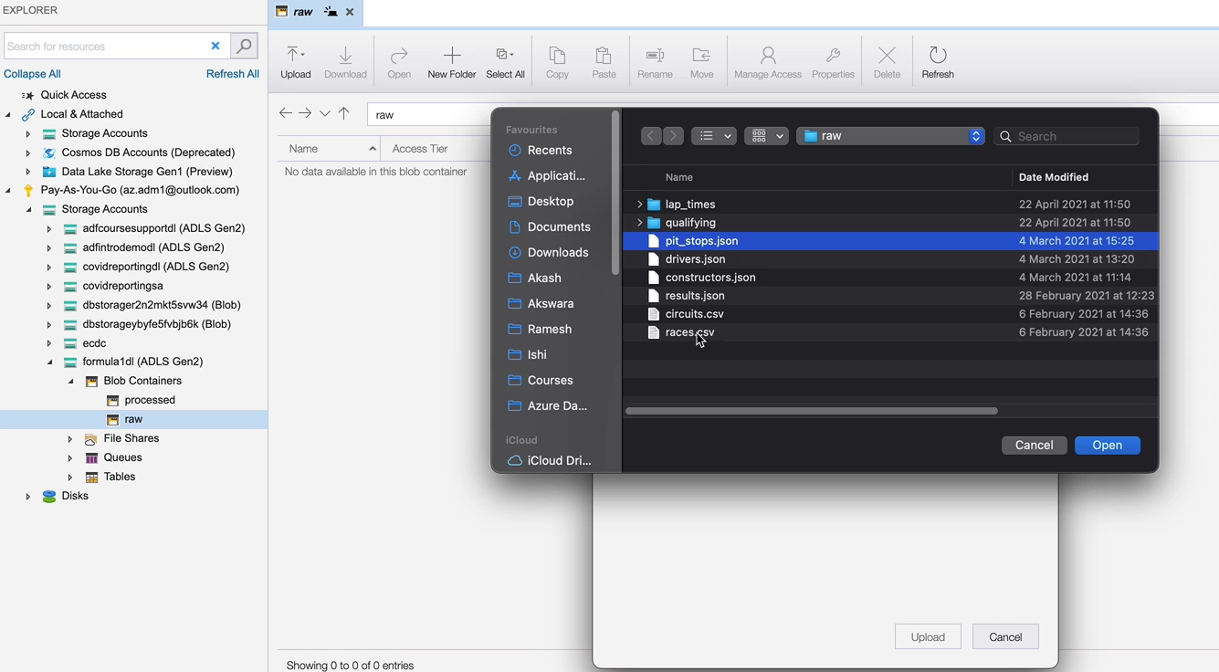

That'll get uploaded. So now that these six files are uploaded, let's upload the folders for the lap times and the qualifying. So in order to do that, come here, click on upload folder and click here. And now it only lets you choose one of them. So I'm going to go for the lap times first and click open and then upload.

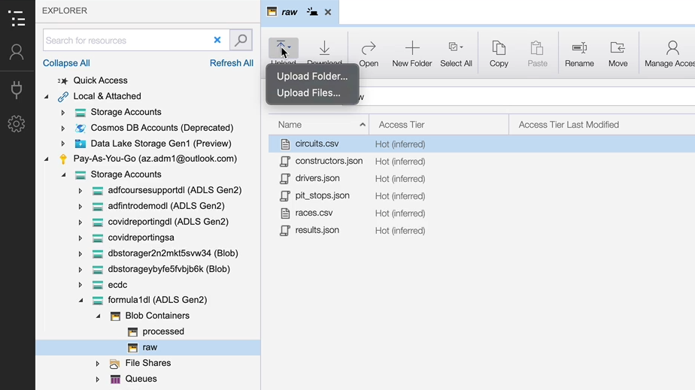

That's uploaded, as you can see, we got the lap times for here, so if I double click on that one that's got the five files and that's a file maintained by the lake. So we don't have to worry about that.

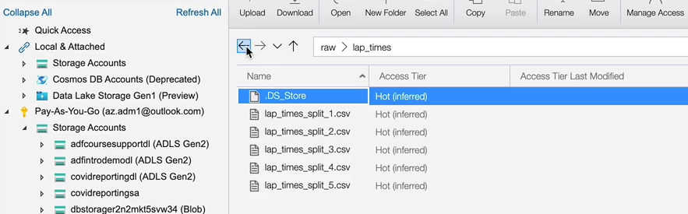

And if I go back and then I'm going to upload the other folder as well, which is our qualifying folder, let's click on that and click open and upload. And that's now being uploaded. OK, so we got all our files here, which is the six points here and the two folders, so we got all our data in the real container.

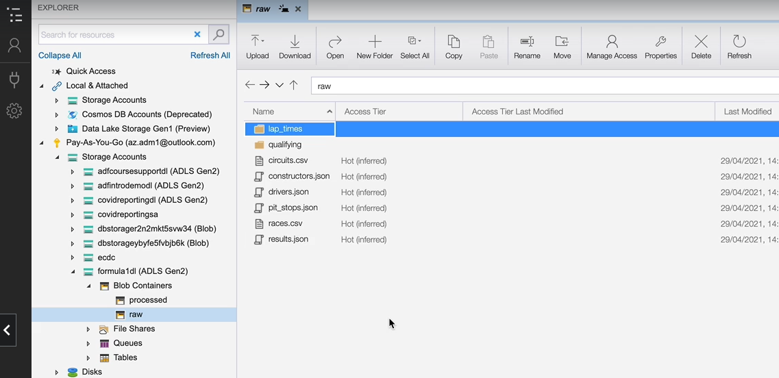

### Project Requirements

Now that we understand the data, let's look at the project requirements. Let's start with the requirements for ingesting data. We want to ingest all of the eight files we talked about spanning various formats, the data ingested into our data should conform to the following requirements. We should apply the right schema to the data, including column names, data types, etc.

|  |  |
| --- | --- |
| We should add some audit columns such as ingested date and the source from where the data has been received. The industry data must be stored in columnar format i.e. parquet files. The data ingested should be available for all kinds of workloads, such as machine learning, further transformation for reporting, and also analytical workloads via SQL. The data ingestion logic must be able to handle incremental data, i.e. if we receive the data for just one race, it should append the data in the lake rather than replacing all data in the lake. Let's now look at the requirements for transformation. We need a table which provides the data join for key data items that are required for our reporting. For example, data from races and results are combined into one data set or a table so that we can produce reports from this table. Similarly, we need tables and data sets with the data joined up to satisfy the analytical requirements. |  |

Similar to the Ingestion tables, we also need audit columns in our transformed tables too. Transformed data should be available for all workloads such as machine learning, BI reporting and SQL analytics. And similar to the ingestion data, transform data should also be stored in columnar format. In this case, as Parquet files finally transformation, logic should also be able to handle implemental data similar to the ingestion requirements. So if we have received data for only one race, the data pipelines will only aggregate the affected data and it will leave the other data as is.

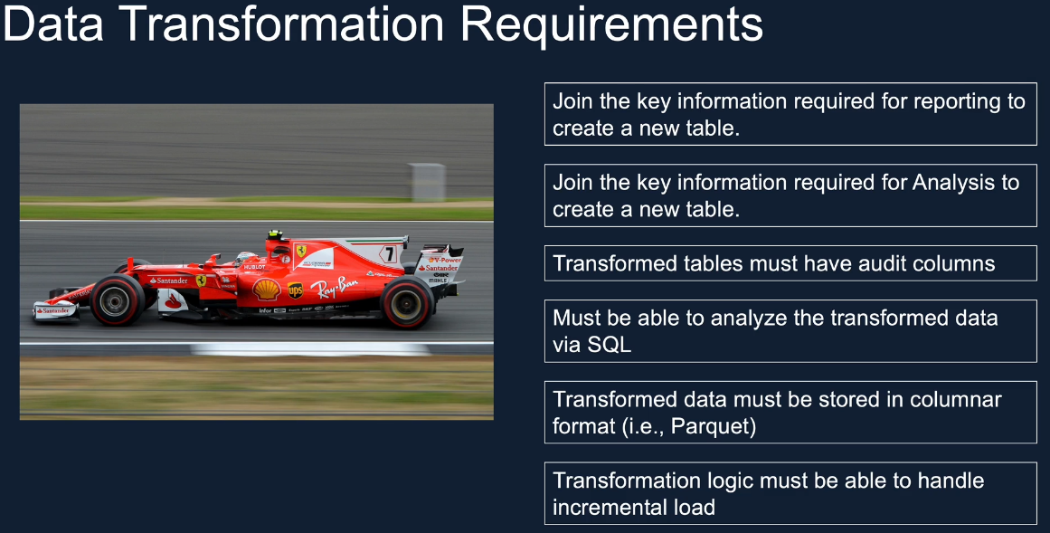

We also have a couple of BI Reporting requirements. We want to produce driver standings as well as constructors standings for the current race year, as well as every year from 1950 onwards. The reports will have a defined list of data items that we'll discuss later.

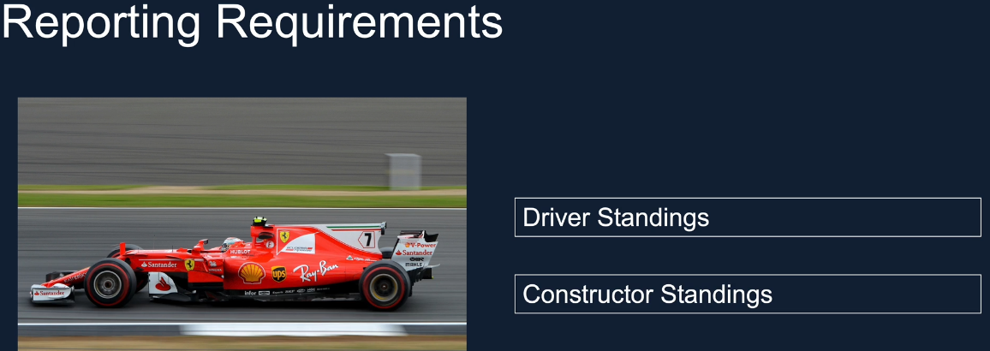

We have a set of analytical requirements, too, we want to find that the most dominant drivers and the teams over the last decade, as well as all time in Formula One. We then want to rank them in the order of their dominance. We also want to create various visualizations to see the period in which the driver or the teams were dominant, as well as their level of performance and the dominance. We also want to create dashboards from these outcomes so that they can be shared with others. These dashboards will have to be created in as your Azure database.

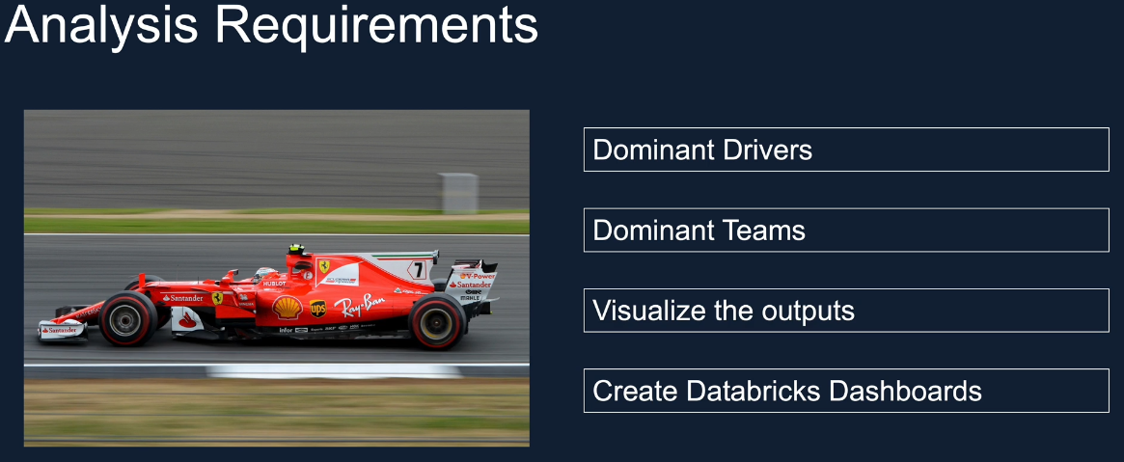

Finally, let's go through some non-functional requirements. We want to schedule the pipelines to run at 10:00 pm every Sunday. If there is a race that vacante, the pipelines should process the data, otherwise they should finish without failures. We want to have the ability to monitor the status of the pipeline, executions, a rerun, failed pipelines as well as we want to have the ability to set up alerts on failures.

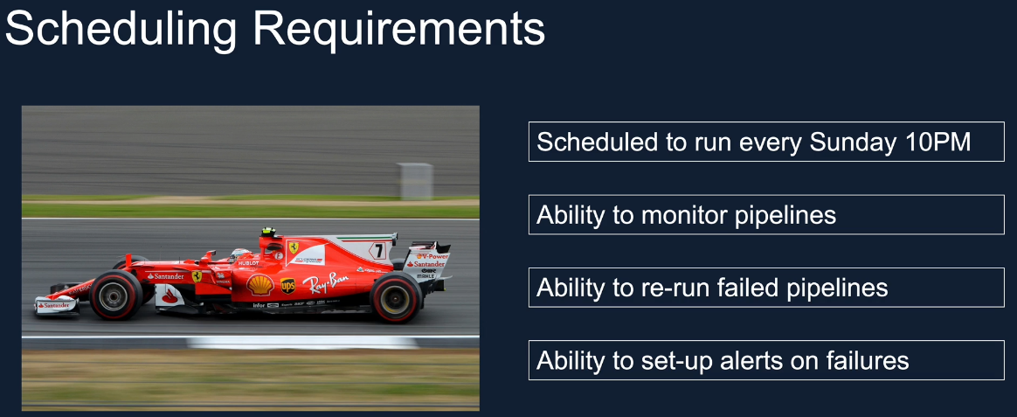

Apart from the scheduling requirements, we have some more nonfunctional requirements, such as being able to delete individual records from the Datalake to satisfy user privacy legislations such as EDPR. We want to be able to see the history of the data and ability to carry the data based on time, which is time travel. Also, we want to be able to roll back the data in the data link to a previous version in cases of issues with the data in the current state. So these are the primary requirements for our project. In the next lesson, we look a solution architecture which could be used to satisfy these requirements.

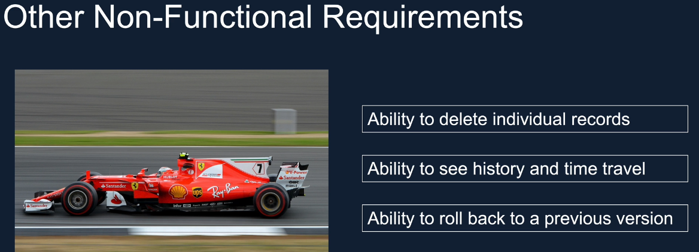

### Solution Architecture Overview

|  |  |
| --- | --- |
|  | Now that we understand the project requirements, let's look at the architecture for a solution. As we discussed, I have already exported the data from the August website and prepared it for you. The import this data manually into our data lake raw container, we are doing a manual import here because the data I have set up is to give you the opportunity to learn about more data types, as well as different design patterns such as full load, incremental load, etc.. Moreover, the main focus of the course is as your data breaks rather than the data integration tools. |

If you are developing a project for your company, you will be using an automated solution such as your data factory pipeline to get this data at regular intervals directly from the ergaster API. But we have used a manual approach here for the reasons I just described, will then take this data and process using data based notebooks to ingest into the ingested or the processed layer. The data in this layer will have the schema applied as well as stored in the column in a format parquet will also create partitions where applicable, as well as add additional information for our purposes, such as ingested date, a source of the data, etc.. We'll do all of this and store the data in Parquet initially and convert them to Delta Lake in a later section specifically focused on Delta Lake. This is so that we can satisfy our other requirements around time travel, etc.. Delta Lake provides all of these out of the box, but I will take you through those in the Delta Lake section. Ingested data will then be transformed via Azure Databricks notebook's again, and the results are stored in the presentation layer. Similar to the ingested data that transformed data is initially created in Parquet format. But as part of the Delta ake section, we will discuss the pitfalls of Data Lake and the benefits brought by Delta Lake. In that section will also convert all of the notebooks to produce data in Delta Lake. We will then use database notebooks to analyze the data and create dashboards to satisfy the requirements for our analysis.

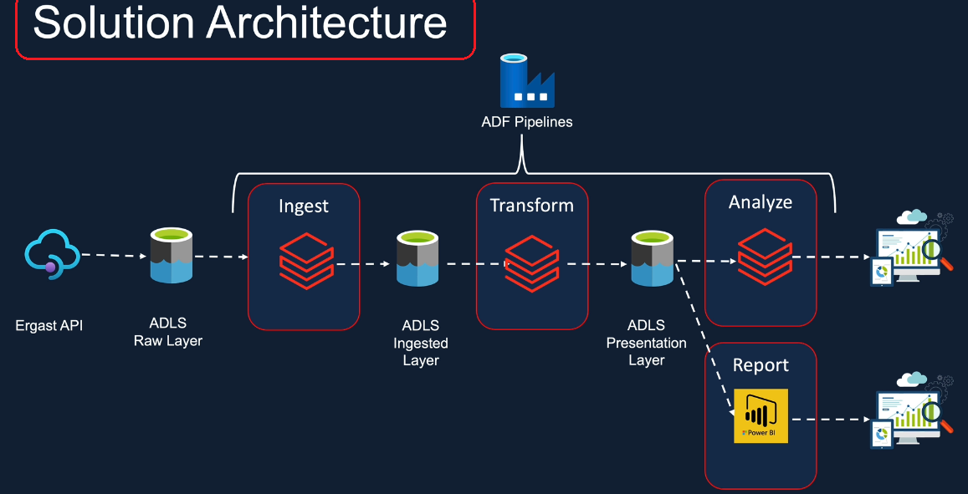

These notebooks will use the data from both the ingested layer as well as the presentation layer. I'll do a quick overview on how to use Power BI to connect to the Delta and create BI reports. As I said, Databricks is the main focus of this course, so Power BI will be covered only a very high level. We also want to build this project to a production quality that means we need some kind of scheduling and monitoring required to keep the pipelines running on a regular basis without any manual intervention. Also, we should be notified if there are any issues. First, we look at the jobs provided by Databricks itself to satisfy these requirements, and then we look at the limitations of Databricks jobs and how we can use as Azure data Factory to bring it together more efficiently. So Azure Data Factory will be the scheduling solution for this project. Again, ADF is not the main focus of this course and it'll take a full course just to learn it. But we will cover everything that's required to implement our pipelines for this project. So that we will be about an hour long section where I'll take you through ADF and how to use that to implement this scheduling solution for our pipelines.

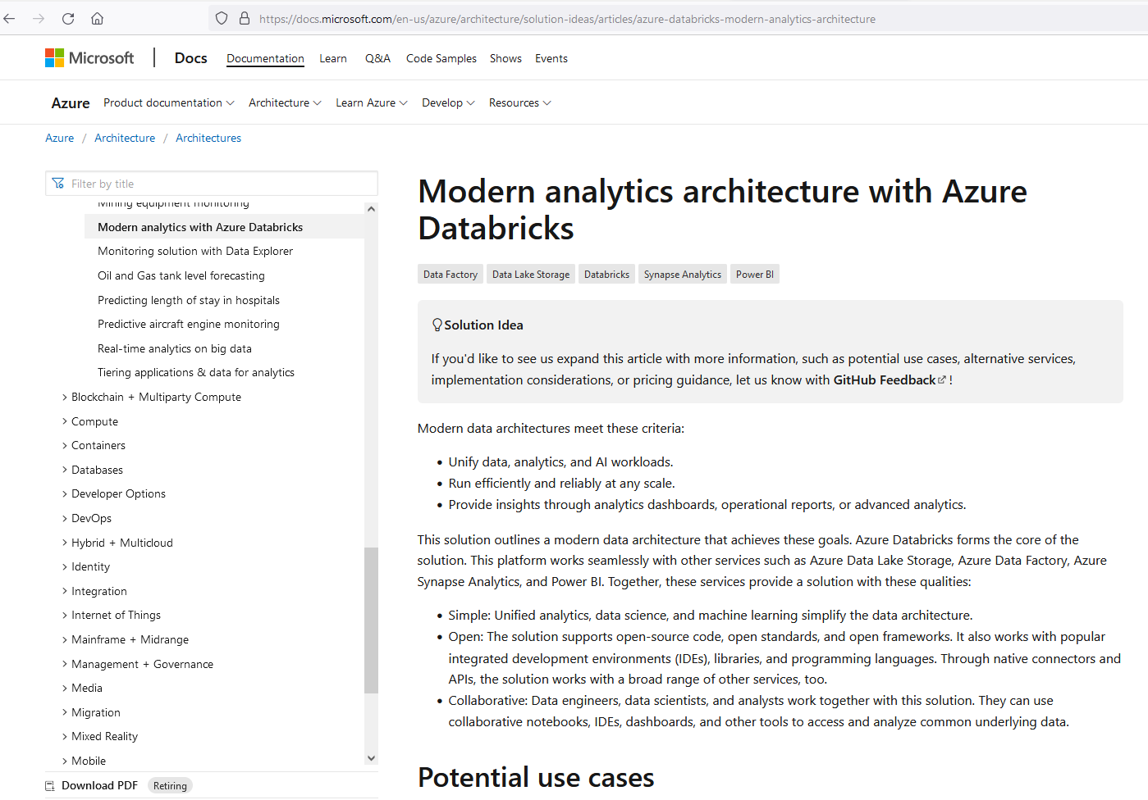

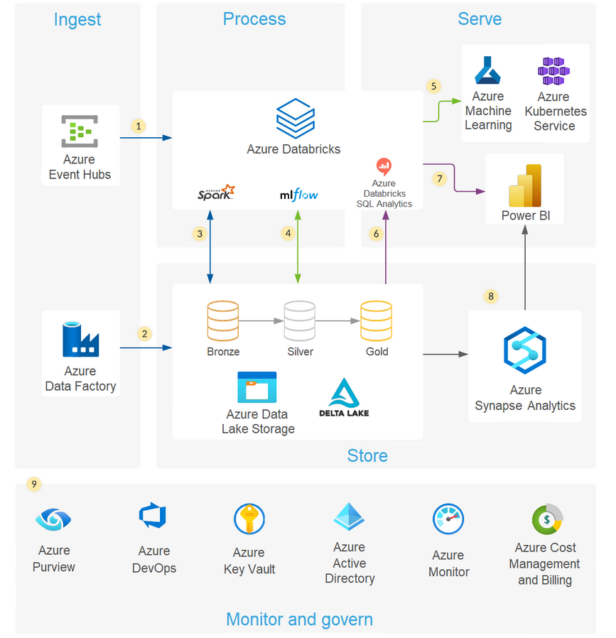

1. Azure Databricks ingests raw streaming data from Azure Event Hubs.
2. Data Factory loads raw batch data into Data Lake Storage.
3. For data storage:
   * Data Lake Storage houses data of all types, such as structured, unstructured, and semi-structured. It also stores batch and streaming data.
   * Delta Lake forms the curated layer of the data lake. It stores the refined data in an open-source format.
   * Azure Databricks works well with a [medallion architecture](https://techcommunity.microsoft.com/t5/analytics-on-azure/how-to-reduce-infrastructure-costs-by-up-to-80-with-azure/ba-p/1820280) that organizes data into layers:
     + Bronze: Holds raw data.
     + Silver: Contains cleaned, filtered data.
     + Gold: Stores aggregated data that's useful for business analytics.
4. The analytical platform ingests data from the disparate batch and streaming sources. Data scientists use this data for these tasks:
   * Data preparation
   * Data exploration
   * Model preparation
   * Model training

MLflow manages parameter, metric, and model tracking in data science code runs. The coding possibilities are flexible:

* + Code can be in SQL, Python, R, and Scala.
  + Code can use popular open-source libraries and frameworks such as Koalas, Pandas, and scikit-learn, which are pre-installed and optimized.
  + Practitioners can optimize for performance and cost with single-node and multi-node compute options.

1. Machine learning models are available in several formats:
   * Azure Databricks stores information about models in the [MLflow Model Registry](https://www.mlflow.org/docs/latest/registry.html). The registry makes models available through batch, streaming, and REST APIs.
   * The solution can also deploy models to Azure Machine Learning web services or Azure Kubernetes Service (AKS).
2. Services that work with the data connect to a single underlying data source to ensure consistency. For instance, users can run SQL queries on the data lake with Azure Databricks SQL Analytics. This service:
   * Provides a query editor and catalog, the query history, basic dashboarding, and alerting.
   * Uses integrated security that includes row-level and column-level permissions.
   * Uses a [Photon-powered Delta Engine to accelerate performance](https://techcommunity.microsoft.com/t5/analytics-on-azure/turbocharge-azure-databricks-with-photon-powered-delta-engine/ba-p/1694929).
3. Power BI generates analytical and historical reports and dashboards from the unified data platform. When working with Azure Databricks, this service uses these features:
   * A [built-in Azure Databricks connector](https://docs.microsoft.com/en-us/azure/databricks/integrations/bi/power-bi) for visualizing the underlying data.
   * Optimized Java Database Connectivity (JDBC) and Open Database Connectivity (ODBC) drivers.
4. Users can export gold data sets out of the data lake into Azure Synapse via the optimized Synapse connector. SQL pools in Azure Synapse provide a data warehousing and compute environment.
5. The solution uses Azure services for collaboration, performance, reliability, governance, and security:
   * Azure Purview provides data discovery services, sensitive data classification, and governance insights across the data estate.
   * Azure DevOps offers continuous integration and continuous deployment (CI/CD) and other integrated version control features.
   * Azure Key Vault securely manages secrets, keys, and certificates.
   * Azure Active Directory (Azure AD) provides single sign-on (SSO) for Azure Databricks users. Azure Databricks supports automated user provisioning with Azure AD for these tasks:
     + Creating new users.
     + Assigning each user an access level.
     + Removing users and denying them access.
   * Azure Monitor collects and analyzes Azure resource telemetry. By proactively identifying problems, this service maximizes performance and reliability.
   * Azure Cost Management and Billing provides financial governance services for Azure workloads.

<https://docs.microsoft.com/en-us/azure/architecture/solution-ideas/articles/azure-databricks-modern-analytics-architecture>

So this is the architecture and the design and we are going to implement. As you can imagine, this architecture is one of the many solutions we could have designed. So I don't want to just prescribe a solution, I want you to have the tools to identify a solution yourself when you have a different scenario. So let me take you through the research I did before designing the solution. I generally look at the architecture solution, ideas from the documentation or company blogs.

Both Microsoft and data bricks have plenty of solutions for us to help. The solution I proposed previously is heavily based on this solution from Microsoft Docs, which is available on the you are at the bottom of this screen. Microsoft included this architecture in the documentation based on the data solution implemented by one of their clients, Swiss Reinsurance. This solution gets real time events via event hub and regular batch data from as your data factory. That data is then processed based Spark on data bricks. The data goes through the layers bronze, silver and gold. The data is available for all workloads, including machine learning using. Azure ML. We will be reporting via Power BI and also for export to associate Azure Synapse Analytics and then further reported by a Power BI. This solution also uses the tools at the bottom for monitoring and governance. We will also use some of these tools. And here, if you look apart from the Azure event Hub, which is dealing with the near real time data, our solution pretty much resembles the solution.

<https://databricks.com/solutions/data-pipelines>

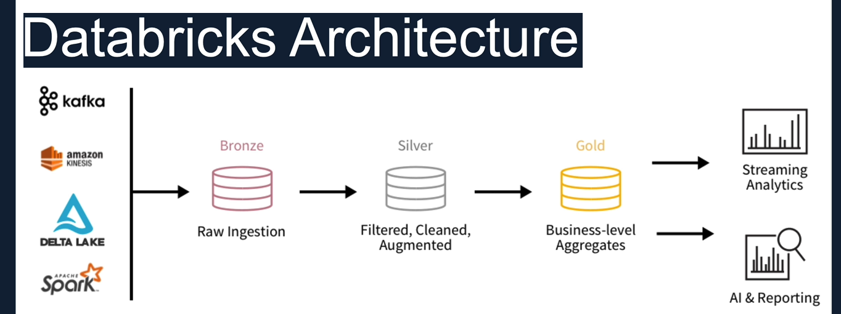

I took the solution architecture and focused mainly on the Azure Data Bricks section of Section 4 of this course. So once I did this, I looked at this architecture from Data Bricks blog <https://databricks.com/solutions/data-pipelines> .

As you can see, these are using similar layers to store our data. Bronze stores the raw data and we call it the Raw layer. Silver stores the data filtered, cleansed and augmented, we call this as our process or the ingested data. And finally, Gold towards the highly aggregated data with key business level information, we call this as the presentation layer. The idea is that when you go through the layers, when you go from left to right, the quality of the data improves and the business value of the data also increases. So having shown you the two architectures from Databricks and Microsoft, I hope I've demonstrated how I generally go about doing my research to build data pipelines, using the learnings from industry experts so that I don't have to start from scratch and I've got a good ground to start my project from. But before we finish, I would like to show the Microsoft page where you can find more solution ideas. Let's switch to the Microsoft docs and I'll take you through that.

<https://docs.microsoft.com/en-us/azure/architecture/>

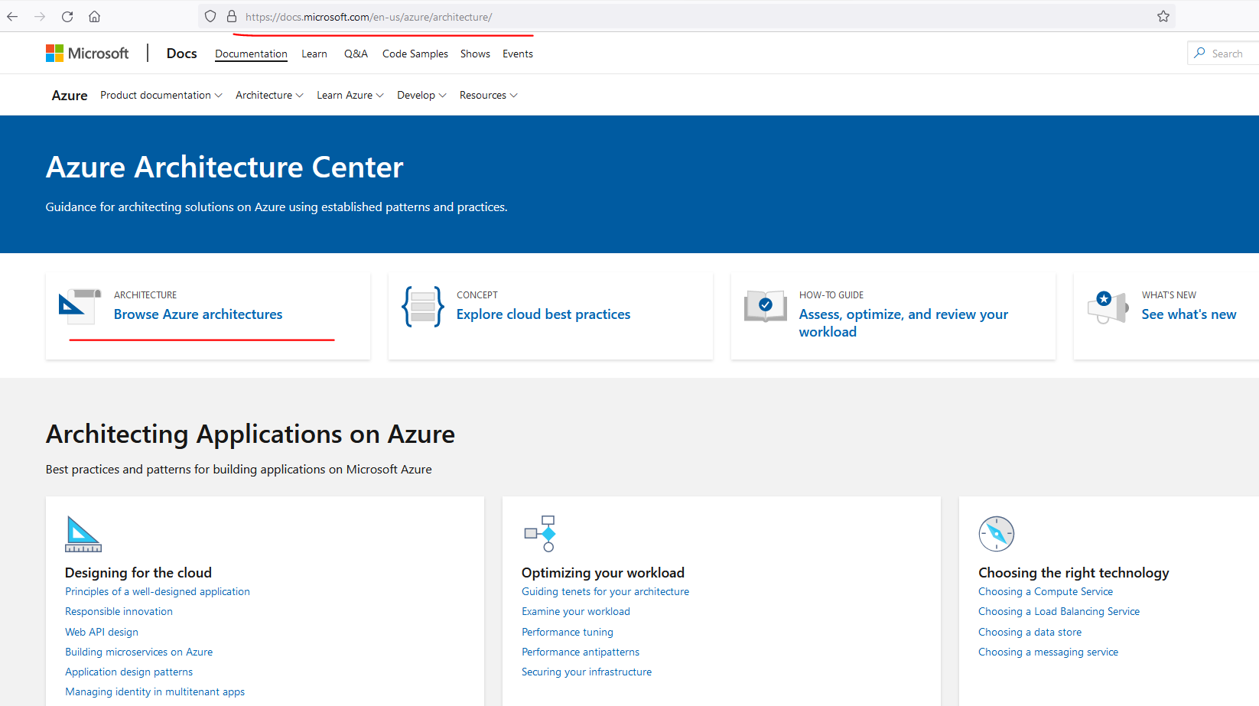

So this is the Azure Architecture Center where you can find plenty of resources which will help you identify solution architectures and design data solutions. So the thing you can do is you can go to browse Azure architectures and then search for what you want. And also you can go through the other documentation here and then go into the browser Azure Architectures and look for what we need. So as you can see here, you can do the filters based on the products or the categories. For example, if you're looking for AI and machine learning architectures, then you would click on that and that would give you the architectures for and machine learning and you can do further searches as well. So I'm going to take that off, but instead I'm going to just simply search for Azure Databricks and that will give me the architectures available within the Microsoft documentation, which uses Databricks.

So this is the Azure Architecture Center where you can find plenty of resources which will help you identify solution architectures and design data solutions. So the thing you can do is you can go to browse Azure architectures and then search for what you want. And also you can go through the other documentation here and then go into the browser Azure Architectures and look for what we need. So as you can see here, you can do the filters based on the products or the categories. For example, if you're looking for AI and machine learning architectures, then you would click on that and that would give you the architectures for and machine learning and you can do further searches as well. So I'm going to take that off, but instead I'm going to just simply search for Azure Databricks and that will give me the architectures available within the Microsoft documentation, which uses Databricks.

<https://docs.microsoft.com/en-us/azure/architecture/browse/?filter-products=Databricks&products=azure-databricks&terms=ETL>

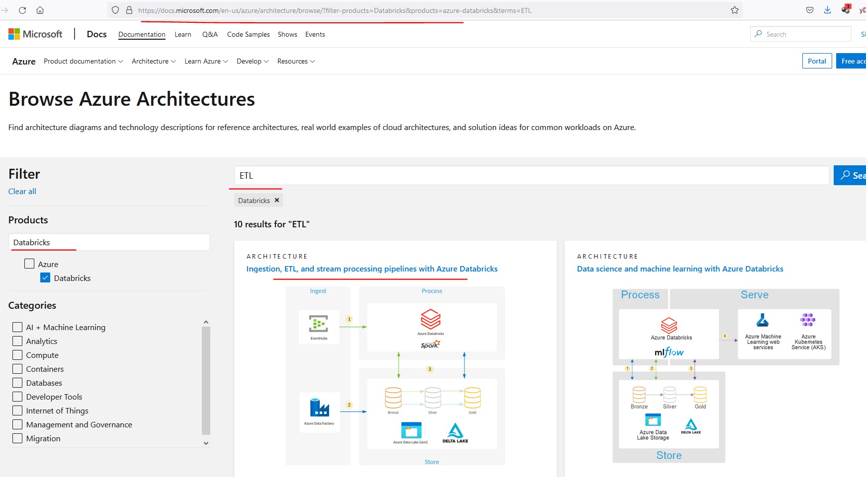

**Also see**

Architectures given here:

<https://docs.microsoft.com/en-us/azure/architecture/solution-ideas/articles/advanced-analytics-on-big-data>

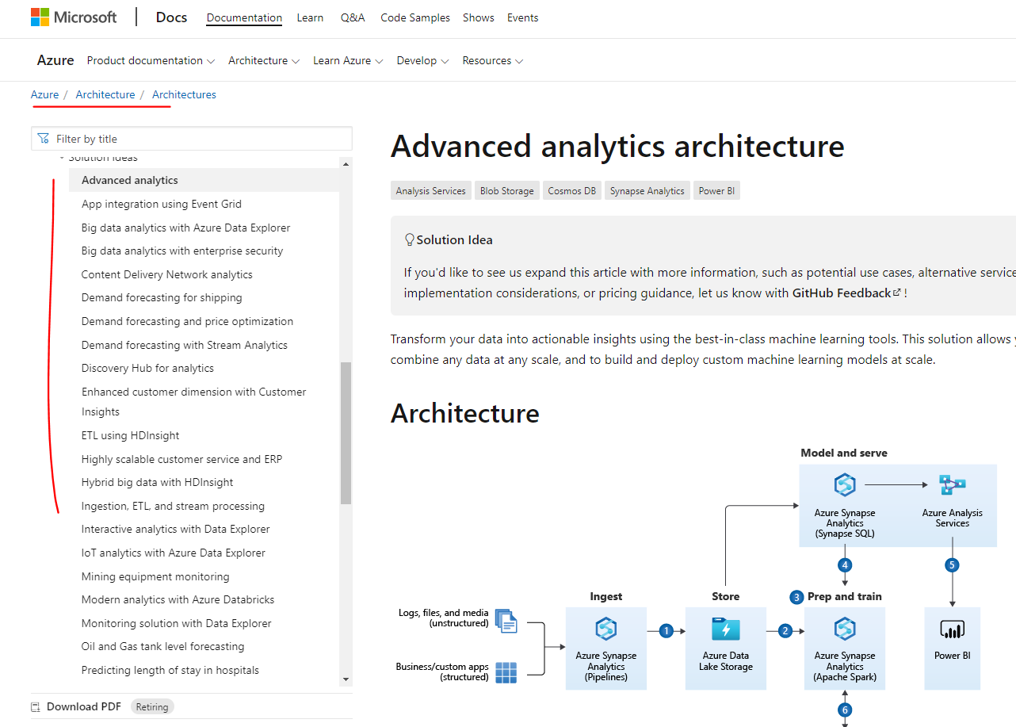

<https://docs.microsoft.com/en-us/azure/architecture/solution-ideas/articles/ingest-etl-stream-with-adb>

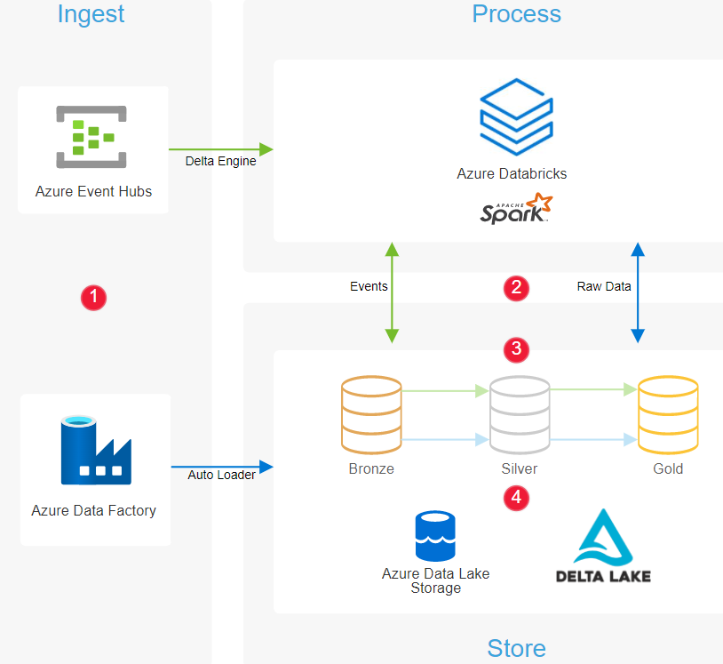

So as you can see, some of these are quite close to what we've done. So this one here is very close to what we have defined for our solution architecture. And the one I showed you in the presentation previously is this one here. And you can go into one of those and read more about the project or the solution being talked about here. For example, this one, as I said, has come from the Swiss reinsurance group, and this is how they design the solution.

<https://databricks.com/blog/2020/08/18/how-to-accelerate-your-etl-pipelines-from-18-hours-to-as-fast-as-5-minutes-with-azure-databricks.html>

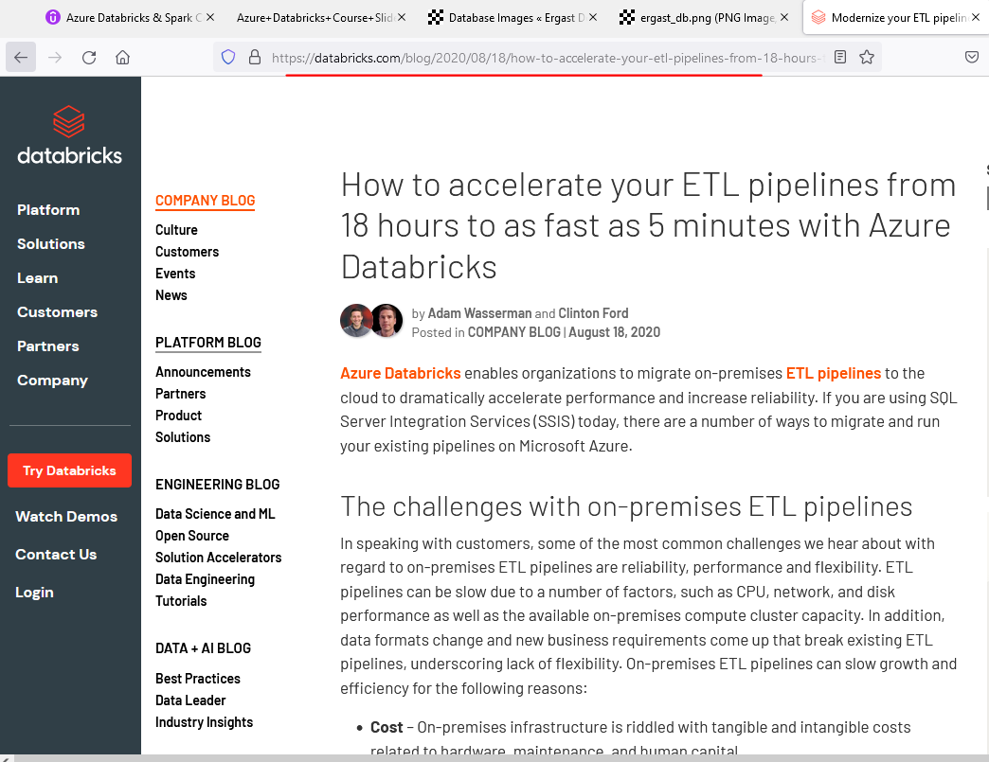

So there'll be more information that you can read from here as well. And the other place where you can look for more information is database blocks, as I said. So you can go into the company blog, for example, this blog here, how to accelerate your ETEL pipeline from 18 hours to as fast as five minutes as your data breaks. Talks about some architectures here. This is from August 2020. I always look for the dates because the technology is evolving so quickly. You don't want to be looking at a solution which was suggested like a couple of years ago. You want to look at something more recent. So here. You can see there'll be a couple of diagrams and the solutions are being suggested again in this case, we got databricks to do and train and data factory to ingest data.

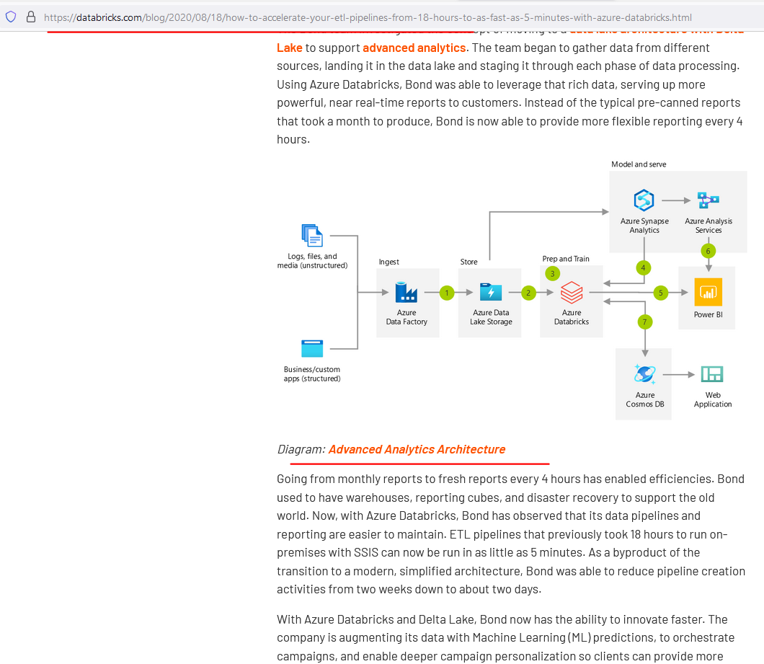

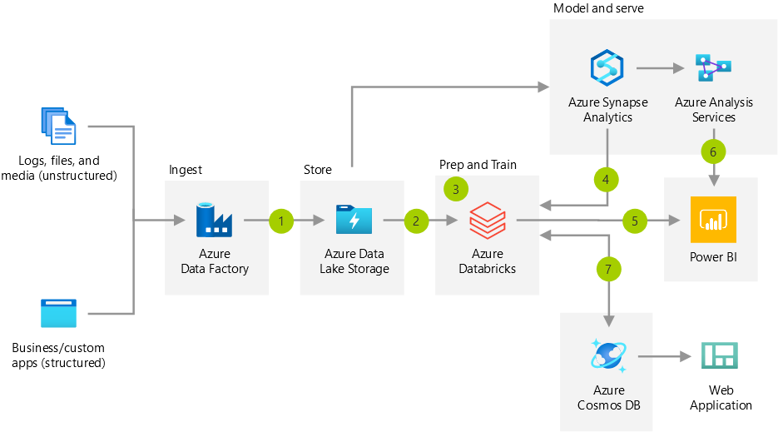

And data lake to store our data and Power BI for reporting and all of those. So the architectures are pretty similar. And it talks about more things here as well. So similarly, you can come into the blog, do your research, find out more architecture and design patterns you want to do if you are interested. I hope you've got a good understanding about the architecture we're going to use for our project, as well as, you know, how to do your own research to come up with a solution architecture for your projects in the future.

### Spark Cluster Architecture

As we've seen earlier, they'll be doing most of her project on database using PySpark and Spark SQL. I've already given you a quick introduction about Spark architecture, but I want to take it a bit deeper before we start the project again. If you find any of this difficult to understand, please come back and watch this video again once you've completed the project. None of this will stop you from progressing with the project because when you're working on Databricks, it takes care of everything for you. Even then, I just thought you should understand these concepts to become a better Spark developer. Let's get started. As we've seen previously, a cluster is a collection of nodes, a databricks cluster has one driver node and one or more worker nodes. A node basically is an individual mission, as we are in Azure, these will be one of the virtual machines on the Azure cloud. Each of the Azure virtual missions generally have at least 4, if not more cores in a database cluster. The driver runs its driver program on the JVM in the driver node and it creates this Spark Context. As the name suggests, the driver program drives the processing and it doesn't perform any of the computations required. For example, it communicates with the Cluster Manager to allocate resources, identifies the number of job stages and tasks to be created, so that the work can be parallelized. Each of the worker nodes will be running Executor JVMs.

|  |  |
| --- | --- |
| In a standard Spark architecture, there can be more than one Executer running on a Node and sharing resources. But Databricks restricts that to just one Executer running on one JVM. And that's considered to be the most optimum and easy to manage configuration. Executors, do all the data processing as well as read and write data to external data sources. Each Executer will have one or more slots to execute the tasks. This is generally equivalent to the number of calls on the Worker Nodes. As we had four slots in our worker nodes, we will have four slots here as well. Slots are just a place to execute the tasks received from the driver.  Program driver is the one which runs the application. For example, when you execute a command in the database notebook or you run as spark submit command from outside of database notebook, it runs as an application on the driver and application is divided into jobs, stages and tasks by the driver program sparked as this by trying to get as much parallelism as possible. This is mainly based on how the data can be partitioned and distributed across the cluster, as well as the stages that can be paralyzed. |  |

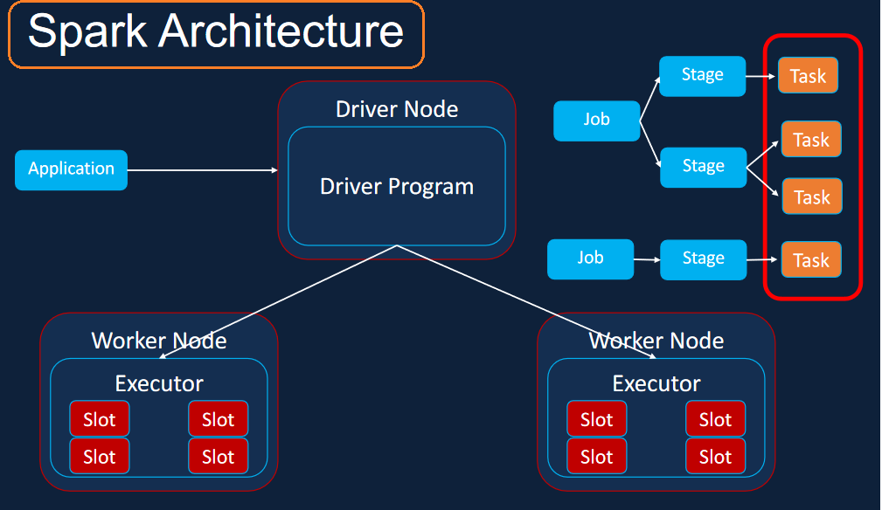 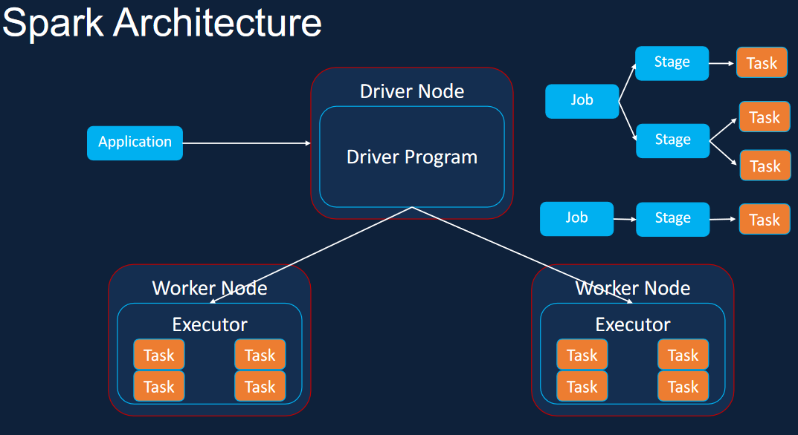

The important thing here is that the tasks are the low level components that need to be executed. The driver assigns the tasks to a slot in the Executor and the Executor performs these operations, it then returns the results back to the driver. The driver then returns the results to the user. Now that you understand how Spark paralyzes the workload, let's take a look at how we can scale the clusters when we need to. There are two ways of scaling the cluster. First one is to have nodes with more cores in them. That means you can go from, for example, for 4 cores to the 6 cores in a node. This is called vertical scaling, but you can only go so far with this before reaching the limit on the maximum number of cores, available on a virtual machine. The next approach is to horizontally scale the cluster in this approach, we add more worker nodes to the cluster, and this approach helps scale the clusters that can process petabytes of data. I hope with this you understand how this park execution model works and how it can be scaled both vertically and horizontally.

### Spark Dataframes

In this lesson, we're going to talk about pop data frames, as we saw in the previous lessons. It's big data processing by breaking down the application into many smaller jobs, stages and tasks to paralyze the work. One of the key constructs behind these are Spark data frames. When Spark reads the data, it reads them into data frames, our data frame can be represented as rows and columns with defined data types. Each Dataframe is then divided into logical partitions, which could then be computed by different executers or slots, as we've seen previously. This gives Spark the ability to divide the work and create smaller tasks and execute them in parallel to get the results quickly. For our project, we now know that we need to read our data into data frame so that spark can paralyze. Spark provides data sources API with data frame read methods to read the data from a number of data formats, including CSV, JSON, ORC, Parquet, etc.. Once the data has been read into data frames, it needs to be transformed.

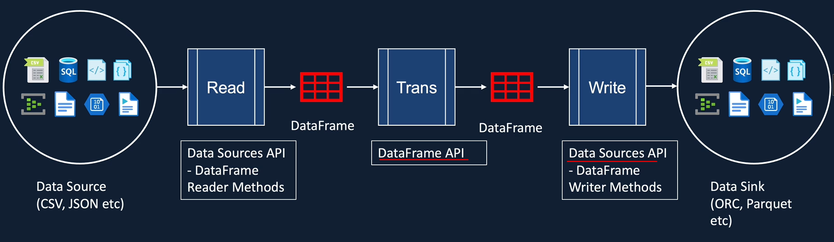

The data frame API provides a number of transformations and actions to achieve these. They range from joining and filtering the data, simple and grouped aggregations as well as window functions, they will be familiar if you've done any kind of sequel programming before. Finally, the transform data from the data frames have to be returned to the data sync in parallel. Similar to that data framework reader api methods Spark Data Sources API provides a number of data frame write methods to write data to various data formats such as Parque ORC, JSON, etc.. I just wanted to give you an introduction to date frames, as well as the apps to work with them, will be using all of this in the forthcoming lessons to strengthen our understanding.

One thing I want to clarify here is that as we've seen here, we've got the Dataframe API and the Data Sources Api and the data sources API provides us the data frame read methods and the data frame writing methods to be able to read or write data to external data sources. In the forthcoming lessons, instead of referring them as data frame read method from data sources API and data frame write method from data sources API. I have referred them as data frame reader API and the data frame writer API for ease of use. So please be mindful of that.